The Sensitivity of Orographic Precipitation to Flow Direction:

An Idealized Modeling Approach

Lee Picard and Clifford Mass

Department of Atmospheric Sciences

University of Washington

Submitted to Journal of Hydrometeorology

August 2016

Revised

February 2017

Abstract

A major question regarding orographic precipitation is its sensitivity to flow direction, with some research suggesting substantial sensitivity. To examine this issue, this paper describes a full-physics model with realistic three-dimensional terrain that is forced by a single input sounding. This system is used to investigate the sensitivity of orographic precipitation to wind direction over the Pacific Northwest for conditions approximating an atmospheric river. The model results show considerable modulation of regional precipitation as flow direction changes, with results for four Washington State river drainages agreeing well with previous observational studies. It is shown that precipitation amounts over such drainages can vary substantially with very small changes in the direction of the incoming flow. To explore the origin of directional sensitivity of precipitation over the Olympic Mountains of western Washington State, additional experiments were carried out using modified terrain fields with smoothed or idealized Olympic Mountains, or with nearby orography removed. These simulations suggest that the sensitivity of Olympic Mountain precipitation to wind direction is more strongly modulated by the presence of surrounding orography than by the specific geometry of the Olympic Mountains.

1. Introduction

Since orographic precipitation has substantial impacts on streamflow, hydropower generation, water resources, and flooding, it is important to understand the sensitivity of terrain-modulated precipitation to small variations in wind direction and other parameters. Although several studies have examined the sensitivity of precipitation intensity and distribution to varying wind speed, stability, freezing level, model microphysics, and barrier geometry, among other parameters, nearly all have considered idealized or two-dimensional terrain (e.g., Rotunno and Ferretti 2001; Jiang 2003, 2006; Colle 2004, 2008; Miglietta and Rotunno 2005, 2006; Kirshbaum and Smith 2008; Kunz and Wassermann 2011; Reeves and Rotunno 2008). Thus, it is useful to extend their work by examining the sensitivity of orographic precipitation to the characteristics of incoming flow for realistic situations, requiring the use of three-dimensional topography, and full physics mesoscale models.
Only a few modeling studies have examined the sensitivity of orographic precipitation to flow direction. Perhaps the most relevant is Nuss and Miller (2001), which investigated the sensitivity of coastal California precipitation to small variations in wind direction in order to quantify errors in mesoscale model initializations. Rotating the model terrain by one degree clockwise and counterclockwise, they found 20-40% differences in model-calculated area-average 4-hour precipitation totals for a cold frontal event. However, only three model runs were conducted, limiting the analysis to a limited set of wind directions and events. In addition, by rotating the terrain, not only was the wind direction relative to the terrain altered, but so was the orientation of the associated synoptic-scale circulation pattern. Furthermore, the grid rotation resulted in the model grid points for each run resampling the true terrain and thus did not represent the same features across all three runs. In short, Nuss and Miller suggests that even small changes in wind direction can greatly impact the distribution of orographic rainfall in complex terrain.
Atmospheric river events (ARs) may be associated with a large sensitivity of precipitation to the characteristics of the incoming flow. ARs are relatively narrow plumes of large integrated water vapor transport (IVT) extending from the subtropics into the midlatitudes (Newell et al. 1992) that are usually associated with the pre-cold frontal low-level jet in the warm sector of midlatitude cyclones (Ralph et al. 2004). Characterized by a layer of warm, saturated air with near-neutral moist stability from the surface to an altitude of two to three kilometers, ARs can produce heavy precipitation upon interacting with topography; thus, the amount and distribution of precipitation can be very sensitive to both the terrain and the characteristics of the incoming flow (Ralph et al. 2004; 2005).
Wind direction has been shown to be a major factor in determining the susceptibility of particular river drainages to AR events (e.g., Neiman et al. 2011; Hughes et al., 2014). Neiman et al. (2011) considered the synoptic-scale conditions leading to flooding in four river basins of the Cascade Range and Olympic Mountains of western Washington State. Using the North American Regional Reanalysis (NARR), they created composites of the synoptic conditions associated with the top ten annual peak daily flows (APDFs) for each river during 1980-2009. The composites confirmed the connection between annual peak flows and AR events, with low-level wind direction being a significant factor controlling precipitation totals in the different river drainages. Specifically, they found that drainages in western Washington are susceptible to AR flows from particular directions based on terrain orientation and upstream topography (cf. their Fig. 15). Thus, in the presence of a landfalling AR, wind direction determines which river drainages are most likely to experience heavy rainfall, with large shifts in precipitation possible with minor changes in direction. Hughes et al. (2014) used a simple linear model of orographic precipitation to examine the effects of changes in the approach angle of atmospheric rivers over southern Arizona. They found that region-mean precipitation was relatively insensitive (6% variation) for a range of physically plausible angles (+/- 40° of the observed direction). Sensitivity was far higher (33% variation for the same directional variation) for basin-mean precipitation.
Considering the demonstrated importance of wind direction for determining the precipitation distribution over terrain, this study examines the influence of varying wind direction on the precipitation distribution across the Olympic and western Cascade Mountains of Washington State using a full physics model with realistic terrain. Using idealized soundings and a high-resolution version of the Weather Research and Forecasting (WRF) model, the resulting system allows the exploration of the effects of changing wind direction and other parameters on the precipitation distribution over a region of complex terrain.
Another interesting question regards the role of regional terrain features, such as the mountains of Vancouver Island and the Cascade Range, on the precipitation over the Olympic Mountains. To address this question, a series of experiments with modified terrain was carried out, including smoothing the Olympic Mountains, replacing the Olympic Mountains with an idealized symmetric dome, the removal of one or more sections of high terrain of the region (e.g.., the Cascade Range, coastal mountains, Vancouver Island), and eliminating frictional contrasts along the coast.

2. Data and methods
Model configuration
Idealized numerical weather simulations were performed on a single domain covering the northwest United States and northeast Pacific. This domain, shown in Figure 1, includes the Cascade Range, the coastal mountains of Washington, Oregon and California, as well as the high terrain of Vancouver Island and southern mainland British Columbia. Using 4-km horizontal grid spacing and 37 vertical levels, the major river valleys are adequately resolved, including the Hoh, Queets, and Quinault rivers on the Olympic Peninsula and the Skagit, Stillaguamish, and Duwamish/Green rivers draining the western slopes of the Washington Cascades. Figure 2 shows an expanded view of the 4-km terrain over western Washington and four river drainages discussed later in this paper. The boundaries of these river drainages were determined using the Watershed Boundary Dataset (WBD) developed by the U.S. Department of Agriculture-Natural Resources Conservation Service, the U.S. Geological Survey, and the U.S. Environmental Protection Agency in order to isolate model grid points within the selected basins.
All experiments were conducted using the Weather Research and Forecasting (WRF) model version 3.5 (WRF-ARW V3.5; Skamarock et al. 2008). WRF was run in a fully-compressible, non-hydrostatic mode with the Thompson microphysics (Thompson et al. 2008), Rapid Radiative Transfer Model (RRTMG) shortwave and longwave radiation schemes (Iacono et al. 2008), the Yonsei University planetary boundary layer (YSU PBL; Hong et al. 2006), and the Simplified Arakawa-Schubert (SAS) cumulus (Pan and Wu 1995) parameterizations. Extensive testing at the University of Washington has found that the inclusion of a cumulus scheme at marginally convection-resolving resolutions (in this case, 4-km) produces more realistic precipitation simulations. A full ice microphysics scheme was chosen since the precipitation distribution can be greatly influenced by the advection of ice species into the lee of barriers (Colle 2004, 2008; Miglietta and Rotunno 2006; Kirshbaum and Smith 2008). The other parameterization choices were motivated by extensive testing for the real-time WRF prediction system at the University of Washington (David Ovens, personal communication, 2014). The time step was 12 seconds and integration was carried out under constant boundary conditions, as prescribed by the initial sounding. The model was run for 48 h, the first 24-h of which were reserved for model spin-up, although near-steady state was reached much sooner. The final 24 hours of each run were used for analysis.

Initialization approach
A single sounding, shown in Figure 3, was used to specify a balanced initial state and to create steady lateral boundary conditions. As noted earlier, the thermodynamic structure was chosen to approximate closely the conditions during an atmospheric river event. To this end, a sounding from an AR event (1200 UTC 07 January 2009) from Quillayute Airport (KUIL) on the Washington coast was applied, after slight smoothing, at a point on Washington’s Olympic Peninsula (47.5°N, 123.75°W). The sounding is characterized by a shallow, stable layer below 925 hPa with a slightly stable temperature profile extending to the tropopause near 250 hPa. The profile was near saturation (RH > 95%) from the surface up to 600 hPa. Winds near the surface ws set to 15 kt (7.7 ms⁻¹), increasing steadily to 115 kt (59 ms⁻¹) at 250 hPa, before decreasing above. Considering the typical low-level jet configuration of atmospheric river events, horizontal shear was included, with the wind speed decreasing smoothly with horizontal distance from the jet core using a Gaussian variation of $V=\frac{1}{2}V_{sond}\left(1+\exp\left(-{d^{2}}/{a^{2}}\right)\right)$ , where $V_{sond}$ is the wind specified in the sounding, $d$ is the perpendicular distance to a line through the sounding point (47.5°N, 123.75°W) along the specified wind direction, and $a$ is the parameter controlling the width of the Gaussian jet, here set to 1 degree of latitude or 111 km.
To determine conditions over the entire 3-D domain, initial winds were assumed to be horizontal and unidirectional everywhere, with relative humidity being constant on pressure levels but varying with height according to the sounding. Geopotential heights were calculated horizontally away from the sounding location assuming geostrophic balance. Temperatures on each level were calculated by determining the temperature gradient on pressure levels through the thermal wind relationship. After these variables were determined everywhere in the model volume, values below the terrain surface were removed, and surface values were set equal to the first vertical level above the surface. Boundary conditions remained constant for the entire integration using the values at initialization.
Since the initial state was in geostrophic/thermal wind balance, drag were not included in the initialization. Thus, during the spin-up period of the model integration, minor adjustments took place, predominantly near the surface, as a result of drag and planetary boundary layer processes in the full physics model. Modifications of the flow due to the interaction with terrain also occur. After a few hours of integration, the flow reached a quasi-steady state, with only small variations in state variables thereafter (not shown). Considering the spin-up period, the initial twenty-four hours of integration were not used in the analysis. In order to quantify the steady-state wind direction, the 925-hPa wind direction at 47.5°N, 125°W, a point offshore and upstream of the Olympic Mountains, was used. This location and level were chosen as representative of the onshore flow because the point is well upstream of any flow modification due to the terrain.
Although this initialization method creates a balanced state, it does not incorporate large-scale forcing of vertical motions. Unlike actual precipitation events, which include both orographically forced and large-scale synoptic motions, this modeling set-up is limited to terrain and surface forcing, which is generally dominant in mountainous regions (Houze 1993). As observed by Browning et al. (1975), even the much lower terrain of southern Wales caused an increase in accumulated precipitation by a factor of six. James and Houze (2005) showed a significant increase in radar-derived precipitation intensity over terrain compared to over water for heavy rain events near Eureka, California (cf., their Fig. 6a). Based on these and other studies, and the large orographic modulation observed precipitation, it is expected that orographic precipitation dominates the regional precipitation variations, although as described by Houze (1993), the feeder-seeder mechanism can produce additional rainfall. It should be noted that all previous idealized studies of orographic precipitation share this lack of direct synoptic-scale forcing of precipitation.
Quillayute sounding climatology
To help guide the idealized modeling system forced by a single sounding, it is useful to evaluate the climatology of lower-tropospheric flow direction along the Washington coast, particularly for heavy precipitation events (mainly ARs). To determine the frequency of moist flow from various wind directions, a climatology (1971-2015) of winter (NDJF) conditions was constructed from soundings launched from Quillayute Airport (KUIL) on the western side of the Olympic Peninsula. Winter conditions near crest level of the Olympics (850 hPa) are summarized (Figure 4) through a histogram of wind direction frequency, binned every ten degrees. There is a single peak centered on southerly to west-southwesterly winds (180-240°), with lower frequencies for northerly to easterly directions. The colored lines show five different percentiles of water vapor flux ($=ρ_{air}w\left|\overset{⃑}{V}\right|$) at 850 hPa over the same wind direction bins, where $ρ_{air}$ is the air density, $w$ is the water vapor mixing ratio, and $\left|\overset{⃑}{V}\right|$ is the wind speed. All water vapor flux percentiles possess maxima around 190-200°, with the distribution becoming more peaked for higher water vapor fluxes. AR events generally exceed the 90th percentile of moisture transport cases, with the moisture flux for this subset largest for southerly to south-southwesterly flow. Since large low-level moisture flux is associated with heavy rain over Pacific Northwest terrain (Warner et al. 2012), it would be expected that major precipitation events occur under southerly and southwesterly 850-hPa flow. Thus, this study will focus on flow from southerly to westerly directions.

3. Results

The results shown below are based on a temperature and humidity sounding associated with an atmospheric river event (12 UTC 07 January 2009), using realistic wind shear and an initially unidirectional sounding (Fig. 3). Model runs were initialized with varying sustained 925 hPa wind directions at the upwind point off the Olympic Peninsula coast, every 5 or 10° from 180° to 280° (180, 190, 200, 210, 220, 225, 230, 235, 240, 245, 250, 255, 260, 270, and 280°) and integrated for 48 hours, with the last 24 hours used for analysis.
Figures 5 and 6 show the 24-hour accumulated precipitation and near-surface winds (second model level at approximately 20 m above the surface) over western Washington/Oregon and the adjacent Pacific Ocean for a range of simulated 925-hPa wind directions. For southerly winds, there are moderate accumulations over the southern slopes of the Olympics and the mountains of Vancouver Island, but little accumulation over the Cascades. As the onshore winds shift from southerly to westerly, precipitation increases over the north-south oriented Cascades. Wind speeds over the Cascades increase dramatically as the wind direction turns from southerly to southwesterly, while the winds speeds are largest for southerly flow for the coastal mountains of Washington.
Figures 7 and 8 show the 24-h precipitation and near-surface winds over western Washington, with four river drainages highlighted. Precipitation enhancement over the Olympics is largest for southerly and south-southwesterly winds, with a more uniform shield of rainfall over that barrier for southwesterly to westerly flow (but still notable enhancement over the windward slopes). Precipitation over the Cascades increases as winds turn to the southwest, producing more upslope flow on that north-south barrier. Subtleties, such as enhanced precipitation over the northern Washington Cascades for south-southwesterly flow, and the development of a rain shadow to the lee of the Olympics are apparent. It is notable that the rain shadow rotates southward into Puget Sound as the winds turn more westerly, a progression that is frequently seen in observations (Mass 2008).
Topographic blocking is apparent in the low-level winds, with pronounced slowing as the flow approaches the Olympic terrain (Figure 8). Upslope winds from 205° slow to less than 5 kt (2.5 ms⁻¹) on the southern flanks of the Olympics and coincide with high precipitation totals over the Satsop River basin. As the wind turns to 215° and greater, slowing and convergence spreads northward and westward. West-southwesterly flow allows for stronger upslope flow over the Cascades. Leeside stagnation over the Strait of Juan de Fuca and the islands of the Puget Sound is also apparent.
The simulated 24-h precipitation over the four river basins is summarized in Figure 9, which indicates large changes in individual basin precipitation as the flow direction changes. The Queets River, on the southwest side of the Olympics, has its primary precipitation maximum between 240 and 250°, and a secondary peak for south-southwesterly flow (185-195°). In contrast, the south-facing Satsop drainage has a primary maximum for south-southwesterly flow (~195°). The west-facing Cascade rivers have different precipitation-direction relationships, with the largest precipitation amounts for southwesterly and westerly flow. The Sauk River in the north-central Cascades has a near Gaussian variation by direction, with the peak precipitation centered on southwesterly flow (230-240°). The Duwamish drainage, located farther south, has maximum precipitation for more westerly flow (~250°).
It is useful to compare these model results with the observed directions of peak precipitation determined for the same drainages by Neiman et al. (2011). As shown in Table 1, the modeled precipitation maxima occur at 247° for the Queets, 195° for the Satsop, 233° for the Sauk, and 253° for the Duwamish/Green, all within 10° of the values from Neiman et al. (2011). These results suggest that the idealized modeling system provides realistic guidance regarding the directional sensitivities of precipitation within specific river drainages.
One of the most dramatic findings of Nuss and Miller (2001) was the suggestion that large changes in areal precipitation can occur for small alterations in the direction of flow interacting with regional terrain (e.g., 20-40% precipitation change for +/-1° direction variation). The largest directional sensitivity found in the idealized WRF results presented above is for the Queets River basin, where the average precipitation increased from 21.1 mm to 45.5 mm as the wind shifted between 253° and 246°, corresponding to an 18% increase per degree of wind rotation. Although slightly less than the directional sensitivity of Nuss and Miller (2001), these results confirm that large changes in areal precipitation can occur for relatively small directional changes, well within typical forecast error for even the shortest temporal projections.

Terrain modification experiments
It is interesting to examine the origin of the directional sensitivities shown in the previous section. How important is the slope and orientation of the immediate barrier? Do regional terrain and land/water contrasts play a significant role? To address these questions, further model runs were completed utilizing modified terrain geometries. First, the Olympic Mountains were smoothed or replaced entirely with a symmetric dome (Figure 10). To smooth the range, the mountains were isolated and a two-dimensional Gaussian filter was applied. Subsequently, the heights were scaled so that the maximum elevation of the range remained the same as the true terrain. To replace the terrain with an ideal dome, the range was isolated and a new height field was calculated as:
$$h=h_{m}\left(1-\frac{1}{1+\exp\left(\frac{c_{1}-d}{c_{2}}\right)}\right)$$
where $h_{m}$ is the maximum height of the Olympics and $d$ is the distance from the center of the ideal dome at 47.5°N, 123.55°W in km. The values of constants $c_{1}$ and $c_{2}$ were chosen to be 70 km and 14 km, respectively, in order to create a shape with similar areal coverage of high terrain and steep slopes as the actual barrier. Model runs were initialized every 10° from 200° to 300°, with additional runs at 235°, 245°, and 255°. As before, only the final 24 h of integration were used for analysis and the 925-hPa winds at 47.5°N, 125°W quantified the actual direction of onshore flow in each experiment.
The average precipitation over the entire Olympics (see boxes in Fig. 10) for the three Olympic terrain geometries for varying wind direction is shown in Figure 11. In general, the specific shape of the Olympic Mountains has only a minor impact on the sensitivity of accumulated precipitation to wind direction. The true and the smoothed terrain produce extremely similar precipitation variations, with the accumulations in the smoothed case being slightly greater (by 1 mm or less) than for the true terrain for wind directions between about 180° and 235°. The symmetric case, while still possessing a similar shape of the precipitation/direction curve, has greater precipitation for more southerly flow. This is likely due to the steeper slopes on the south and southwest faces of the symmetric terrain compared to the actual and smoothed Olympics.
Why does precipitation vary significantly by direction if the shape of the Olympics has little effect? And why do all three cases possess a large increase in precipitation between 200° and 210°? To explore this directional precipitation modulation further, additional model experiments were carried out with the terrain geometries shown in Fig. 12. In the first experiment, the symmetric Olympic terrain was used while eliminating the coastal mountains of Oregon and Washington (no coastal ranges). Other experiments removed the mountains on Vancouver Island, eliminated the Washington Cascades, or all terrain other than the Olympics. Finally, a simulation in which surface drag/friction was eliminated was completed.
The results of these terrain-modifying experiments are summarized in Figure 13, which show how Olympics-total precipitation varies by wind direction. Removing Vancouver Island, which is downstream of the Olympics for most of the directions shown, has little impact on the precipitation modulation, while eliminating the coastal ranges of Oregon and Washington produces the same precipitation variation, but modestly reducing precipitation amounts (~1 mm) for directions north and west of 210°. It appears that uplift due to these coastal terrain features increases precipitation over the Olympics. Far more significant changes occur when the Washington Cascades are removed, although a substantial directional dependency remains. Specifically, the peak precipitation shifts from 210-220° to 230-235°, with a large reduction in precipitation from southerly and south-southwesterly directions. Taking out all terrain (symmetric Olympics only), with or without surface friction/drag, results in minimal precipitation variation with direction. The key message of these experiments is that surrounding terrain can have a large impact on the precipitation variation by direction, even if the terrain is downstream of the barrier in question.
Further insight regarding the influence of terrain on precipitation is found in Figure 14, which shows the precipitation distribution for directions between 235° and 239°. The full terrain, smoothed Olympics, and symmetric Olympics runs have similar precipitation spatial distributions, with precipitation over the windward side of both the Cascades and Olympics. Removing the coastal ranges south of the Olympics has only a minor effect, as does the removal of Vancouver Island (except for the precipitation over the windward Vancouver Is. coastal zone, of course). In contrast, removing the Cascades has a substantial influence, increasing the precipitation over the southwest side of the symmetric Olympics. It appears that removing the Cascades and the resulting upstream blocking effects, produces modestly increased upslope flow on the Olympics and thus greater precipitation.
The corresponding low-level (second model level) winds for the various terrain experiments with incoming southwesterly flow (235-239°) are shown in Figure 15. For the full terrain experiment there is slight deflection of air approaching the Olympics and low wind speeds in the lee side trough to the northeast of the barrier. Smoothing the barrier has very little impact on the winds. Deflection on the southwest side of the Olympics increases for the symmetric Olympics, due to the increased steepness of the southwest portion of the barrier. Removing the coastal ranges has minimal influence and removing all terrain other than the symmetric Olympics results in an extended lee wind shadow. Reducing drag results in stronger wind speeds over the domain and less upstream blocking, while maintaining drag and removing the Cascades increases the windward deflection and lee wind shadow.

4. Summary and conclusions
Recent modeling studies have investigated the impacts of varying terrain and upstream flow characteristics on orographically enhanced precipitation using idealized terrain, but few have used realistic, three-dimensional orography with full physics modeling. Only a limited number of papers (e.g., Nuss and Miller 2001; Neiman et al 2011) have examined the sensitivity of orographic precipitation to flow direction, and these studies have found evidence of a large sensitivity. This study explores the impacts of direction change on orographic precipitation using a full physics, three-dimensional mesoscale modeling system (WRF) driven by a single upstream sounding. The Pacific Northwest is used as a regional testbed, with special emphasis on the Olympic Mountains of western Washington State. The paper also evaluates the origin of directional sensitivity for the Olympics, including the impacts of other regional terrain features.
As a preliminary step, climatologies of winter 850-hPa winds and moisture fluxes at Quillayute Airport (KUIL) on the Washington coast were calculated. The most frequent winds are from the south to west, with the largest moisture fluxes associated with flow from the south-southwest. Such large moisture fluxes are generally associated with atmospheric rivers and heavy precipitation, as documented by Neiman et al. (2008), Neiman et al. (2011), Warner et al. 2012, and Hughes et al. (2014), among others.
The centerpiece of this paper is the initialization of full-physics, three-dimensional Weather Research and Forecasting (WRF) model simulations using a single upstream sounding of temperature and relative humidity, and a jet-like horizontal structure of the wind field. Three-dimensional fields of geopotential height and temperature were calculated through the application of geostrophic and thermal wind balance, while relative humidity was assumed to uniform in the horizontal. Wind direction, initially unidirectional in the soundings, was varied to explore the impacts of changing flow direction. The experiments described in this paper were meant to explore the impacts of an atmospheric river intercepting Pacific Northwest terrain from varying directions. To mimic the effects of the associated low-level jet, a Gaussian horizontal variation of wind speed with distance from the jet core was assumed.
Varying the direction of flow from 185° through 253° resulted in large changes in the regional precipitation distribution. Southerly flow produced little precipitation over the north-south oriented Cascade Mountains and moderate precipitation over the Olympic Mountains and the mountains of Vancouver Island. Rotating to more westerly flow resulted in substantially more precipitation over the Cascades.
Examining the precipitation simulated over four river drainages, two in the Olympic Mountains and two in the Cascades, showed well-defined maxima for specific flow directions. These results agree well with the observation-based compositing analysis of Neiman et al. (2011), suggesting that the idealized modeling system provides realistic variation of precipitation with flow direction. The model results showed slightly less sensitivity than the 20%-40% change over two degrees of rotation determined in the modeling study of Nuss and Miller (2001).
Additional experiments varied the regional terrain to explore the origin of the directional dependence of precipitation over the Olympics. These experiments included a smoothed Olympic Mountains, idealized dome-shaped Olympic Mountains, and the removal of the coastal mountains of Washington and Oregon, the Washington Cascades, or Vancouver Island. The impacts of removing surface friction were also investigated. Simulations showed that the shape of the Olympic Mountains is not a dominant factor in determining the directional sensitivity of precipitation. Removal of Vancouver Island or the coastal mountains only marginally impacted Olympic precipitation for southerly to westerly flow, while the removal of the extensive Cascade Range resulted in large differences in precipitation for southerly to southwesterly flow. The removal of all terrain other than the ideal symmetric Olympics resulted in both significantly less precipitation and reduced directional sensitivity.
All simulations in this work were initialized using a temperature profile smoothed from the 1200 UTC 07 January 2009 sounding at Quillayute Airport on the Washington coast. While this sounding exhibited many of the qualities typical to an AR event, future studies should consider the impacts of differing vertical temperature profiles that alter the freezing level and the moist stability of the column. The initialization method applied in this research, while used here exclusively to simulate AR events, can be applied to any initial sounding and could prove useful in studying the dynamics of ideal flows over real terrain in other locations and situations.

Acknowledgements
This research resulting in this paper was supported by NASA though grant NNH15ZDA001N-PMM. We acknowledge the input of two reviewers of this manuscript.

References
Browning, K. A., Pardoe, C. W., and Hill, F. F., 1975. The nature of orographic rain at wintertime cold fronts. Quarterly Journal of the Royal Meteorological Society, 101, 333–352.
Colle, B. A., 2004. Sensitivity of orographic precipitation to changing ambient conditions and terrain geometries: An Idealized Modeling Perspective. Journal of the Atmospheric Sciences, 61, 588–606.
Colle, B. A., 2008. Two-dimensional idealized simulations of the impact of multiple windward ridges on orographic precipitation. Journal of the Atmospheric Sciences, 65, 509–523.
Hong, S.-Y., Noh, Y., and Dudhia, J., 2006. A new vertical diffusion package with an explicit treatment of entrainment processes. Monthly Weather Review, 134, 2318–2341.
Houze, R. A., 1993. Cloud Dynamics. Academic Press, San Diego, 573 pp.
Houze, R. A., McMurdie, L., Petersen, W., and Schwaller, M., 2015. OLYMPEX ground validation experiment field operations plan (Version 3). Available from http://olympex.atmos.washington.edu, 56 pp.
Hughes, M., Mahoney, K. M., Neiman, P. J., Moore, B. J., Alexander, M., and Ralph, F. M. , 2014. The landfall and inland penetration of a flood-producing atmospheric river in Arizona. Part II: sensitivity of modeled precipitation to terrain height and atmospheric river orientation. Journal of Hydrometeorology, 15, 1954–1974.
Iacono, M. J., Delamere, J. S., Mlawer, E. J., Shephard, M. W., Clough, S. A., and Collins, W. D., 2008. Radiative forcing by long-lived greenhouse gases: Calculations with the AER radiative transfer models. Journal of Geophysical Research: Atmospheres, 113, 2339-2361
James, C. N., and Houze, R. A., 2005. Modification of precipitation by coastal orography in storms crossing northern California. Monthly Weather Review, 133, 3110–3131.
Jiang, Q., 2003. Moist dynamics and orographic precipitation. Tellus A, 55, 301-316
Jiang, Q., 2006. Precipitation over Concave Terrain. Journal of the Atmospheric Sciences, 63, 2269–2288.
Kirshbaum, D. J., and Smith, R. B., 2008. Temperature and moist-stability effects on midlatitude orographic precipitation. Quarterly Journal of the Royal Meteorological Society, 134, 1183–1199.
Kunz, M., and Wassermann, S., 2011. Sensitivity of flow dynamics and orographic precipitation to changing ambient conditions in idealized model simulations. Meteorologische Zeitschrift, 20, 199–215.

Mass, C., 2008. The weather of the Pacific Northwest. University of Washington Press, 268 pp.
Miglietta, M. M., and Rotunno, R., 2005. Simulations of moist nearly neutral flow over a ridge. Journal of the Atmospheric Sciences, 62, 1410–1427.
Miglietta, M. M., and Rotunno, R., 2006. Further results on moist nearly neutral flow over a ridge. Journal of the Atmospheric Sciences, 63, 2881–2897.
Neiman, P. J., F. M. Ralph, G. A. Wick, J. Lundquist, and M. D. Dettinger, 2008b: Meteorological characteristics and overland precipitation impacts of atmospheric rivers affecting the West Coast of North America based on eight years of SSM/I satellite observations. J. Hydrometeor., 9, 22-47.

Neiman, P. J., Schick, L. J., Ralph, F. M., Hughes, M., and Wick, G. A., 2011. Flooding in western Washington: the connection to atmospheric rivers. Journal of Hydrometeorology, 12, 1337–1358.
Newell, R. E., Newell, N. E., Zhu, Y., and Scott, C., 1992. Tropospheric rivers? – A pilot study. Geophysical Research Letters, 19, 2401–2404.
Nuss, W. A., and Miller, D. K. (2001). Mesoscale predictability under various synoptic regimes. Nonlinear Processes in Geophysics, 8, 429–438.
Pan, H. L., and Wu, W. S., 1995. Implementing a mass flux convective parameterization package for the NMC medium range forecast model. NMC office note, 409.40, 20-233.
Ralph, F. M., Neiman, P. J., and Rotunno, R., 2005. Dropsonde observations in low-level jets over the northeastern Pacific Ocean from CALJET-1998 and PACJET-2001: mean vertical-profile and atmospheric-river characteristics. Monthly Weather Review, 133, 889– 910.
Ralph, F. M., Neiman, P. J., and Wick, G. A., 2004. Satellite and CALJET Aircraft Observations of Atmospheric Rivers over the Eastern North Pacific Ocean during the Winter of 1997/98. Monthly Weather Review, 132, 1721–1745.
Rotunno, R., and Ferretti, R., 2001. Mechanisms of Intense Alpine Rainfall. Journal of the Atmospheric Sciences, 58, 1732–1749.
Scorer, R. S.,1949. Theory of Waves in the Lee of Mountains. Quarterly Journal of the Royal Meteorological Society, 75, 41–56.
Skamarock, W. C., Klemp, J. B., Dudhia, J., Gill, D. O., Barker, D. M., Duda, M. G., Huang, X.- Y., Wang, W., and Powers, J. G., 2008. A description of the Advanced Research WRF version 3. NCAR Tech. Note NCAR/TN-475+STR, 125 pp.
Thompson, G., Field, P. R., Rasmussen, R. M., and Hall, W. D., 2008. Explicit forecasts of winter precipitation using an improved bulk microphysics scheme. Part II: implementation of a new snow parameterization. Monthly Weather Review, 136, 5095– 5115.
U.S. Department of Agriculture-Natural Resources Conservation Service, US Geological Survey, and US Environmental Protection Agency. Watershed Boundary Database. Retrieved from http://datagateway.nrcs.usda.gov.
Warner, M. D., Mass, C. F., and Salathé, E. P., 2012. Wintertime extreme precipitation events along the Pacific Northwest coast: climatology and synoptic evolution. Monthly Weather Review, 140, 2021–2043.

Table 1

Directions of Maximum Precipitation for Four Washington River Drainages (°)
River Drainage Model Neiman et al. (2011)
Queets 247 247.5
Satsop 195 202.5
Sauk 233 225
Duwamish/Green 253 246-275

Figure Captions

Figure 1: WRF-ARW 4-km resolution model domain used in all experiments. Terrain elevation ASL (m) is shown by color shading
Figure 2. Terrain heights (shaded and contoured every 500 m) for western Washington with the four river basins analyzed outlined in red
Figure 3. The sounding, smoothed from the 1200 UTC 07 January 2009 sounding from KUIL, used to initialize all model runs. The vertical profile of temperature is shown in red and the vertical profile of dew point in blue. 270° initial winds case shown for illustration
Figure 4. A climatology of winter (NDJF) 1971-2015 wind and water vapor flux at 850 hPa for soundings launched from Quillayute, Washington (KUIL). The number of wind observations in each 10-degree wind bin is shown in the grey columns and five different percentile values of vapor flux (kg m⁻² s⁻¹) in each bin are shown by the blue lines
Figure 5. Precipitation totals (mm) for the final 24 h of integration over western Washington and Oregon and the northeast Pacific Ocean for various 925-hPa wind directions.
Figure 6. Wind speeds (shaded, in kt) and directions (arrows) at the second model level averaged over the final 24 h of model integration over western Washington and Oregon.
Figure 7. 24-h precipitation total over western Washington (mm), with four drainages (Queets, Satsop, Duwamish/Green, and Sauk River) shown in white outlines.
Figure 8. Winds over western Washington for various directions, with four river drainages outlined in white.
Figure 9. 24-h precipitation (mm) averaged over the Queets (blue), Satsop (green), Duwamish/Green (red), and Sauk (orange) River basins for various 925-hPa wind directions.
Figure 10. Real and simplified Olympic Mountain terrain elevations (m, shaded and contoured every 300 m) with the box (in red) over which precipitation was averaged.
Figure 11. 24-h precipitation (mm) averaged over the boxes shown in Figure 10 for the true terrain (blue), smoothed terrain (red), and ideal symmetric terrain (green) of the Olympics.
Figure 12. Terrain heights (shaded, in m) for the four modified terrain cases with symmetric Olympic Mountains. Precipitation was averaged over the boxes shown in red.
Figure 13. As Figure 11, for modified terrain runs using the ideal, symmetric dome terrain.
Figure 14. 24-h precipitation total over western Washington (mm), for steady wind directions near 235° for a variety of modified terrain simulations.
Figure 15: Low-level wind directions (arrows) and wind speed (color shading) for various terrain experiments for southwesterly winds (236-239°)

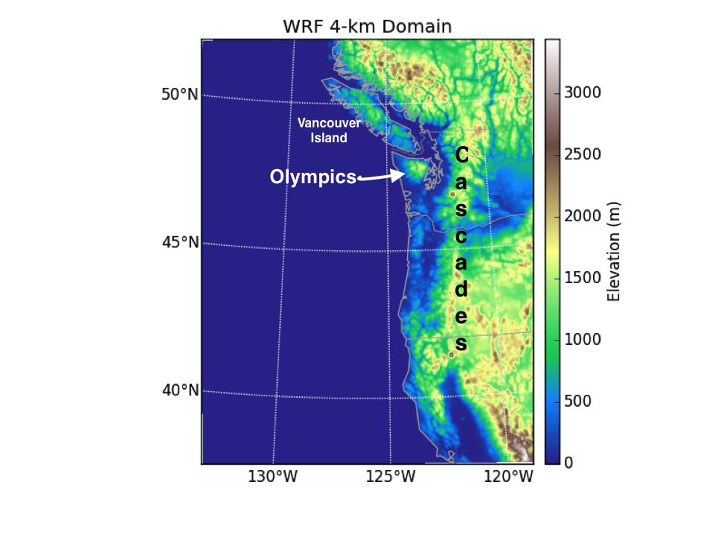
Figure 1. WRF-ARW 4-km model domain used in all experiments. Terrain elevation ASL (m) is shown by color shading
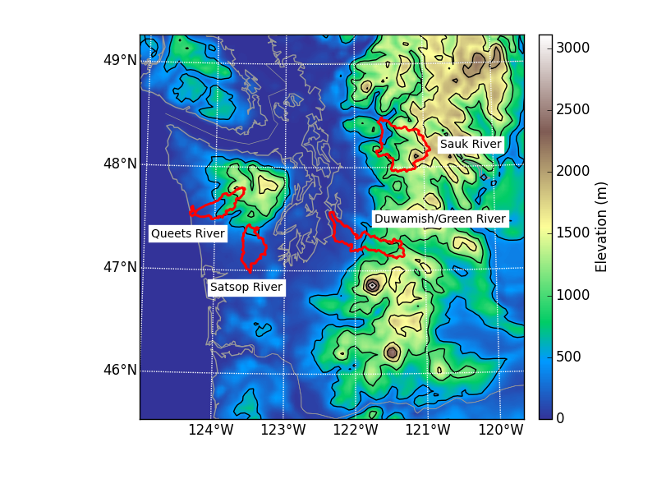
Figure 2. Terrain height (shaded and contoured every 500 m) for western Washington, with the four river basins that are considered in this study are outlined in red

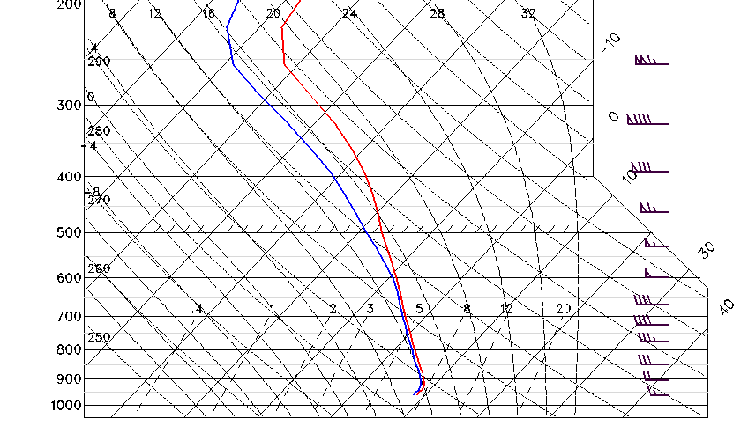a.
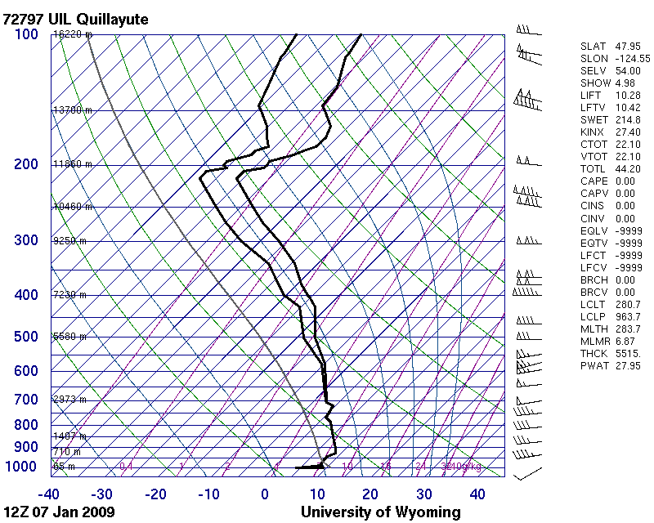b.

Figure 3. The sounding, smoothed from the 1200 UTC 07 January 2009 sounding from Quillayute, WA (KUIL), used to initialize all model runs (a). The vertical profiles of temperature (red) and dew point (blue) are shown. 270° initial winds case shown for illustration. The original sounding before smoothing (b).

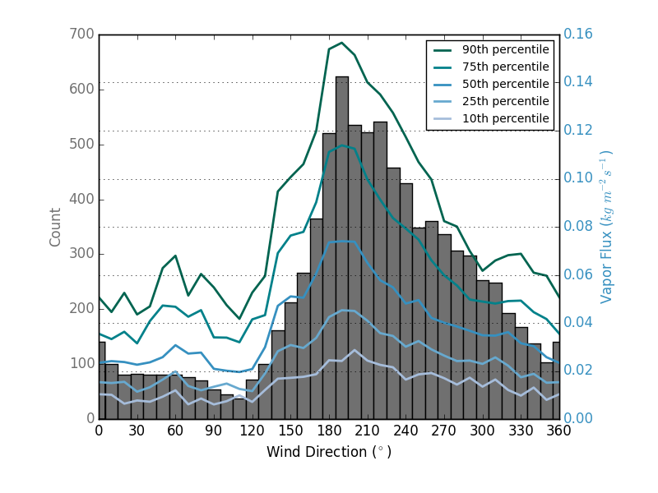
Figure 4. A climatology of winter (NDJF) 1971-2015 wind and water vapor flux at 850 hPa for soundings launched from Quillayute, Washington (KUIL). The number of wind observations in each 10-degree wind bin (grey columns) and five different percentile values of vapor flux (kg m⁻² s⁻¹) in each bin (blue lines of varying shades) are shown.
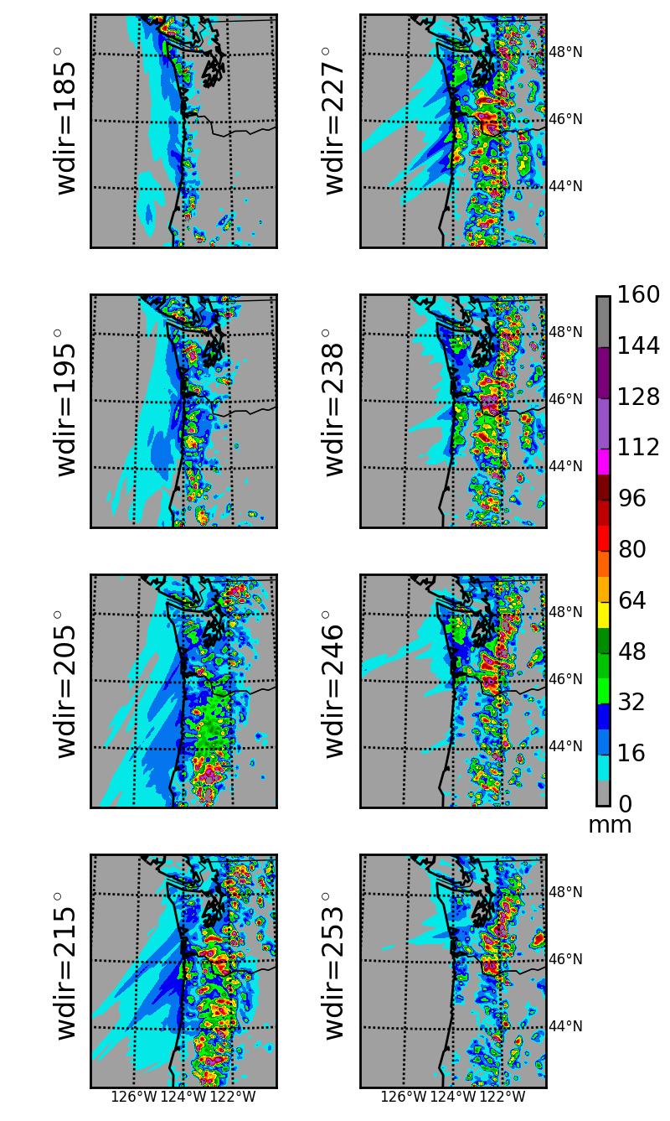
Figure 5. Precipitation totals (mm) for the final 24 h of integration over western Washington, western Oregon, and the northeast Pacific Ocean for various 925-hPa wind directions.

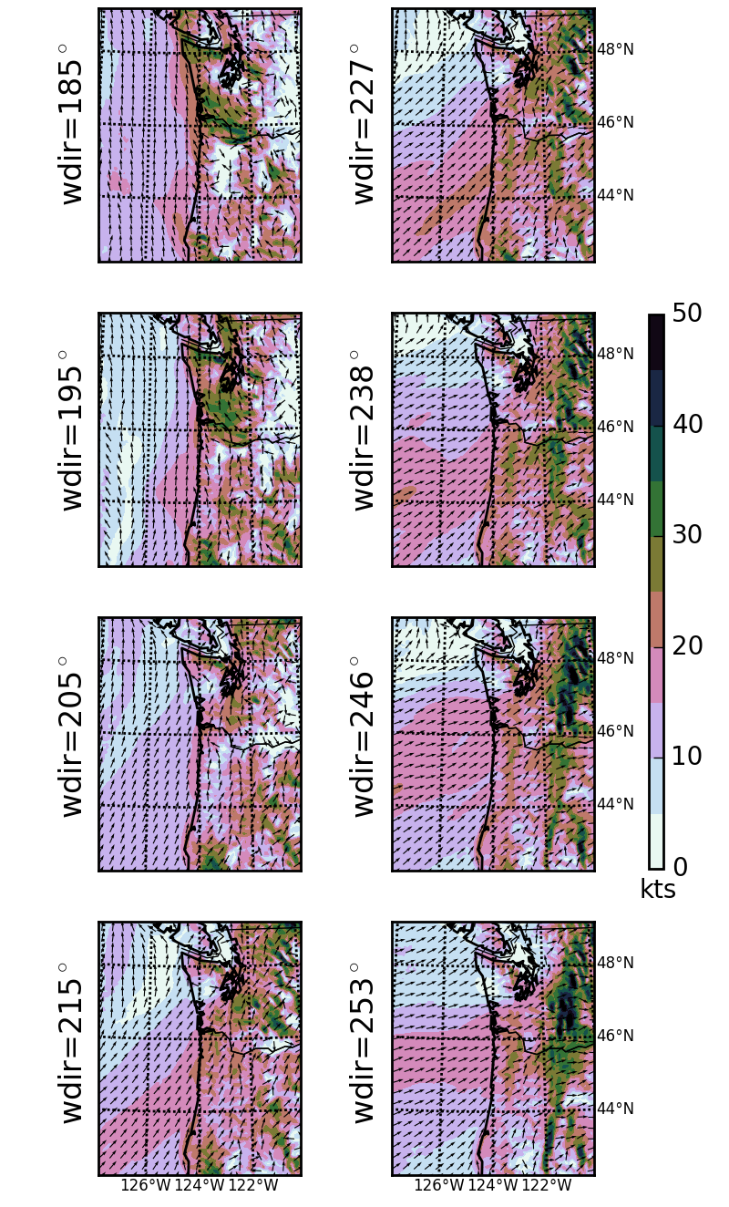
Figure 6. Wind speeds (shaded, in kt) and directions (arrows) at the second model level averaged over the final 24 h of model integration over western Washington and Oregon.

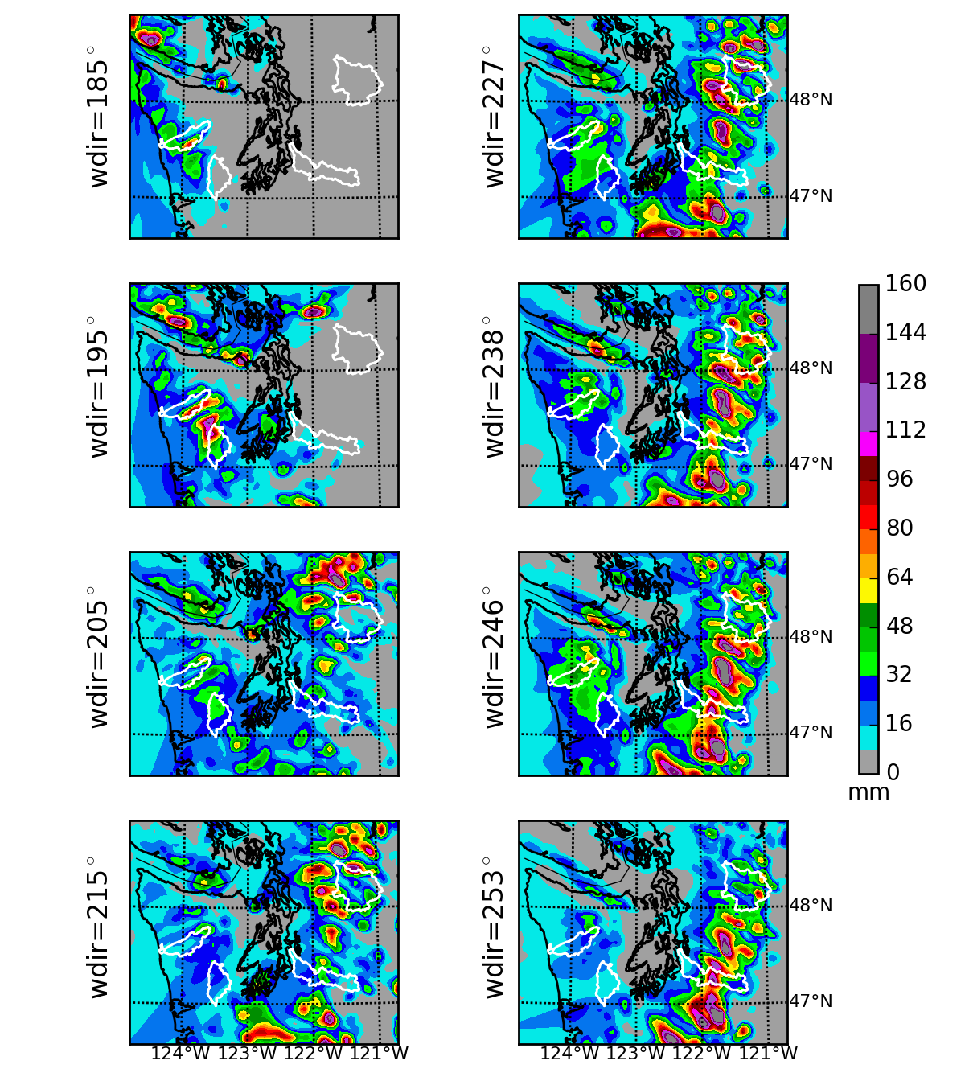
Figure 7. 24-h precipitation total over western Washington (mm), with four drainages (Queets, Satsop, Duwamish/Green, and Sauk River) shown by white outlines.
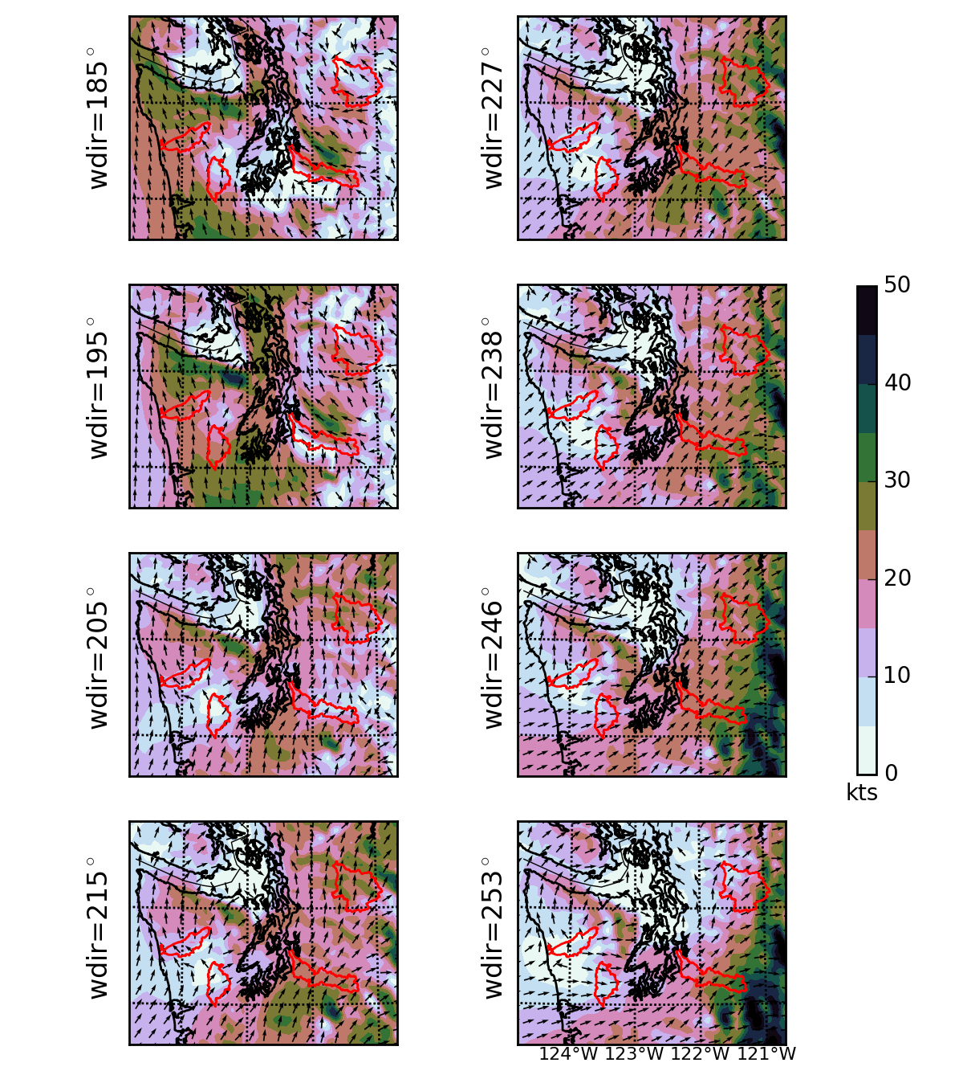
Figure 8. Winds over western Washington for various directions, with four river drainages outlined in red.

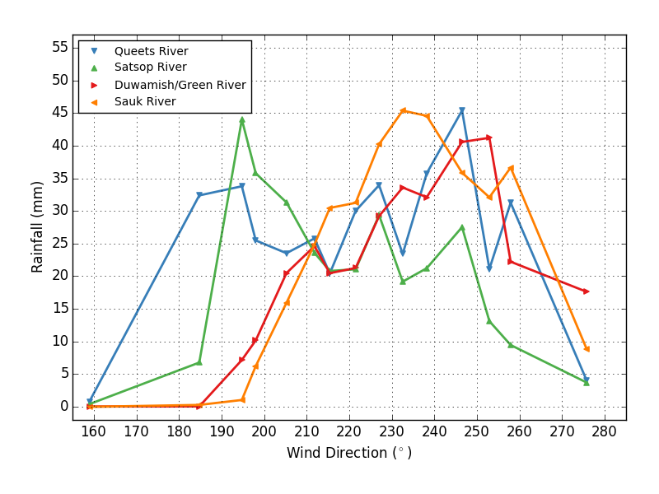
Figure 9. 24-h simulated precipitation (mm) averaged over the Queets (blue), Satsop (green), Duwamish/Green (red), an Sauk (orange) River basins for various 925-hPa wind directions.
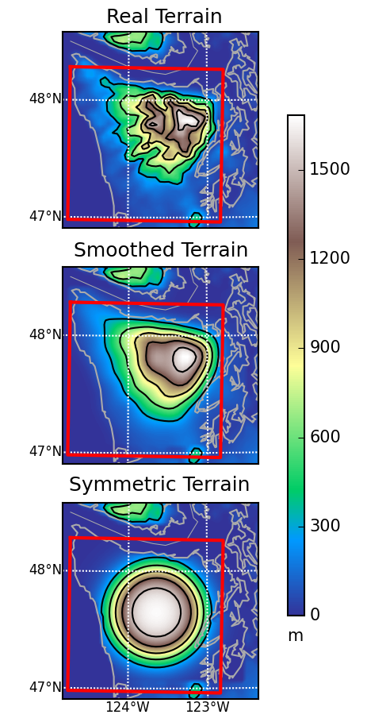
Figure 10. Real and simplified Olympic Mountain terrain elevations (m, shaded and contoured every 300 m) with the box (in red) over which precipitation was averaged.
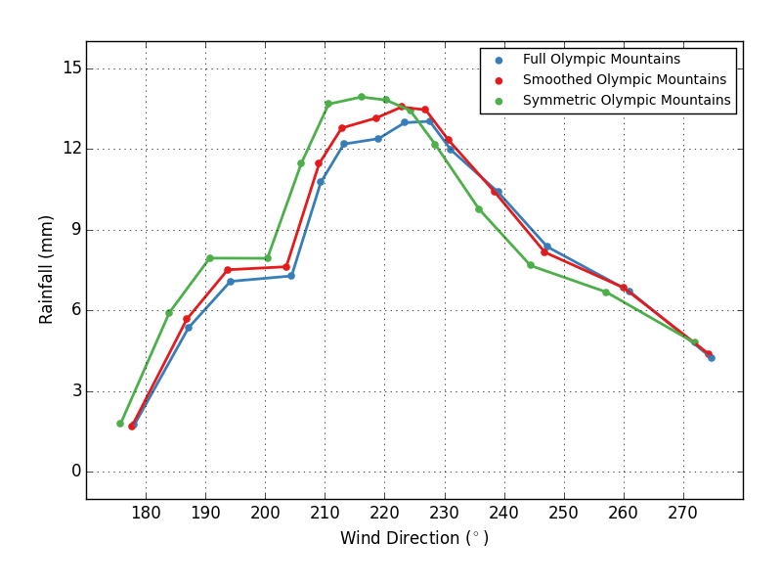
Figure 11. 24-h precipitation (mm) averaged over the boxes shown in Figure 10 for the true terrain (blue), smoothed terrain (red), and ideal symmetric terrain (green) of the Olympics.

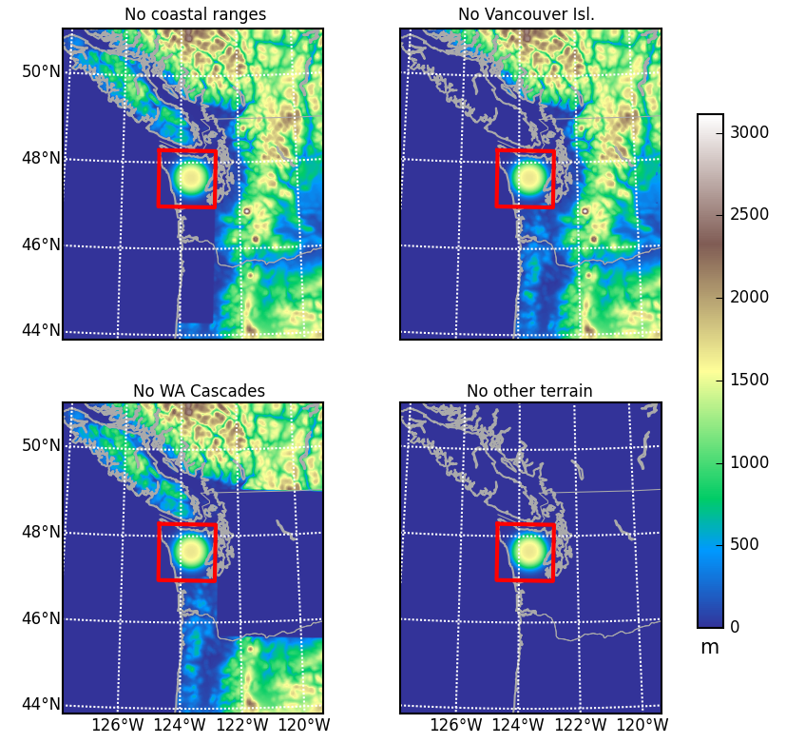
Figure 12. Terrain heights (shaded, in m) for the four modified terrain cases with symmetric Olympic Mountains. Precipitation was averaged over the boxes shown in red.
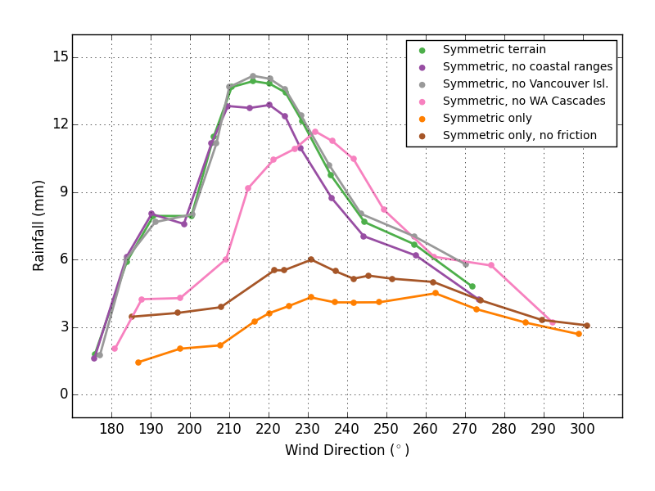

Figure 13. As Figure 11, for modified terrain runs using the ideal, symmetric dome terrain.

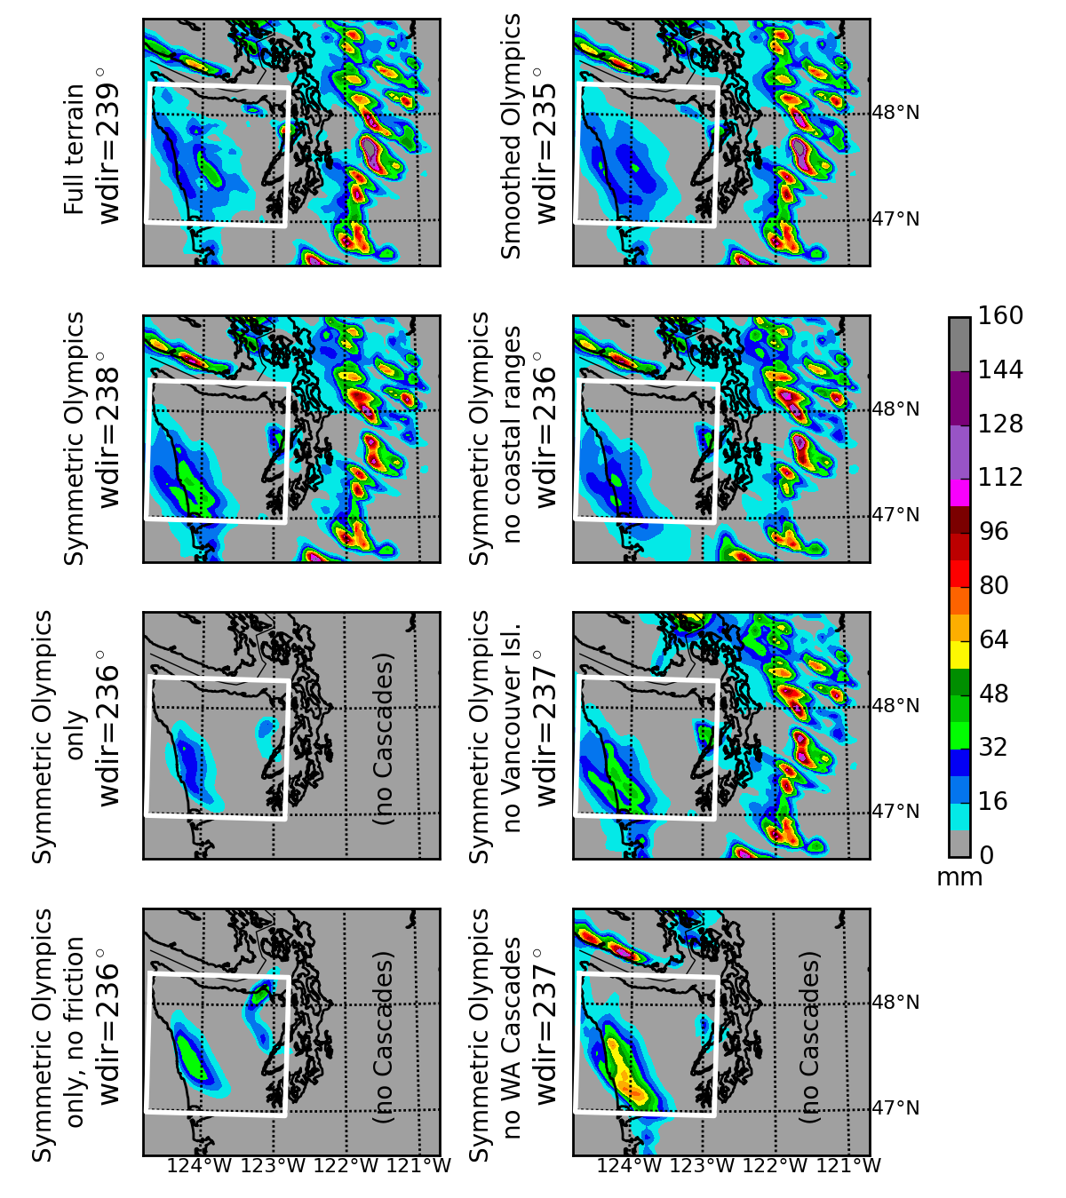
Figure 14. 24-h precipitation total over western Washington (mm), for steady wind directions near 235° for a variety of modified terrain simulations.

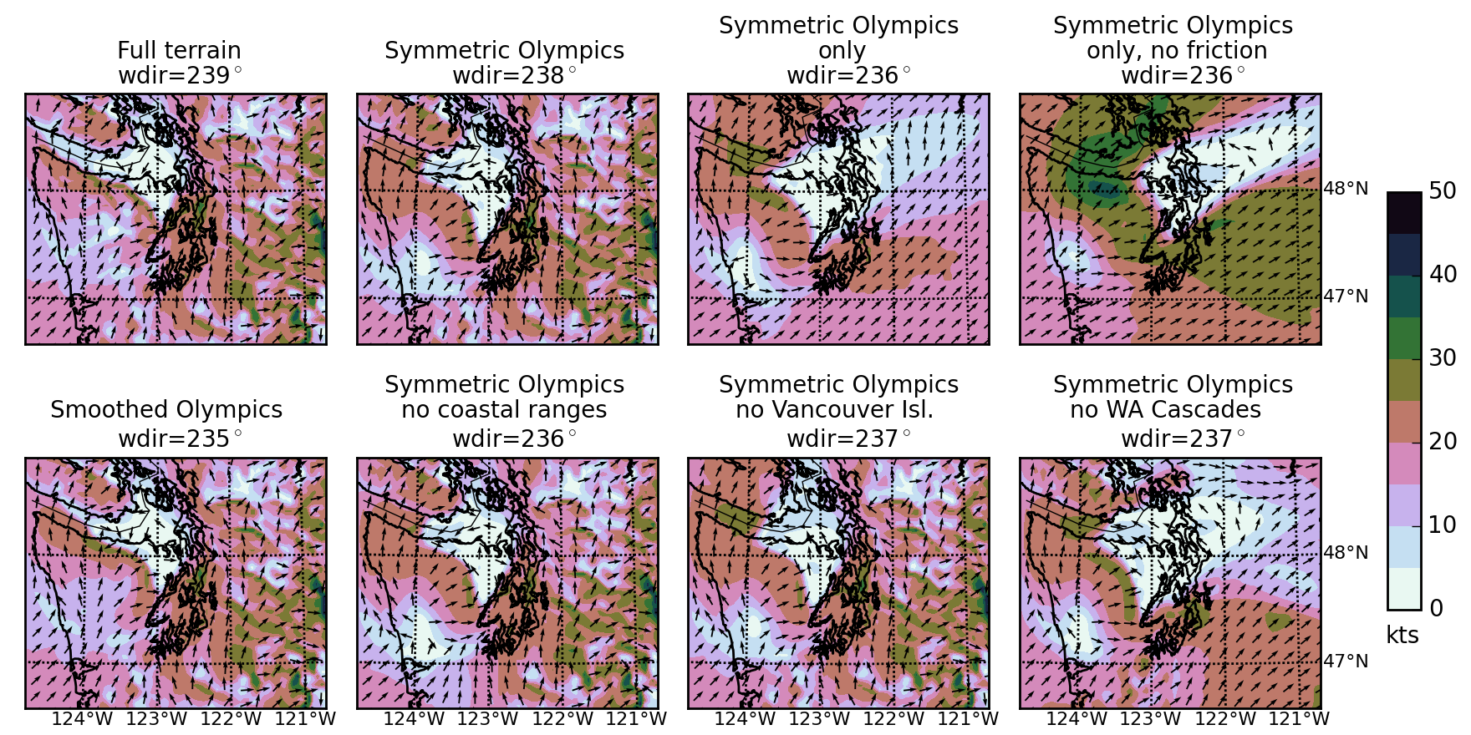
Figure 15: Low-level wind directions (arrows) and wind speed (color shading) for various terrain experiments for southwesterly winds (235-239°)

Current affiliation: Fleet Numerical Meteorology Oceanography Center, N34, Monterey, California
Corresponding author. Department of Atmospheric Sciences, Box 351640, University of Washington, Seattle, Washington 98195, 206 685-0910, cmass@uw.edu

