Advanced Approaches for the Collection, Quality Control, and Calibration of Smartphone Pressure Observations and Their Appliciation in Numerical Weather Prediction.

Conor Mc Nicholas

A thesis
submitted in partial fulfillment of the
requirements for the degree of

Master of Science

University of Washington
2017

Committee:
Clifford Mass
Gregory Hakim
Dale Durran

Program Authorized to Offer Degree
Atmospheric Sciences

©Copyright 2017 Conor Mc Nicholas

University of Washington

Abstract

A Novel Smartphone Pressure Network for Numerical Weather Prediction.

Conor Mc Nicholas

Chair of the Supervisory Committee:
Dr. Clifford Mass
Atmospheric Sciences

Distributed worldwide, over 300 million smartphones are now capable of measuring atmospheric pressure, providing a potential surface observing network of unprecedented density and coverage. To examine the utility of such a network and test potential approaches for collection, quality control, and calibration of smartphone pressures, a novel smartphone pressure app was developed. Within this app, observational uncertainty was quantified, quality control was performed, and sources of stochastic error were minimized. New machine learning techniques were developed to proactively correct observation bias. To test the performance of the app and evaluate the utility of smartphone pressure observations, WRF-EnKF experiments were performed for two case studies. In both case studies, smartphone pressures were able to constrain forecasts and analysis of observed and unobserved variables. In the second case-study full-cycling experiments assimilating smartphone pressures were able to successfully predict the forecast track and intensity of a major wind storm. Partial cycling experiments revealed that by improving initial conditions smartphone pressure assimilation can enhance forecasts at short lead times.

Table of Contents

Chapter 1: The Utility of Surface Pressure and The Potential of Crowdsourcing………………….1
1.1) Review of crowdsourcing surface pressure networks………….…….……………….1

1.2) Background and Literature Review…………………………………………………...2

1.3) Motivation and problem statement……………………………………………………5

Chapter 2: Development and Performance of uWx, an Innovative Pressure Collection app………6
2.1) In-app quality control framework…………………………………………………….6

2.2) Pressure retrieval procedure…………………………………………………………11

2.3) App summary and current status…………………………………………………….12

2.4) App comparison…………………………………………………………………......13

Chapter 3: A Machine Learning Approach to Post Processing Smartphone Pressure Observations……………………………………………………………………………………..17
3.1) Motivation…………………………………………………………………………...17

3.2) Bias Correction with Random Forests……………………………………………….20

3.3) Quality Control with Radial Basis Functions………………………………………..30

Chapter 4: DART-WRF EnKF experiments with Bias Corrected Smartphone Pressure observations……………………………………………………………………………………...41
4.1) Background………………………………………………………………………….41

4.2) Methods……………………………………………………………………………..44

4.3) Results………………………………………………………………………………47

4.4) Summary…………………………………………………………………………….68

4.5) Implications…………………………………………………………………………70

Chapter 1

THE UTILITY OF SURFACE PRESSURE AND THE POTENTIAL OF CROWDSOURCING

  - Review of crowdsourcing surface pressure networks.
Over the past quarter century, the advent of the Internet and advances in telecommunication and sensor technology have resulted in a substantial increase in the availability of real-time surface pressure observations from local MESONETs and privately operated citizen weather observer networks. Three of the most prominent citizen weather networks are the Citizen Weather Observer Program (CWOP) which has grown to over 6000 members, the WeatherBug network which has deployed over 8000 weather stations at neighborhood schools and public facilities across the US, and the Wunderground network which consists of over 30,000 private weather stations worldwide. Combined, these networks provide tens of thousands of near-real time surface pressure observations across the United States. While these networks have rapidly increased the number of available pressure observations across the US, sizeable gaps in data availability remain, especially in rural areas, as most private weather stations are located in urban areas. Furthermore, quality control issues and limited temporal resolution remain a challenge for existing privately operated weather networks. Fortunately, a rapid increase in the temporal and spatial resolution of surface pressure observations may be achieved with the aid of smartphones.
Over the past three years, well over half a billion smartphones capable of measuring atmospheric pressure have been sold worldwide (eMarketer). Two crowd-sourcing applications that have taken advantage of the proliferation of smartphone barometers are PressureNet and OpenSignal. In 2015, the mobile collection of surface pressure from both of these apps exceeded 100,000 observations an hour. In August 2016, The Weather Channel app, with over 50 million downloads, began collecting upwards of 3 million observations an hour from a mere 3% of their user-base. By mid-2017, 30 billion pressures will be retrieved every month from the Weather Channel app. If infrastructure and data quality challenges can be met, these observations could revolutionize numerical weather prediction (NWP) by providing unprecedented observational coverage and density. Potentially even more smartphone pressures could be collected if other major apps were provided with pressure-collection code.
1.2) Background and Literature Review
As of January 2017, over 170 smartphones are capable of measuring surface pressure. Surface pressure is arguably the most valuable observed surface variable due to its ability to provide information on all scales of motion ranging from convectively induced cold pools to mid-latitude cyclones. Surface pressure reflects atmospheric structure aloft above the planetary boundary layer (PBL), in contrast to surface temperature, moisture, and wind. Unlike other surface measurements, surface pressure is less affected by representation error as the distribution of surface pressure, corrected for elevation variation, is typically more spatially homogeneous than other surface parameters and has little variation between the inside and outside of buildings. Measurements of pressure exhibit fewer exposure problems and are less sensitive to the placement of instrumentation than measurements of other surface variables. For these reasons, among others, a number of a studies during the last decade have examined the impact of surface observations, and in particular surface pressure, on numerical simulations and forecasts across a variety of atmospheric scales.
At the planetary scale, Whitaker et al. (2004) showed that assimilating surface pressure at a relatively sparse collection of locations could produce realistic lower and middle tropospheric analyses, with 500 hPa errors similar to present 2.5 day forecast errors. Compo et al. (2006) assimilated surface pressure observations using ensemble techniques and found surface pressure observations alone could reproduce the entire upper tropospheric circulation, even during the first half of 20th century. This remarkable conclusion led to the construction of the 20th Century Reanalysis using surface pressure observations alone (Compo et al. 2011).
Dirren et al. (2007), assimilating observations from an idealized regional network of surface pressure observations, was able to constrain lower-tropospheric fields and geopotential heights through the middle troposphere. A recent study examining the impact of assimilation frequency by Lei et al. (2014) came to a similar conclusion, noting that assimilation of surface pressure observations at all frequencies constrained observed state variables and reduced error and uncertainty through the depth of the troposphere. As assimilation frequency was increased, the analysis error through the depth of the troposphere decreased. This conclusion is in agreement with a previous idealized study by Anderson et al. (2005), which observed a monotonic decrease of prior error for all state variables as the density and frequency of assimilated surface pressure observations was increased.
While high frequency (hourly or less) assimilation of surface pressure has produced significant reductions in analysis error in idealized planetary and synoptic scale simulations, a major question asks whether the same result could be achieved in mesoscale experiments. Wheatley and Stensrud (2010) assimilated altimeter setting and 1-h surface pressure tendency along with traditional surface observations such as temperature, moisture, and winds from METAR stations. The hourly assimilation of altimeter setting, and to a limited extent surface pressure tendency, constrained errors in meso-high position and intensity, resulting in improved model depictions of cold pools associated with MCS events. Madaus et al. (2014) performed a similar study utilizing a high-density network of routine METAR and non-traditional MESONET observations from private operators such as the Citizen Weather Observer Program (CWOP). In this study, quality control and bias correction techniques were implemented, using the RSAS altimeter analysis as truth. Implementation of these techniques resulted in substantial improvements in 3-h forecasts of altimeter setting. In full-cycling experiments, Madaus et al. (2014) observed a significant reduction in domain averaged error when additional, high-density, pressure observations were assimilated. However, without bias correction this error reduction was not observed. Since pressure tendency is independent of bias, Madaus et al. (2014) examined the effects of assimilating pressure tendency and found that increasing the frequency of pressure tendency assimilation from 3-h to 1-h produced a more realistic distribution of mesoscale precipitation during a Puget Sound Convergence Zone event.
Recently available smartphone pressures have characteristics that are similar to the MESONET observations employed in the aforementioned studies. Both smartphone and MESONET pressures suffer from quality control issues and representation error due to uncertainty in elevation. Like MESONET sites, smartphones are capable of submitting observations at high temporal frequency. But smartphone pressures observations (SPOs) outnumber MESONET pressure observations by an order of magnitude.
During the past two years, several first smartphone case studies appeared in the literature. Hanson and Greybush (2016) performed idealized simulations with synthetic smartphone observations. They concluded that if observational uncertainty can be well represented, smartphones pressures could improve model forecasts of surface variables. **ADD BAMS ARTICLE** Madaus and Mass (2017) assimilated quality controlled smartphone pressure observations from networks like PressureNet and OpenSignal but failed to produce improvements in forecasts of surface variables. The forecasts skill for some surface variables, like 2m-temperature and 2m-humidity, decreased after the assimilation of quality controlled SPOs. This results suggests significant advances in quality control and post-processing of smartphone observations need to occur before SPOs may be of value to NWP.
1.3) Motivation and problem statement.
The utility of surface pressure assimilation has been demonstrated in the literature. With the availability of millions, and potentially, billions of SPOs from providers like the Weather Company, a global pressure network of unprecedented density has become a feasible. Lei et al. (2014) and Anderson et al. (2005) suggested a monotonic relationship between observation density and prior error. If even a fraction of smartphone observations can be utilized for NWP, their superior spatial coverage could potentially provide significant improvements in forecast skill. Unfortunately, no current apps have been designed to provide SPOs suitable for NWP. Incoherency and a lack of consistency among SPOs currently undermines the use of the smartphone pressures in NWP. If smartphones are to contribute to NWP and become a viable atmospheric observing platform, sources of observational uncertainty must be constrained and quantified. New approaches to quality control and calibration are needed, as is insights into the best design of pressure-collection protocols on mobile platform And the results of such quality controlled/calibrate smartphone pressures must be tested in relevant real-life situation. These are some of the challenges that are addressed in this thesis. **NEED TO TAKE THE UWX business out of the problem statement**

Chapter 2

DEVELOPMENT AND PERFORMANCE OF AN INNOVATIVE PRESSURE COLLECTION APP, uWx

2.1) In-app quality control framework

2.1.1 Motivation
**NEED TO TALK ABOUT WHY DEVOPMENT OF AN APP IS NEEDED frist** Need to experiment with collection protocols, onboard QC, etc.

A quality control (QC) framework was developed within the app to reduce observational error, both systematic and stochastic, quantify uncertainty and bias, and provide QC estimates of pressure change. Previous SPO providers such as PressureNet and OpenSignal performed no such QC in-app. Consequently, QC techniques performed remotely were only able to utilize pressure and location information**?? Why?? NOT CLEAR**. The results of Madaus and Mass (2017) show that remote QC techniques performed on SPOs without the benefit of in-app QC are insufficient. **how did Madaus and Mass show this?? Benefits of in-app QC include immediate access to a wealth of potentially useful environmental data from photodetectors, accelerometers, and Global Positioning System (GPS) hardware. In app-QC also speeds up post-processing of SPOs by eliminating the burden of performing QC for thousands of phones remotely.

2.1.2 Constraining Observation Error and Quantifying Uncertainty
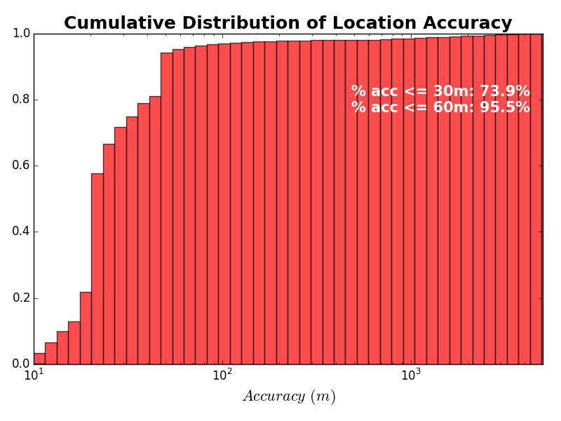
The largest source of systematic error for SPOs is elevation error. The elevation of a smartphone is required to compute altimeter setting, a reduction of pressure to sea-level using the U.S. Standard Atmosphere. Since a smartphone’s location is inherently linked to its elevation, errors in the position of a smartphone can lead to large errors in elevation. To reduce location errors, the in-app QC framework forces all location retrievals to utilize the onboard GPS in high accuracy - high power mode. Wi-Fi and the Cellular Network location detection are used in tandem with the GPS to enhance location retrieval. By mandating the use of the GPS, location accuracy can be constrained to tens of meters (Fig. 1). Since multiple GPS locks can improve location accuracy, up to two GPS locks are performed if a smartphone’s position deviates more than 60 meters from its previous position. The ground elevation at the smartphone’s location (latitude, longitude) is retrieved from a USGS Digital Elevation Model (DEM) with a resolution of 30 meters and an RMSE of 1.55 meters (Gesch and al., 2014). Elevation uncertainty is found by computing the variance of the elevation estimate and the surrounding eight elevation estimates??not clear, eight grid points?*** and adding it to the RMSE of the DEM. Since GPS-derived location error is typically less than 45 meters, this technique for estimating elevation uncertainty is generally sufficient. why is it sufficient??
Figure 1: CDF of location accuracy of uWx SPOs averaged over a 1 month period.
A secondary source of error in SPOs is dynamic lag. Dynamic lag is a consequence of the measurement process. Smartphone pressure sensors are microelectromechanical (MEMS) sensors which utilize a sensing diaphragm formed on a silicon substrate, which bends with applied pressure. This bending causes a deformation in the crystal lattice of the diaphragm. The deformation initiates a change in the band structure of piezoresistors placed on the diaphragm, leading to a change in resistivity of the material. Since MEMS pressure sensors are extremely sensitive, oversampling and an internal Infinite Impulse Response (IIR) filter are often used to reduce the signal bandwidth **??* and help suppress high frequency noise caused by wind, doors/windows shutting, etc. A sample IIR filter formula from the BMP280, a microelectromechanical (MEMS) pressure sensor used in a variety of high-end smartphones, is provided below:
$$x_{f } = [x_{f}(t-1) * {(f}_{c}-1) +x] / f_{c } where f_{c }= filter coefficient ; x_{f }= filtered data ; x=unfiltered data$$
Filter coefficients for a typical MEMS sensor can range from two to sixteen. Figure 2., shows the effect of different filter coefficients on the dynamic response of a MEMS sensor to a five hectopascal (hPa) step response.
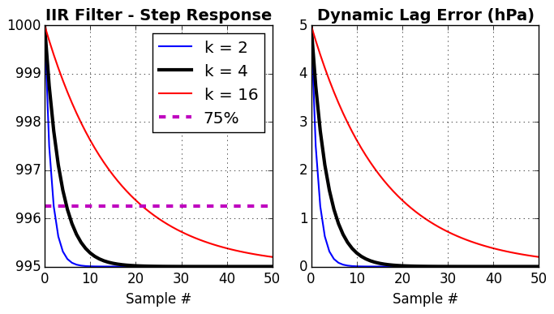
Figure 2: An example of the dynamic lag caused by an IIR Filter with various filter coefficients.

In the android operating system, the IIR filter coefficient is set to four in smartphones with the BMP280 MEMS sensor. At this setting, five samples are required before 75% of the step response**what is step response??* is achieved. With a filter coefficient of sixteen, twenty-two samples are required before 75% of the step response is achieved. For a five hPa step-response, taking the minimum number of samples to achieve 75% of a step-response leads to a 1.25 hPa dynamic lag error. **this paragraph is confusing and unneccesary… would remove and summarize the IIR response information in one sentence*
The frequency of pressure collection is governed by user behavior?? Why?? and is thus quasi-periodic in nature. Since atmospheric pressure and phone elevation can change significantly over time, the quasi-periodicity of pressure collection results in a wide range of observed IIR step-responses. **still confusing** To minimize dynamic errors from step-responses of variable magnitude, the in-app QC framework employs a long spin-up period to allow the pressure signal to reach a state of quasi-equilibrium before pressure retrieval is performed. A typical spin-up period can last from 30-40 seconds. With a sampling rate of 20 Hz, between 600-800 measurements are retrieved during this spin-up period, minimizing dynamic lag error for the vast majority of MEMS sensors. You don’t talk about the key issue—how long do you have to sample pressures before you use them. Just say there is a response time and tell how long you wait. All you need here.

2.1.4 Bias Estimation
It is important to note that in many cases smartphones are not at ground level. For example, the phone could be elevated in a building. Thus, even with a precise location, the ground elevation estimate can deviate substantially from the true elevation of a smartphone. Most dwellings are built on foundations which can be a foot to several feet above ground level. In urban and suburban areas phone elevations, can deviate tens to hundreds of meters in multi-story buildings, high rises, and underground rail stations. These deviations are quantified by the in-app QC framework as an additional component of observational uncertainty. To quantify this added vertical uncertainty an estimate of the true altimeter setting is retrieved from surrounding, bias corrected, MESONET and METAR observations, retrieved from the Meteorological Assimilation Data Ingest System (MADIS) (Miller et al., 2005). **and then what??*
MADIS observations are bias-corrected using two-months of gridded altimeter analysis produced by computing thin-plate spline radial basis functions (Duchon, 1976) from point METAR observations. To interpolate bias-corrected altimeter observations to a smartphone location, an optimum interpolation (OI) scheme was developed. Nearby MADIS observations are placed into four quadrants spanning the four cardinal directions around the smartphone location. The nearest two observations, in each quadrant, are retained for OI. The OI is only performed if at least three quadrants contain observations within 300 km of the SPO. This is to ensure that the OI interpolant will be representative and not spatially biased. A piecewise cubic spline is used to temporally interpolate MADIS observations to the time of the SPO. An inverse distance weighting (IDW) technique is then employed to spatially interpolate nearby MADIS observations to the location of the SPO. Cross-validation is used to estimate an appropriate power factor for IDW and jackknifing is performed to estimate the uncertainty of the synthetic MADIS observation at the location of the SPO. The difference between this synthetic observation and the SPO is defined as phone bias and archived for later post-processing.

2.1.5 Pressure Change QC
In previous studies, such as Madaus and Mass (2017), pressure change was computed during post-processing. Observations with the same unique identifier, separated in time by a given time interval, and within thirteen meters of each other, were used to compute pressure change. With these requirements in place only a small fraction of phones contributed pressure change observations. No consideration to location accuracy, elevation variance, and phone movement was given since such information was not provided by previous SPO providers.
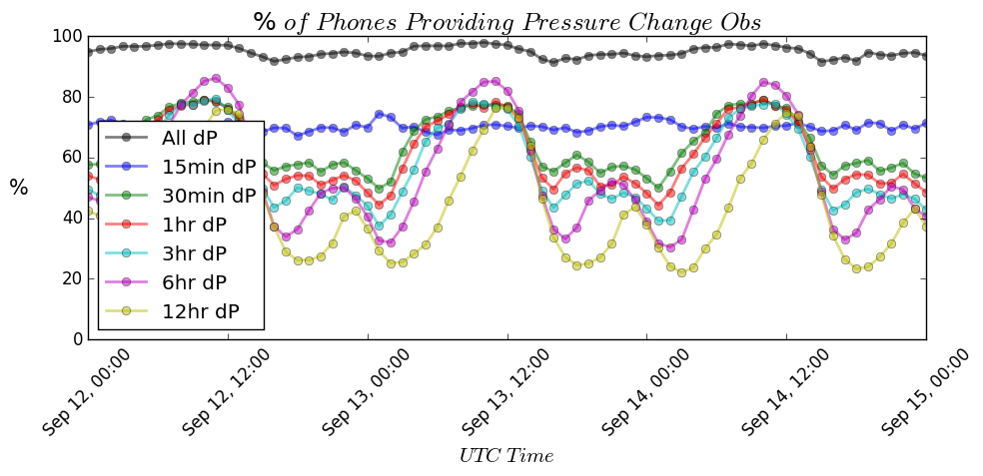
To improve the quality of smartphone pressure change observations (SPCOs) sensor data from auxiliary environmental and motion sensors such as the accelerometer and photodetector (light sensor) are retrieved. Illuminance, significant motion detection, pressure noise, location (latitude/longitude), location accuracy, and GPS speed are used to estimate the probability that a smartphone moved a distance exceeding a set threshold defined by the terrain variance and location accuracy. In regions with minimal terrain variance, smartphones were allowed up to ninety meters of movement between observations. By retrieving additional sensor-data in-app, the QC framework was able to retrieve frequent SPCOs from over 90% of smartphones (Fig. 3).
Figure 3: Time series of the percentage of uWx smartphones contributing pressure change observations.
2.2) Pressure Retrieval Procedure
One of the motivations behind developing the pressure collection app, uWx, was to define the best practices for mobile pressure collection. Extensive testing was performed with uWx, to achieve a balance between power consumption, observation frequency, and measurement accuracy. The following procedures are the final product of these tests.
- An android background service is initiated on the smartphone triggering the collection and submission of pressure data. The user-adjustable frequency of this service, varies from 5 - 60 minutes and is initially determined by the battery capacity of the smartphone.
- The barometer, light sensor, significant-motion sensor (if available), and temperature sensor (if available) are activated and allowed to spin-up for 10-15 seconds to avoid the influence of dynamic lag.
- The GPS receiver is powered on and set to high-accuracy mode (if permissible). Location retrieval is aided by utilizing nearby Wi-Fi networks (if available) and the cellular network, in conjunction with the GPS. A maximum of two location updates are retrieved to improve location accuracy. To conserve power consumption, only one location update is retrieved if the phone’s position has moved less than sixty meters from the location of the last observation.
- Sensor measurements are processed and pressure along with a plethora of other statistics (diagnostics like GPS speed, accuracy, etc) are submitted to the app server. The server returns the elevation and elevation uncertainty at the location of the phone. This information is used to compute phone altimeter setting.
- 15 minute, 30 minute, 1 hour, 3 hour, 6 hour, and 12 hour pressure change observations are computed by examining prior observations to determine if they fall in one of the aforementioned time windows. If so, the current and prior observation are evaluated by the in-app QC framework to determine whether the current observation was taken at the location of the prior observation.
- If location accuracy was sufficient (< 60 meters), observational data retrieved over an hour prior are uploaded for bias estimation. By this time, nearby MADIS observations are available allowing for the computation of a synthetic altimeter observation at the phone’s prior location. The difference between the phone altimeter setting and the synthetic observation is defined as the phone bias.
2.3) App Summary and Current Status

As of January 2017, the pressure collection app, uWx, has been downloaded over 5000 times. 3800 users actively use the app. Approximately, 1900 users actively contribute pressure observations. The large discrepancy between the number of active users and the number of users contributing pressures is in part due to the fact that any phone can download the app, regardless of whether it contains a barometer or not.
Since the background service that retrieves pressure is run at pseudorandom intervals, uWx collects pressures continuously. On average, ten observations are retrieved every eight seconds. Hourly retrieval rates vary from 3500-4000 observations per hour. During National Weather Service issued severe weather watches/ warnings uWx doubles the pressure collection frequency allowing for hourly retrieval rates to approach 8000 observations per hour.
A key reason for the success of uWx has been its limited power consumption and minimal economic cost. On a typical android device the power draw from uWx averages around 20 milliamps (mA), but can range from 5- 40 mA depending on the frequency of pressure collection and app use. The average android device has a battery capacity of $∼2800$mA. Thus, it would take uWx alone, approximately 140 hours (5 days 20 hours) to drain a typical android battery. By comparison, a background music player app, like the VideoLan Client (VLC) app, can consume 150-200 mA on a typical android. The modest power footprint of uWx demonstrates the viability of sub-hourly retrieval of crowd-sourced smartphone pressures. This is an important achievement as it opens the door for large-scale crowdsourcing of smartphone pressures.
2.4) App comparison

Previous work, performed by Hanson and Greybush (2016) and Madaus and Mass (2017) utilized crowd-sourced SPOs from PressureNet and OpenSignal. As of August, 2016 the Weather Company has provided SPOs from a small percentage of their user base. PressureNet, OpenSignal, and the Weather Channel do not apply QC techniques in-app. To evaluate the utility of in-app QC, a comparison between uWx and the three aforementioned SPO providers is provided in Table 1.
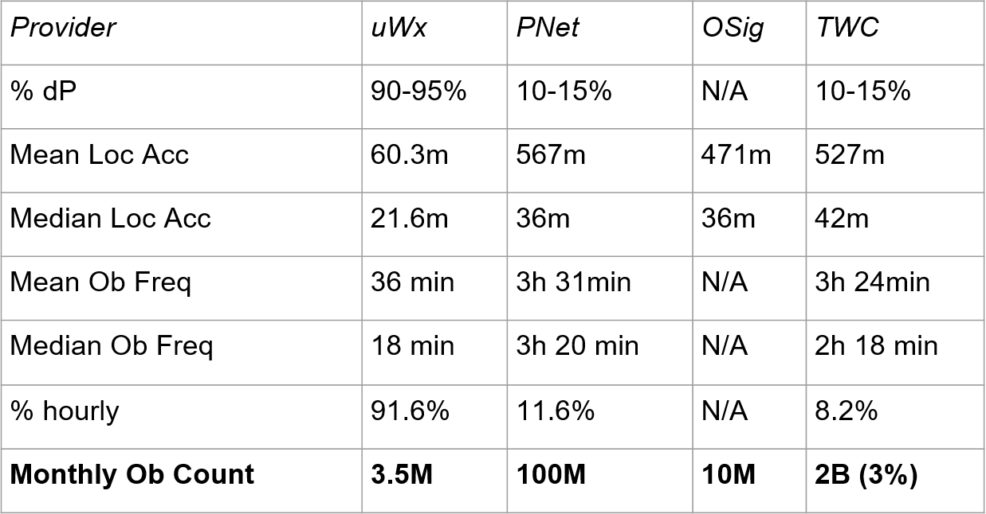
Table 1: Comparison of crowd-sourcing pressure apps.

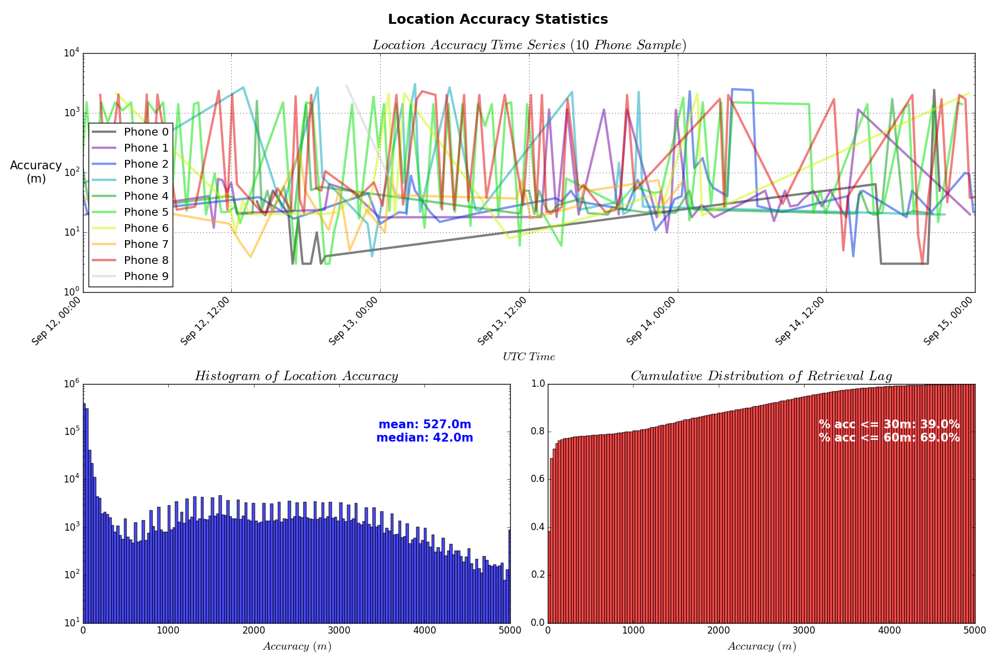
While uWx collects the fewest SPOs it outmatches the performance of PressureNet, OpenSignal, and the Weather Company app in all other categories. The mean location accuracy of SPOs collected by uWx is nearly an order of magnitude smaller than the mean location accuracy of SPOs from all other providers. uWx collects SPOs at nearly five times the frequency of all other SPO providers. As a result, over 90% of smartphones in the uWx network submit SPO’s every hour. By using ancillary sensor data to aid pressure change collection in-app, uWx is able to retrieve SPCOs from over 90% of phones in the network at any given time. By comparison only 10-15% of phones, on average, contribute SPCOs from PressureNet and the Weather Company. The reason for this difference is the nature of the location retrieval procedure used by PressureNet and the Weather Company. Both apps likely use the default fused location provider which does not mandate the use of the GPS. The default fused location provider can switch between the Wi-Fi Network and Cellular Network to get a location. This behavior is demonstrated in Figure 4, which shows a sample time series of location accuracy from ten Weather Company phones.
Figure 4: Time series of location accuracy from ten randomly sampled WC app users
The frequent variability in location accuracy observed in Figure 4., is likely a result of the location retrieval switching between the Wi-Fi and Cellular networks. Since a location lock from a Wi-Fi Network often provides a different location estimate than a location lock from the Cellular Network, even when the phone is at the same location, this behavior can lead to spurious phone movement. This inhibits the collection of SPCOs, which are computed by comparing the spatial distance between two observations separated in time. uWx does not suffer from this problem as it’s in-app QC framework specifies stringent procedures for location retrieval substantially reducing the variability of location accuracy responsible for spurious phone movement (Fig. 5).
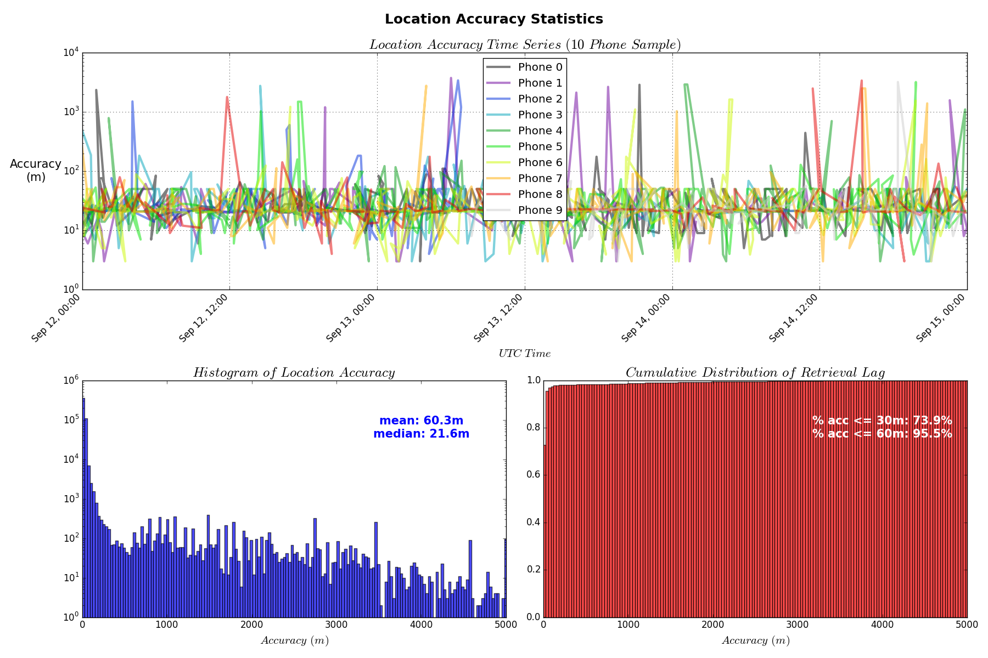
Figure 5: Time series of location accuracy from ten randomly sampled uWx users

Figure 5: Time series of location accuracy from ten randomly sampled uWx users

Chapter 3

A MACHINE LEARNING APPROACH TO POST PROCESSING SMARTPHONE PRESSURE OBSERVATIONS

  - Motivation
Analysis of observations from smartphones can reveal patterns associated with user behavior that can be useful for quality control applications. For example, phone statistics like location accuracy, elevation uncertainty, and phone bias often present some degree of similarity at frequented locations. For phones in motion, common modes of travel can be discerned from GPS data**give example**. With sufficient observations, relationships between statistics like GPS speed and elevation uncertainty can provide insights into dynamic lag and phone bias.. Such relationships between phone statistics and phone pressure bias are often subtle and nonlinear. This presents a formidable challenge for traditional multivariate regression techniques. In contrast, machine learning techniques excel at identifying hidden insights and quantifying patterns in data. A variety of machine learning techniques have been applied to both uWx and Weather Company (WC) data to determine whether phone bias can be predicted from data derived from environmental sensors and GPS hardware. Due to the sheer size of the WC dataset and its limited collection of observation reports, only WC data from the Pacific Northwest (PNW) has been used in this study.
  - Methodology

To determine the optimal machine learning algorithms a variety of different machine learning algorithms were tested on uWx data collected between August 15 – October 15, 2016. The algorithms included extremely randomized trees, random forests, adaptive boosted trees (AdaBoost), gradient boosted trees (Gradient Boost), and logistic regression. Since the behavior of every phone is unique, each algorithm was trained on time-series data from a single phone. While generating a unique algorithm for each phone is costly, it is expected that an optimum machine learning algorithm will eventually be incorporated into uWx relieving the burden of generating a distinct algorithm for every phone during post-processing.
To quantify the performance of each machine learning algorithm, four-fold cross-validation was performed. Data from each phone was randomly ordered and split into four quartiles. One quartile was used for verifying the machine learning algorithm, while the remaining three quartiles were used for training. This process was repeated three additional times so that all quartiles were used for both evaluation and training. Phones with fewer than fifty observations during the two-month period were discarded. The input matrix for each machine learning algorithm included the eleven variables collected in real-time by uWx: latitude/longitude (arbloc), luminosity (lux), elevation (elev), elevation variance (estd), pressure (pres), altimeter setting (alts), pressure noise (pstd), location accuracy (gps_acc), GPS Fix boolean (gps_fix), number of satellites in view (gps_sat), indoor/outdoor boolean (loc), significant motion boolean (sigmotion). This multivariate input was regressed to the phone bias. Phone bias was computed by taking the difference between the phone altimeter setting and a synthetic “truth” altimeter setting derived from bias-corrected quality controlled MESONET and METAR observations. Once the algorithm was trained, the test data was used as input to the machine learning algorithm which returned an estimate of phone bias. The difference between this machine learning estimate of phone bias and the observed (known) phone bias **how did you determine that?* is hereafter referred to as the bias prediction error.
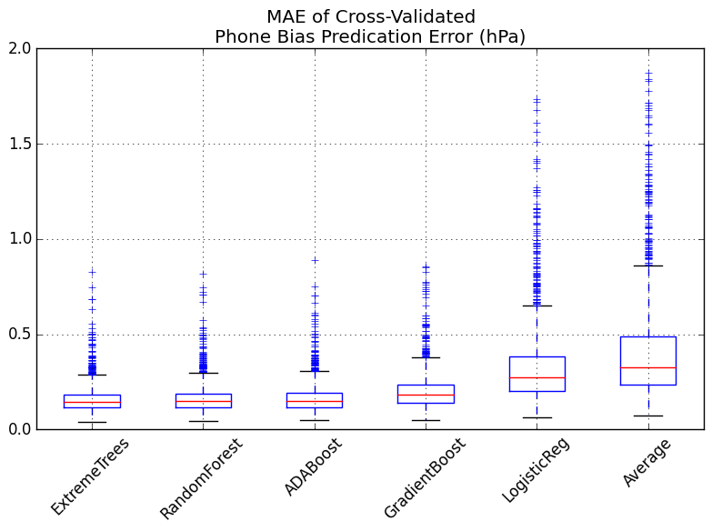
For each phone, the absolute value of bias prediction error was computed and then averaged to produce an estimate of MAE. In Figure 6, the distribution of MAE for all phones is displayed for a variety of machine learning algorithms. The distribution of MAE from a simple averaging technique is provided for comparison. The simple averaging technique is akin to a persistence forecast, it computes the average phone bias during the training period and uses this value as the predicted phone bias for all test data.
Figure 6: Comparison of machine learning techniques applied to uWx SPOs.

Compared to this averaging technique, all decision tree based learning algorithms do a remarkable job of predicting the phone bias. The median, MAE of bias prediction error is markedly low because for any given phone the vast majority of observations are taken at a handful of frequented locations where, through repeated sampling, the distribution of phone bias has become more narrowly peaked. From the four decision tree based learning algorithms examined, the Random Forest algorithm (Breiman, 2009) was selected for SPO bias prediction due to its efficiency, simplicity, and diagnostic capabilities.
  - Bias Correction with Random Forests

3.3.1) Random Forests

Random forests are a form of ensemble decision tree learning. Decision tree learning works by sub-setting/splitting input data based on information gain (classification) or variance reduction (regression) until further splitting is not possible or provides no added value. Since decision trees mimic human decision making, they are easy to interpret and comprehend. Individual decision trees can lack robustness and suffer from overfitting, due to excess complexity. One technique used to reduce this overfitting problem is (“bagging”) or bootstrap aggregation (Breiman 1996). Bagging creates an ensemble of decision trees by selecting random samples with replacement from a training data set and fitting individual decision trees to these samples. This bootstrapping technique can improve performance by decreasing variance without increasing bias, but is still prone to overfitting if a few independent variables (features) in the input training data are strong predictors of the predictand.
To improve the diversity of decision trees within a bagged ensemble the random subspace method can be employed (Ho 1998). This method randomizes the selection of features during each split in the tree learning process. For regression problems, the number of features randomly sampled at each split is typically one third of the total number of features. At each candidate split, the randomly sampled feature which minimizes the mean-squared error of the prediction is chosen as the feature to split. By randomly sampling features, strong predictors can be prevented from dominating bootstrapped trees, ensuring that trees in the ensemble do not become correlated. \ By employing bagging (randomizing observations) and the random subspace method (randomizing features), random forests can produce an ensemble of uncorrelated trees that, when averaged, produce predictions with small mean squared error and low bias.
3.3.2) Feature Importance
The ensemble nature of random forests precludes direct interpretation of the tree learning process. Nevertheless, random forests can be used to evaluate the importance of independent variables (features). Consider a variable f. For each node in a tree, which split on f, the variance reduction of the node is weighed by the number of training observations that reached the node. This weighted variance reduction estimate is summed for all nodes in the tree which split on f, providing an estimate of the importance of f for a single tree. This process is repeated for all trees in the ensemble so that an average across the ensemble of trees can be computed, producing an estimate of the importance of f for the entire random forest. Feature importance is typically normalized for easier interpretability.
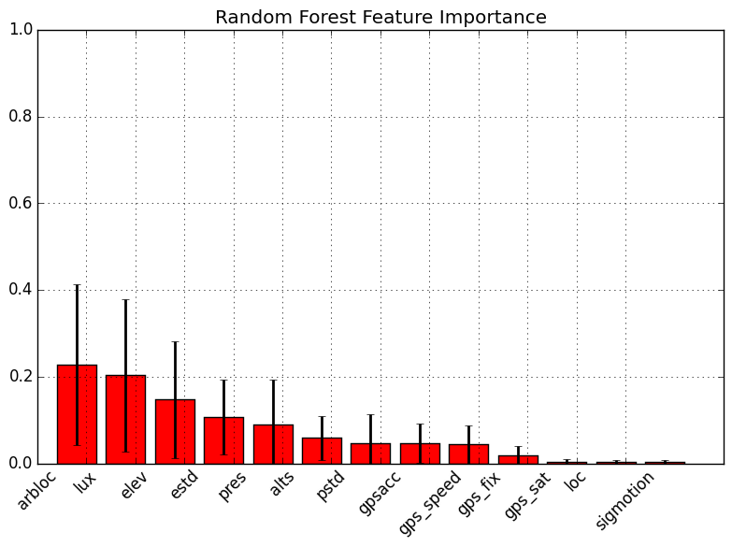
Random forest feature importance for uWx SPO’s collected between August 15 – October 15, 2016 is displayed in figure 7.It is notable that no single feature dominates. The best predictor of phone bias error, latitude/longitude location (arbloc), has a modest importance of ~0.2 on a scale from 0-1. Since all features exhibit relatively low importance it can be concluded that sensor and GPS data are individually weak predictors of phone bias. It is interesting that the illuminance from the phone light sensor (unit: lux) is the considered the second most important feature. This result was unanticipated but sensible. Illuminance is correlated with the environment. In residential homes illuminance averages between 160-320 lux, in the workplace illuminance is often greater (320-640 lux) as many workplaces are lighted with industrial fluorescent lights. Differences in illuminance aid phone bias prediction by serving as a secondary predictor of location.
Figure 7: uWx random forest feature importance.
3.3.3) Training Window
To evaluate how the extent of the training window affects bias prediction error, random forests were trained on uWx data over a one, two, and three-month period spanning August 15 to November 15, 2016 (Fig. 8). Since a continuous stream of users installed and/or uninstalled uWx during the training period, the extent of the training data set for every phone is unique IQR **define IQR—interquartile range??**. Around October 15th the number of users doubled due to additional app advertising during a local windstorm. This jump in users, mainly in the Seattle metro area, resulted in a slight increase in the number of outliers and the size of the IQR for the three-month analysis. Interestingly, it also produced a notable change in feature importance. During the 3-month window the importance of location markedly increased, while the importance of nearly all other featured decreased. It is unclear why this occurred as little change in feature importance was observed between the one and two-month cases. For this reason, it is hypothesized that changes in feature importance are more likely to be a consequence of the doubling of users than any increase in the length of the training window.
Both the MAE and MSE of bias prediction error did not change significantly when the training period was expanded from one to three months (Fig 8).
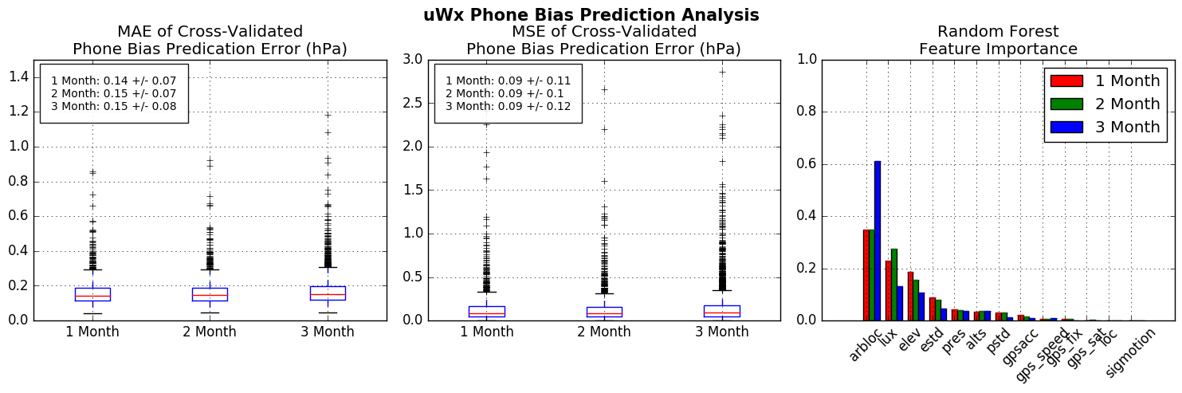
Figure 8: Training period comparison (uWx)
This is likely due to the fact that the MAE of bias prediction error had saturated **after one month??* . For all three cases, the median MAE of bias prediction error is approximately equal to the relatively accuracy of a typical MEMS barometer **which is?**. Since uWx collects pressures at an hourly frequency, hundreds to thousands of observations may be taken from a phone over the course of a month, providing sufficient training data to accurately predict phone bias.
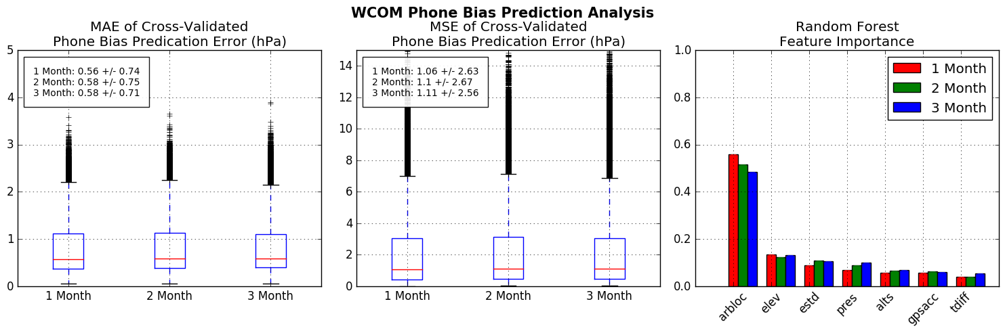
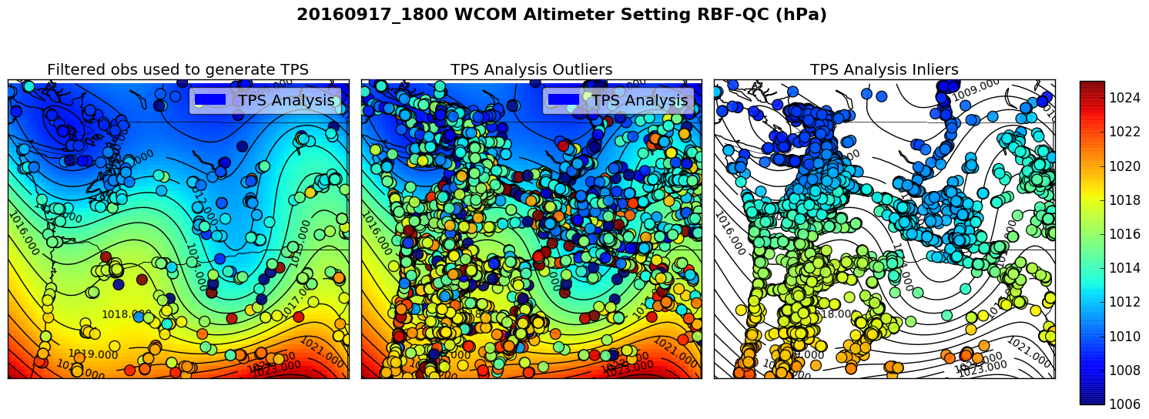
The analysis described above for uWx data was repeated for WC observations (Fig. 9).
Figure 9: Training period comparison (Weather Company)

Like the uWx analysis, the MAE of bias prediction error was consistent for all training datasets, irrespective of duration. The most notable difference between the uWx and WC analysis is the magnitude and skewness of the errors. Unlike the uWx analysis, the WC analysis is right skewed toward outliers. The spread in the MAE of bias prediction error is also notably larger with the IQR for all cases spanning ~ 0.8 hPa. This result could be caused by a failure to account for dynamic lag, fewer features, and/or poor location retrieval. The latter issue is known to affect WC observations (see Table 1). While WC data lacks some of the features provided by uWx, such as illuminance and GPS speed, the order of WC feature importance is in agreement with that found in the uWx analysis (Fig. 9). It is unclear how the absence of certain features, like illuminance, effects random forest performance.
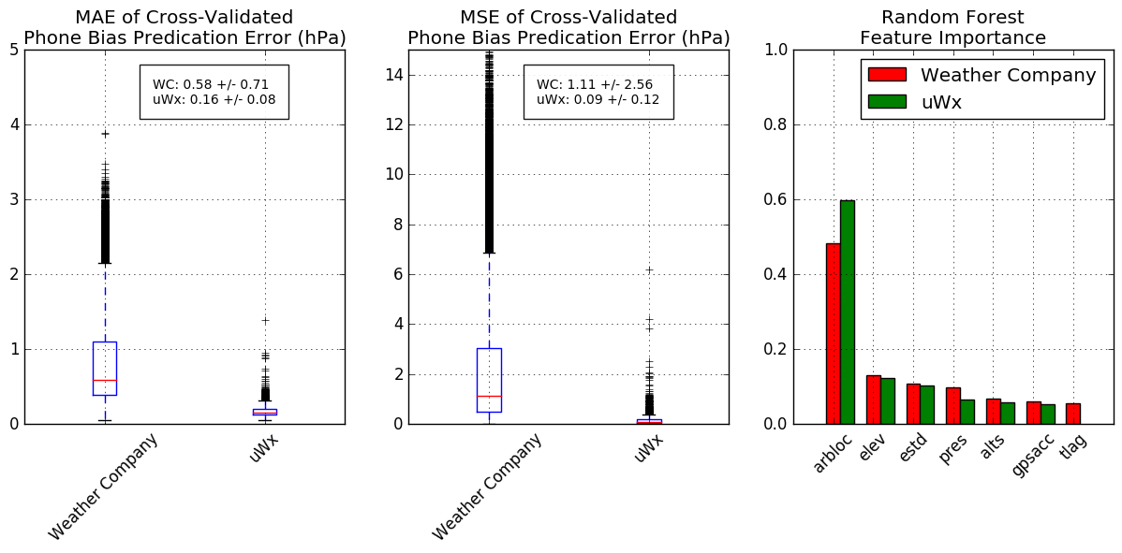
For a better comparison between uWx and WC data, uWx feature selection was limited to those features available in the WC dataset. Three months of uWx and WC data were then used to cross-validate random forests with the same input features. One exception to this is the tlag feature. This variable is defined as the time delay between the observation time and the retrieval time of the observation. Since the majority of uWx data is retrieved in real-time (within thirty seconds of the observation time) the tlag feature was not derived from uWx data. Even with four features removed, random forests still performed well on the uWx data (Fig. 10).
Figure 10: Comparison between uWx and WC random forest bias prediction.
This suggests, that the difference in the magnitude and skewness of the uWx and WC error distributions is more closely related to location accuracy. Improved location accuracy refines estimates of altimeter setting (i.e., the synthetic observations) used as the ground truth to train the random forest algorithm. Better location accuracy also provides better elevation and elevation uncertainty estimates, which in turn produce more accurate phone altimeter setting observations. The variance of location accuracy also plays an important role. If location accuracy frequently varies at a given location (Fig. 4) due to changes in location provider (like switching from GPS to Wi-Fi/cell network), this will lead to a wider distribution of altimeter error (phone bias) and poorer random forest performance.
3.3.4) Clustering Analysis
When traditional**what is traditional??* in-situ observations are bias-corrected, the average bias is simply taken to be the mean of the observation error over a period of time. This calculation is straight-forward since the observing instrument is fixed. Such analysis is not practical for instruments like smartphones that are capable of travel in three-dimensions and often in motion. Fortunately, many phones spend considerable amounts of time at a select few locations. These common locations, like homes and workplaces, can serve as de-facto in-situ observing sites.
To identify these common locations a data mining clustering technique, density-based spatial clustering of applications with noise (DBSCAN), was employed. DBSCAN is an ideal technique for clustering smartphone data as it is unsupervised**??**, capable of identifying arbitrarily shaped clusters, and is robust to outliers. An example of DBSCAN clustering analysis, performed on a month of uWx data from the author’s smartphone, is displayed in Figure 11. In this analysis, a cluster radius of sixty meters was applied. The DBSCAN analysis reveals statistically significant differences in phone bias and illuminance between clusters.
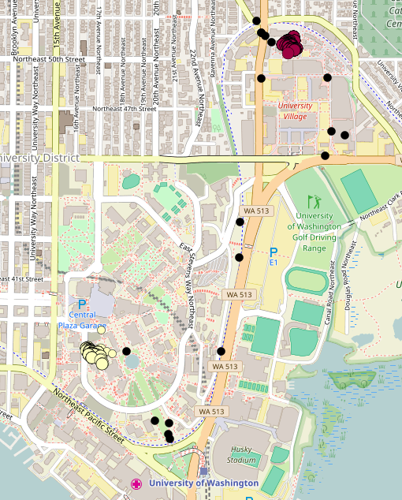
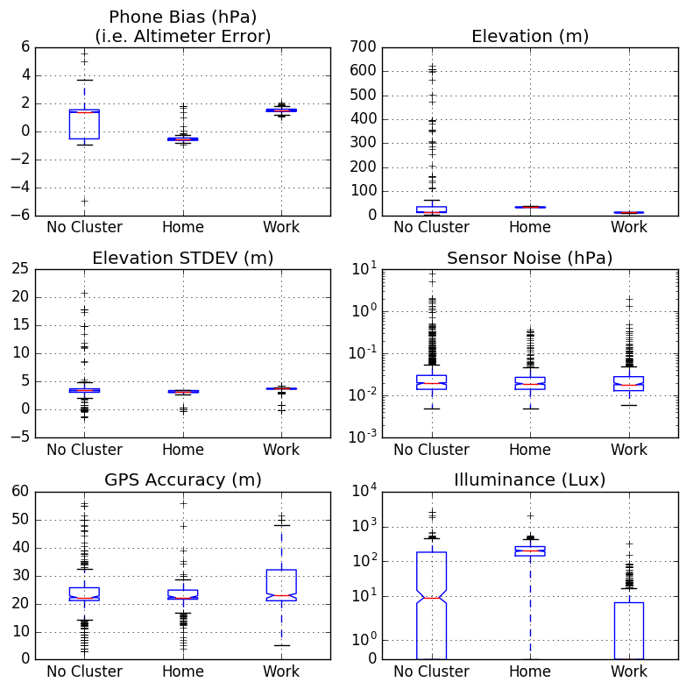
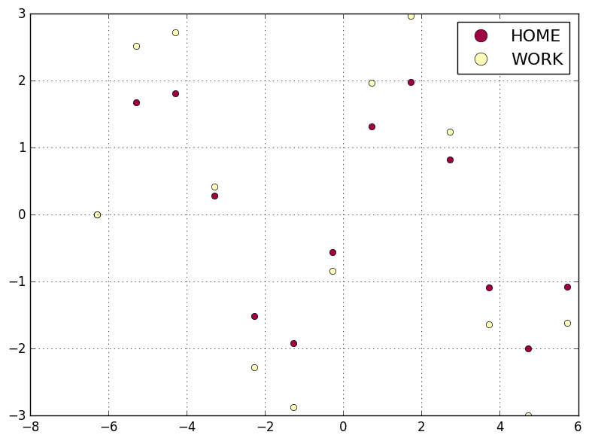
Figure 11: DBSCAN analysis of one month of uWx data from the author’s smartphone

For both clusters, the IQR of phone bias is reduced by an order of magnitude, from ~2 hPa to ~0.2 hPa. This suggests that sensor bias is fairly conservative, as the IQR of phone bias at each cluster is roughly proportional to the relative accuracy of a typical MEMS pressure sensor. The median sensor noise and GPS accuracy are roughly the same for each cluster; however, at the home cluster the variance of GPS accuracy is notably larger. Decomposing phone statistics with DBSCAN helps visualize and explain why random forests are so successful at constraining bias prediction error. **it is successful because of what? Finish the logic**
To better understand why the performance of random forests differs **??differs from what??? Not clear** for WC phones DBSCAN analysis for a randomly selected WC phone was performed (Fig. 12).
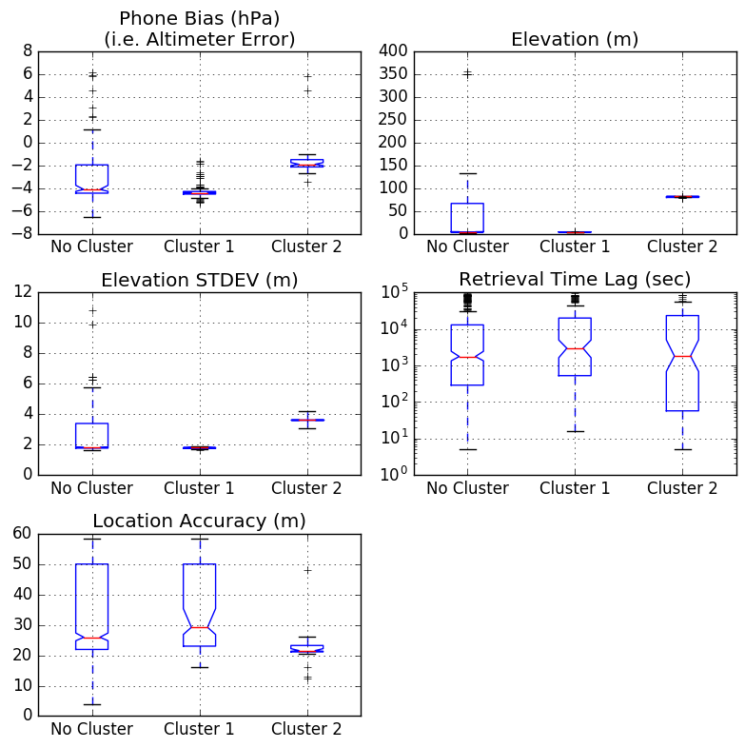
Like uWx data from the author’s phone, the bias of this WC phone is notably different at the two identified cluster locations. ** why only two?? ** Significant differences in the location accuracy between the two clusters are also observed. DBSCAN analysis of WC and uWx data suggests that clustering could be used to help predict phone bias and even augment random forests.
Figure 12: DBSCAN analysis of two months of WC data from a randomly selected phone in the PNW.
3.3.5) Clustered Forests
To examine whether clustering could improve bias prediction, three DBSCAN analyses were performed on two months of WC data **for how many phones??* . Distance thresholds of fifteen, thirty, and sixty meters were used to define cluster points. Different cluster radii were set to evaluate how clustering and location accuracy impact bias prediction error. For each cluster radius, only observations with a location accuracy less than or equal to the radius were used. Thus, for DBSCAN analysis with a cluster radius of fifteen meters only observations with location accuracy less than or equal to fifteen meters were used. For a cluster to be defined, at least twenty-five observations had to fall within the cluster radius. Observations not falling within a cluster were labeled with a zero, while observations falling within a cluster were labeled with a positive real number. This cluster identifier was supplied to the random forest algorithm in place of the latitude/longitude (arbloc) feature. The performance of cluster-based random forests is displayed in Figure 13. Previously, it was hypothesized that poor and variable location accuracy may explain why random forests are less effective at constraining bias prediction error for WC phones. Although bias prediction error decreases as the threshold on location accuracy and cluster radius decreases, reducing the threshold on location accuracy to a mere fifteen meters does not produce error statistics comparable to those derived from uWx data. This suggests that location accuracy alone cannot explain the gap between uWx and WC random forest performance.
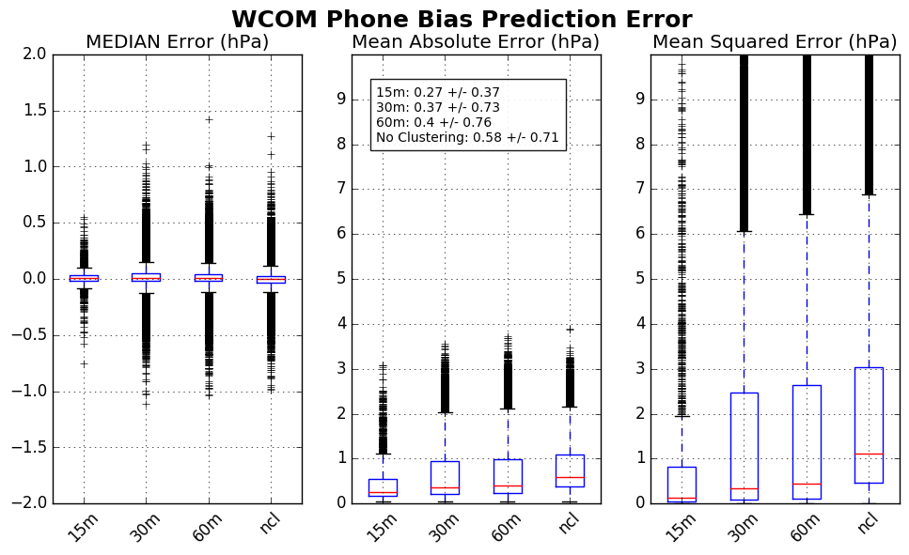
As the cluster radius and constraint on location accuracy is reduced, the shape of the distribution of MAE does not change (Fig. 13).
Figure 13: Performance of random forest bias correction with clustering for WC observations. NCL refers to the control case, for which clustering was not performed.

Regardless of location accuracy, the distribution of the MAE is right skewed. It is hypothesized that this skewness could be explained by a combination of infrequent pressure collection and a failure to account for dynamic lag. If dynamic lag was not accounted for, the variable frequency of pressure collection employed by the WC app would result in a wide range of dynamic lag errors. Figure 14, shows the distribution of the mean observation frequency for WC phones.
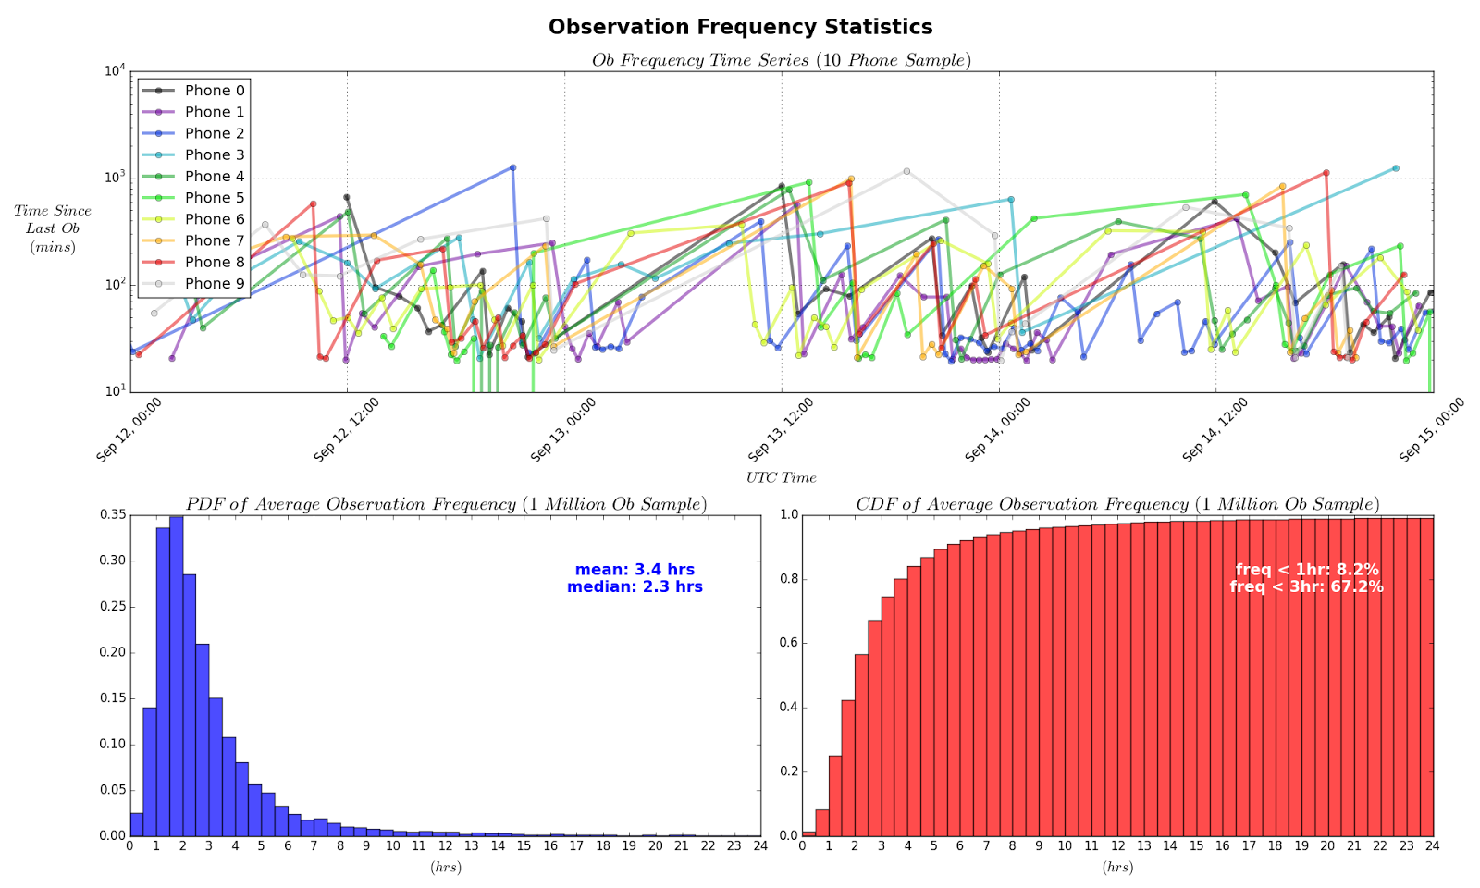
Figure 14: Histogram of WC observation frequency (one million observations sampled).

The distribution of observation frequency, like the distribution of MAE, is right skewed. Dynamic lag error is linked to observation frequency as it scales with the magnitude of pressure change (Fig. 2). Synoptic-scale changes in atmospheric pressure often increase in magnitude as time progresses. For this reason, WC phones falling in the right tail of the observation frequency PDF, may be expected to exhibit larger dynamic lag errors. This mechanism offers an explanation for why the right skew of MAE is observed in Figure 13. It may also clarify why error statistics comparable to those derived from uWx are not achieved even when location accuracy is not an issue. A failure to fully account for dynamic lag adds a pseudo-random source of uncertainty to phone bias since the magnitude of dynamic lag error is a function of changes in elevation and atmospheric pressure. This added uncertainty limits the predictability of phone bias and the performance of random forests. Whether the WC app accounts for dynamic lag or not is unclear, as the relevant source code has not been provided or examined. Nevertheless, the evidence suggests that dynamic lag, observation frequency, and location accuracy limit the skill of WC phone bias prediction. ** too much material in this section…I would cut it down by 50% if possible*
  - Quality Control with Radial Basis Functions

3.4.1) Motivation
Machine learning with random forests allows for phone bias to be proactively predicted from sensor and GPS data collected in real time. One consequence of using random forests is that phone bias predictions will not exceed the range of phone bias observed during training. This can occasionally lead to poor predictions of phone bias which appear as outliers in bias-corrected altimeter analysis. Outliers can also arise when a phone ventures to an unfamiliar location where observational uncertainty is large, like the interior of a moving subway car. Since random forests cannot adequately predict phone bias 100% of the time, novel QC techniques have been developed to intelligently remove outliers from bias-corrected observations.

3.4.1) uWx Quality Control
Prior to performing QC, data from uWx phones are bias-corrected by random forests trained on past data. The first stage of QC employs simple validity checks to remove prominent outliers (i.e., altimeter setting < 890 hPa or > 1100 hPa). The second stage of QC involves a statistical check which removes statistical outliers exceeding four standard deviations from the mean **which mean??*. Statistical outlier thresholds are modified to adjust for skewness using the double histogram technique outlined in McNicholas and Turner (2014). The third and final stage of QC is a spatial consistency check which utilizes a radial basis function (RBF) in the form of a thin plate spline (TPS). RBFs are ideal for fitting pressure observations as they produce smooth surfaces and lack free parameters in need of tuning . Once a TPS is fit to the observations, outliers are determined by comparing the variance of the surface around the observation to the error of the interpolation (i.e. the difference between the observation and surface).
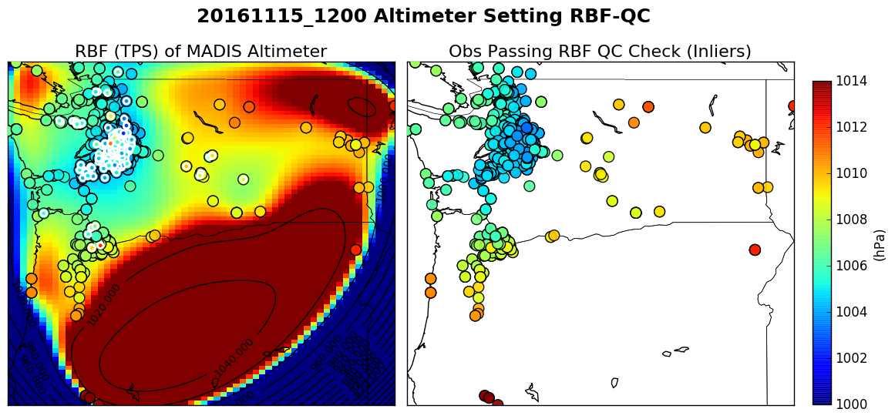
Figure 15 provides an example of the RBF spatial consistency check (RBF check). Observations displayed in this figure were bias corrected with random forests trained during the month prior.
Figure 15: Example of uWx TPS analysis used during the spatial RBF check stage of QC. In the left plot, outliers are outlined in white. **define acronyms used**
In rural regions, where smartphone observations are sparser, the quality of the TPS is reduced and the surface is less smooth. In urban areas, the plethora of available smartphone observations produce a very smooth surface with low variance. Consequently, outlier removal is more liberal in urban areas and more conservative in rural areas. In regions where data does not exist, the TPS analysis is clearly unphysical. On the peripheries of data sparse regions, the TPS analysis exhibits large gradients increasing the outlier detection threshold. In urban areas around Seattle and Portland, the TPS analysis is fairly smooth decreasing the outlier detection threshold. By taking advantage of the properties of RBFs, intelligent, density dependent outlier removal can be achieved allowing for crucial rural observations to be retained and for the removal of unnecessary noisy observations in urban areas. **Figure 13 looks to be going bad very quickly at the Oregn/WA border)**

3.4.2) WC Quality Control
The same set of QC techniques applied to uWx observations are applied to WC data, with one exception. The RBF-check for WC observations utilized a multiscale (hierarchical) RBF model with a Gaussian basis. A different form of RBF was used for QC as the large quantity of observations demanded a more efficient RBF algorithm (Bochkanov, 1999). To further reduce the computational burden of QC, a spatially filtered sample was extracted. WC observations were binned into 1x1 degree latitude/longitude boxes and then sorted by total uncertainty. Total uncertainty was defined as the sum of the random forest uncertainty (mean absolute bias prediction error), pressure uncertainty (elevation variance/sensor noise), and bias uncertainty (uncertainty of MADIS interpolation used to estimate phone bias). If the number of phones within a bin exceeded ten, then the ten phones with the lowest total uncertainty were selected. For bins with fewer than ten observations, all observations were added to the sample distribution. One degree box is very large over and near complex terrain.
An example of the spatially filtered RBF check described above is provided in Figure 16. WC observations displayed in this figure passed the first two stages of QC and were bias-corrected with random forests trained during the month prior. Although the sampled observations were not entirely self-consistent, especially in rural areas, the RBF fit to the data is still able to produce a realistic altimeter analysis from the selection of spatially filtered observations. This is due to the limited number of outliers and the intrinsic smoothness of the RBF.

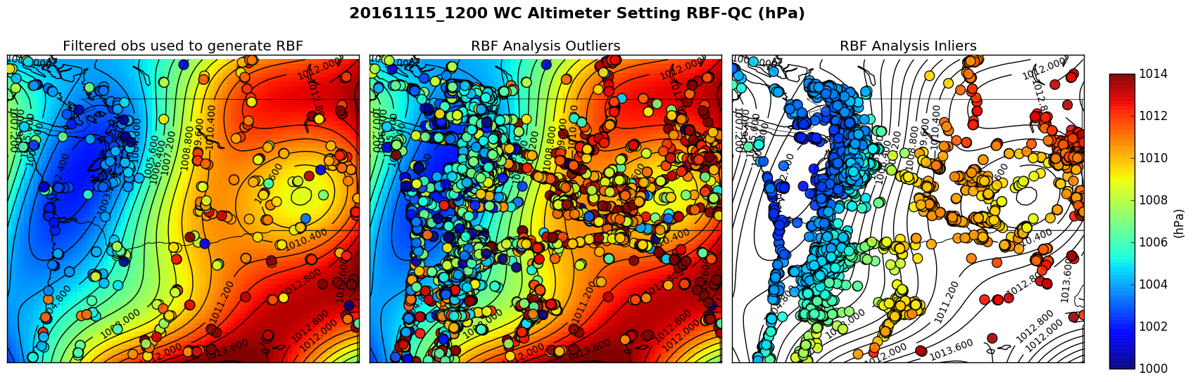
Figure 16: Example of the spatial filtered RBF check applied to WC observations.
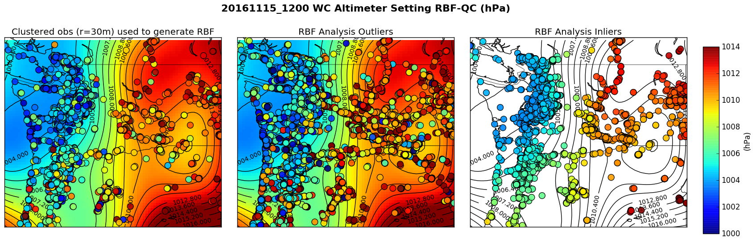
Since spatially filtering observations based on uncertainty may not always produce an optimum sample free of outliers, an alternative approach to spatial QC was developed. This approach utilized clustered observations to generate the RBF surface used to detect and remove outliers. In this approach, the random forest algorithm is applied to bias corrected observations whose location has been determined as falling within a previously defined cluster. These clustered observations are then used to generate an RBF analysis for outlier removal (fig. 17)
Figure 17: Example of the clustered RBF check applied to WC observations.
The observations used to generate the RBF surface were bias-corrected with random forests trained on observations clustered with DBSCAN. DBSCAN clustering was performed with a cluster radius of thirty meters. Like the spatial filtering technique, the cluster approach to spatial QC is able to produce a realistic altimeter analysis. One downside of the cluster approach is that fewer rural observations contribute to the RBF fit. Consequently, not as many observations are retained in rural regions like northeastern Oregon. Since Figures 15-17 display bias-corrected QC observations from the same date/time, a comparison can be made. Compared to the uWx TPS analysis, both the spatially filtered RBF analysis and the clustered RBF analysis underestimate the north-south pressure gradient, west of the Cascades. The clustered RBF analysis is more consistent with the uWx analysis in northwestern Washington, while the spatially filtered RBF analysis overestimates the east-west pressure gradient across the cascades. In this case, the cluster RBF analysis appears slightly better than the spatially filtered RBF, due to its closer resemblance to the higher quality uWx analysis.

3.4.3) Post Processing Performance
uWx altimeter analyses, at each stage of post-processing, are displayed in Figure 18. The post-processing procedure begins with bias correction, simple statistical checks, and density dependent spatial consistency checks. Random forests are only trained on phones that have submitted at least fifty observations. Out of all the phones in the uWx network, less than 15% fail to meet this requirement for bias-correction. Overall, the random forests do a remarkable job at predicting and correcting uWx phone bias (Fig. 18).

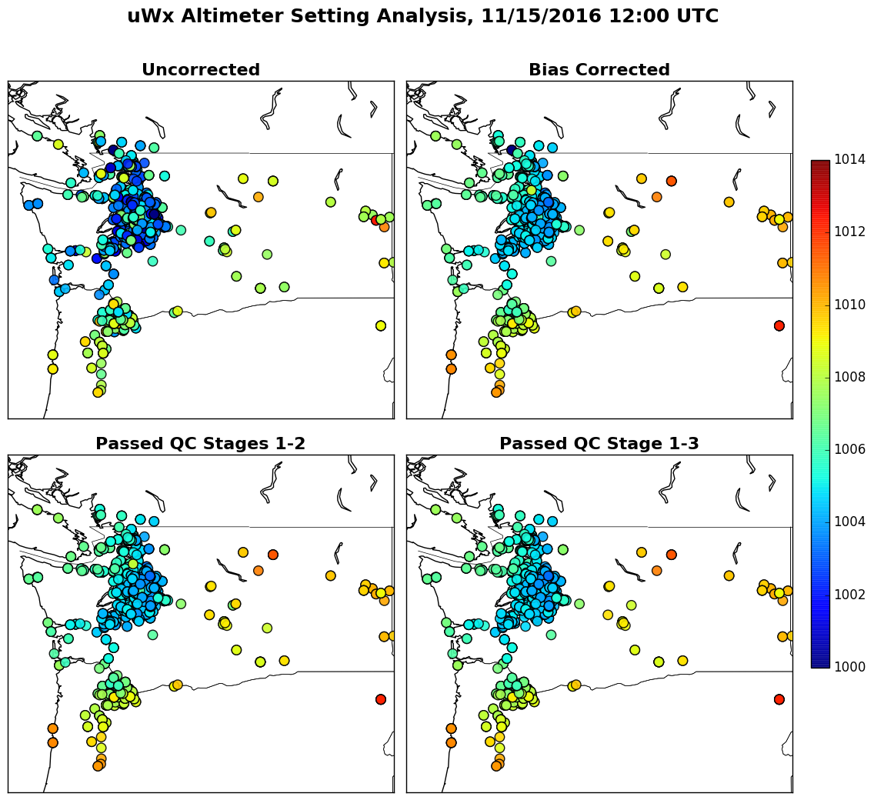
Figure 18: uWx altimeter setting at different stages of post-processing.

Even before QC checks are applied, bias-corrected uWx observations already appear self-consistent and coherent. Table 2, provides a summary of post processing statistics, for the case displayed in figure 18.
uWx | % of all observations | % of bias corrected observations
Ineligible for Bias Correction (insufficient training data) | 14.08 | N/A
Failed Validity Check | 0 | 0
Failed Statistical Check | 0.39 | 0.45
Failed RBF Check | 13.8 | 16.06
Completed Post-Processing and passed all QC checks | 71.73 | 83.48
Table 2: Summary of uWx post processing statistics for observations taken between 11-12 UTC, Nov 15, 2016

When statistical and validity checks were applied, fewer than 1% of observations were removed. When the TPS spatial check is applied approximately 16% of bias corrected observations were rejected as outliers. The vast majority of observations rejected by the QC framework were located in urban centers where sufficient observational density already exists. This is why the spatial extent and density of uWx observations do not appear to significantly change before and after post-processing (Fig. 15). In total, over 80% of bias-corrected observations passed all three stages of QC.
WC altimeter analyses, at each stage of post-processing, are displayed in Figure 19.
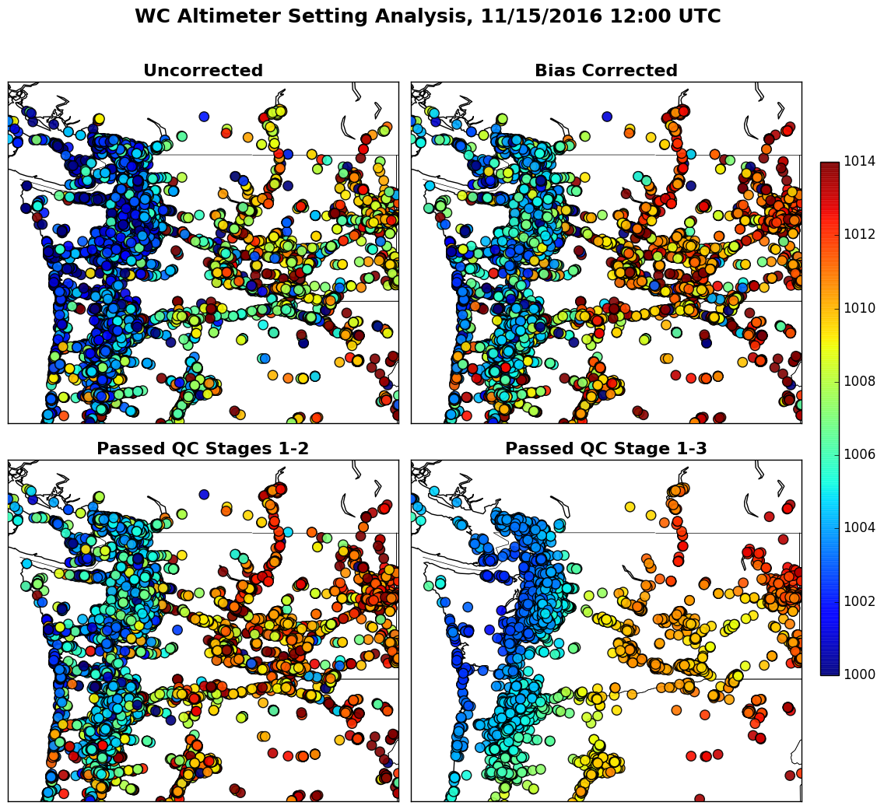
dataset. In contrast to use of the uWx data set, the random forest bias-correction does not perform well on WC data. Incongruity**?? What do you mean by incongruity??* between observations remains after bias correction. Even filtered observations with minimal uncertainty and clustered observations exhibit some incoherence. Further statistical and RBF-QC checks do a satisfactory job of eliminating discontinuities in the WC altimeter setting analysis. However, this comes at a significant price. Table 3, provides a summary of post processing statistics, for the case displayed in figure 19.
Figure 19: WC altimeter setting at different stages of post-processing.
WC | % of all observations | % of bias corrected observations
Ineligible for Bias Correction (insufficient training data) | 22.69 | N/A
Failed Validity Check | 0.09 | 0.11
Failed Statistical Check | 0.47 | 0.6
Failed RBF Check | 49.58 | 64.12
Completed Post-Processing and passed all QC checks | 27.18 | 35.16
Table 3: Summary of WC post processing statistics for observations taken between 11-12 UTC, Nov 15, 2016
Over 60% of bias-corrected observations are removed by the spatially filtered RBF check, with less than 1% removed by statistical and validity checks. The majority of the removed observations are in urban areas, however a notable amount are also removed from roadways and more rural areas. The limited frequency of observation retrieval also contributes to the reduction of viable observations. The random forest algorithm is only performed on phones from which at least fifty observations have been retrieved. This criterion results in over 20 % of WC phones being ineligible for post-processing. In total, only 35% of bias-corrected WC observations are included in the final altimeter setting analysis.
While post-processing bias-corrected observations can produce realistic altimeter analyses, it remains unclear whether these analyses are accurate. To evaluate the accuracy of the post-processed altimeter analysis displayed in Fig 18-19, a comparison was made between conventional in-situ observations and phone altimeter observations (Fig. 20).
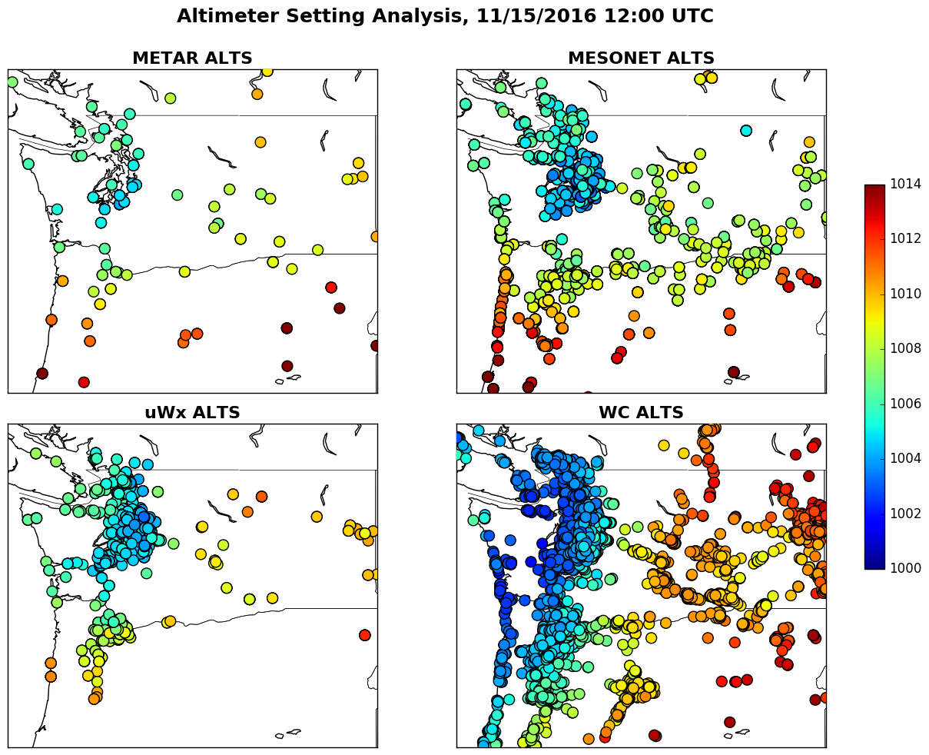
The uWx analysis compares well with both the METAR and MESONET analysis. The magnitudes of both the cross and along-barrier pressure gradients are roughly equivalent in the uWx, METAR, and MESONET analyses. The uWx analysis, like the METAR analysis, is smoother than the MESONET analysis. A less homogeneous uWx analysis could be generated by relaxing the thresholds used to detect outliers in the RBF check. The only notable difference between the uWx analysis and the analyses from in-situ observations is a slight high bias in observations to the east of the Cascades in central Washington. Compared to the uWx analysis the WC analysis performs poorly. The along-barrier pressure gradient is underestimated while the cross-barrier pressure gradient is overestimated in the WC analysis. Altimeter observations are low biased west of the cascades and high biased east of the cascades. The low in northwestern Washington is also too deep in the WC analysis. The poor quality of the WC analysis can be traced back to the inability of random forests to constrain large bias prediction errors. In RBF, spatial checks, the majority of WC observations are rejected. For this reason, bias-corrected WC observations cannot produce meaningful altimeter analysis. Spatial consistency checks are only effective when the majority of observations are accurate. This is clearly not the case for WC observations. More work must be done to reduce bias prediction error**??** and improve coherency among observations so that spatial checks can be effective. Don’t understand…you saying the WC altimeter data is not useful?
Figure 20: Comparison between phone altimeter and conventional altimeter observations

3.4.4) QC of Moving Phones
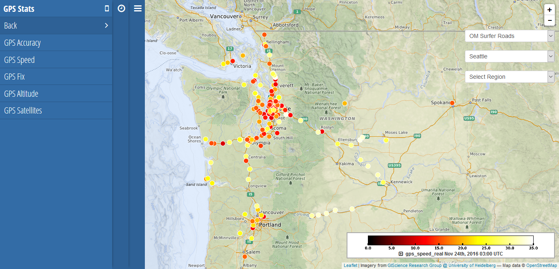
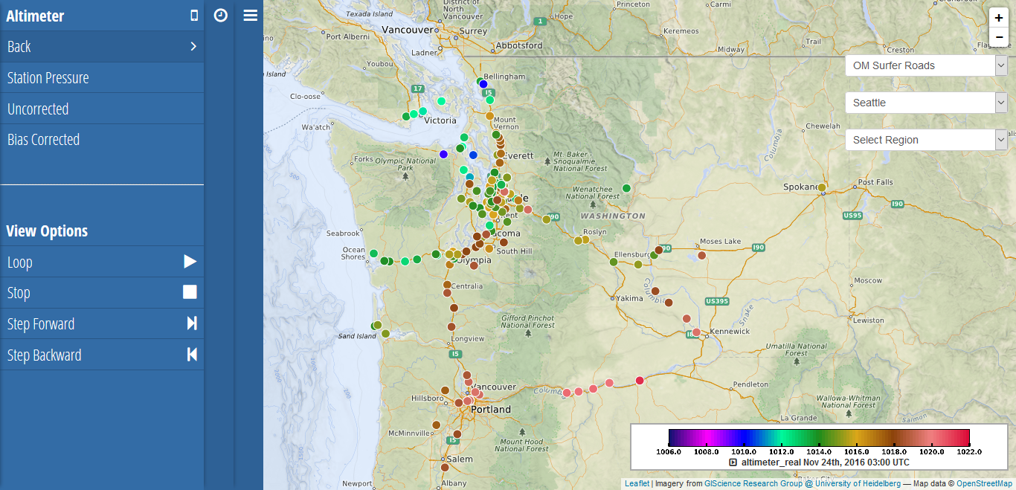
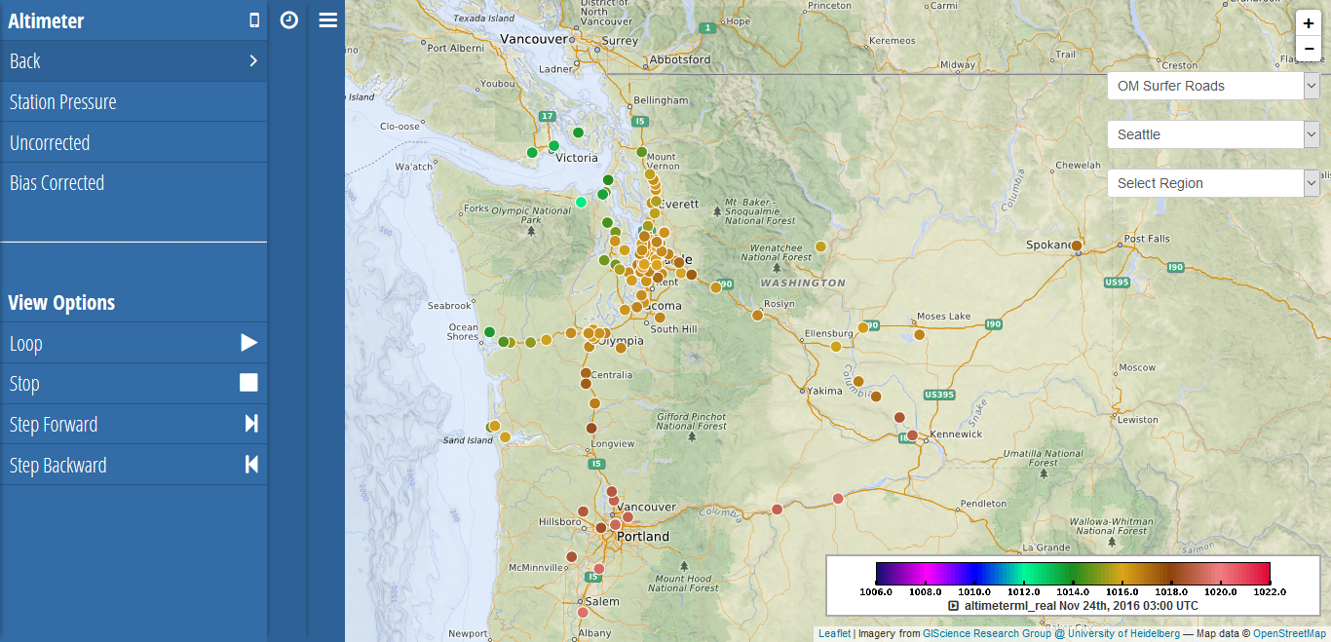
One of the more novel aspects of random forests is their ability to accurately predict phone bias even for phones in motion. Figure 21, displays post-processed uWx observations from smartphones moving at speeds exceeding five meters per second (derived from GPS data).
GPS Speed (m/s)
Altimeter Setting
Post Processed Altimeter
Figure 21: uWx altimeter setting analysis for phones moving at speeds exceeding 5 m/s.

Even for phones in motion the random forest performs remarkably well. This may be a consequence of the random forest algorithm identifying weak relationships between phone bias, GPS speed, and elevation variance. Bias-correction of moving phones is also likely aided by an algorithm built into uWx which modifies pressure retrieval when the GPS speed of the phone exceeds walking/running speeds. When the phone is moving at a significant pace, the pressure sensor is run for a set amount**??how much??* of time after the GPS location has been retrieved. This delay in pressure retrieval increases as the speed of the phone increases. The collection of pressure is delayed when the phone is in motion to account for dynamic lag. It takes some time for the sensor to respond to changes in pressure, so that when the GPS location is retrieved the pressure recorded by the sensor is likely a few seconds behind what it should be at the recorded location.

Chapter 4

DART-WRF ENKF EXPERIMENTS WITH BIAS CORRECTED SMARTPHONE PRESSURE OBSERVATIONS
  - Background

To examine the potential of smartphone pressures for NWP, potential case-studies were evaluated during the Fall of 2016. During this period, the second Wind Forecast Improvement Project (WFIP2) was ongoing. WFIP2 is a Department of Energy project to improve short-term forecasts of wind energy generation in regions of complex terrain (Marquis et al, 2015). The WFIP2 field campaign, centered just east of the Columbia River Gorge (CRG), included a network of sonic detection and ranging (SODAR) instruments in addition to radar wind profilers. WFIP2 weather discussions and forecast verification tools were used to select an optimal case study for SPO experiments. Since the number of phones in the uWx network doubled in mid-October, an initial case study in mid-November was selected.
In this event, a surface low developed off the coast of Oregon before tracking northeastward from the Columbia River delta into north central Washington. Accompanying the surface cyclone was a warm front, which passed through the CRG region between 10-12 UTC on November 15th. A subsequent cold front passed through the same region five hours later, between 1500-1700 UTC. Following the passage of the cold front, wind energy generation by the Bonneville Power Administration (BPA) climbed from near zero to 4000 Megawatts (MW) as westerly winds picked up behind the front (Fig. 22). West of the Cascades, widespread light to moderate precipitation persisted until around 1300 UTC, when heavier banded precipitation began. The surface low achieved its maximum strength just after making landfall around 1200UTC.

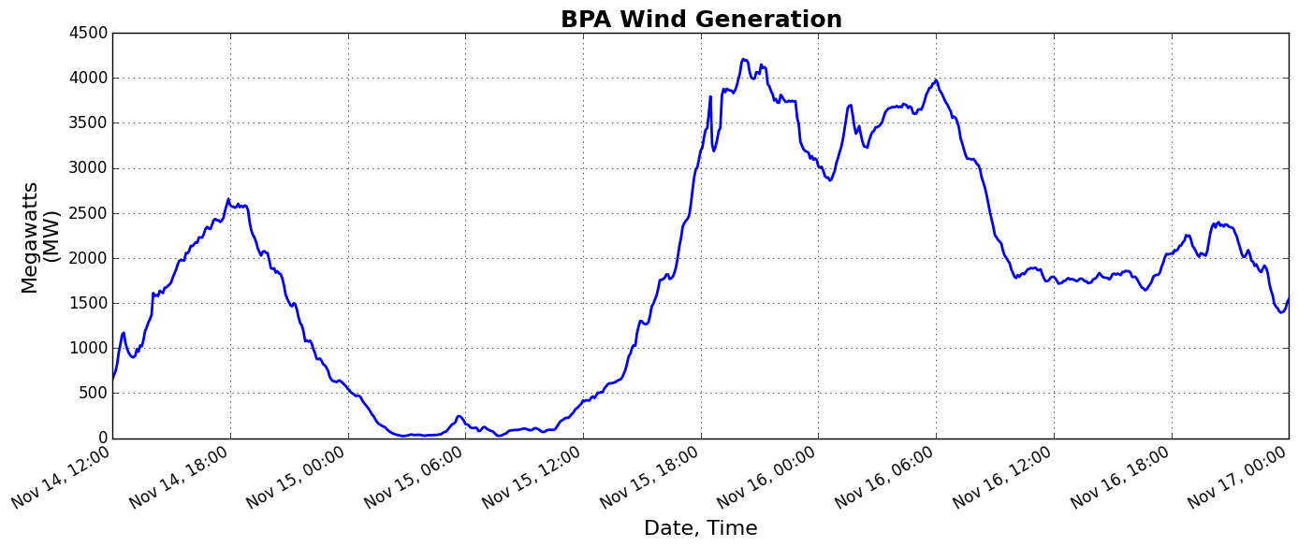
Figure 22: Time series of wind energy production from the Bonneville Power administration during the first case study (1200 UTC Nov, 14 – 0000 UTC Nov, 17).

This case was selected as the operational NOAA/NWS High Resolution Rapid Refresh (HRRR) failed to capture the timing and strength of the wind-ramp event in the WFIP2 study region. Figure 23, shows a time-height cross-section from a SODAR near Rufus, Oregon.
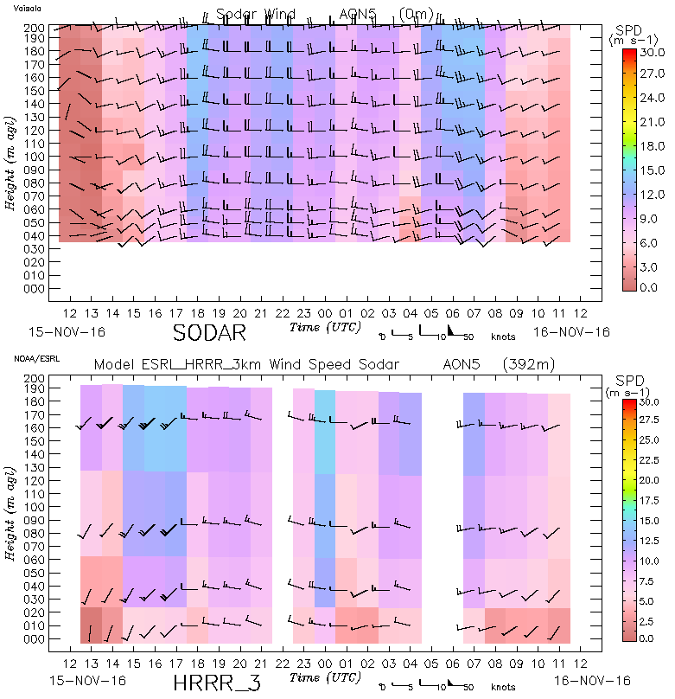
The HRRR brings strong winds down to the surface at 15 UTC, while the SODAR reveals that stronger winds did not occur in the rotor layer (80-150m) until 18 UTC. A similar two-hour timing error was also observed by a radar wind profiler at nearby Boardman, Oregon (not shown). Aside from the frontal timing issue, the HRRR in general overestimates the strength of low-level winds. This is likely due to overmixing in the PBL. Failing to correctly time the onset of strong low-level winds poses a challenge to wind energy providers, who seek to anticipate when an up-ramp in wind energy production will occur. One goal of this study will be to determine whether SPOs can constrain near-surface wind forecasts during an up-ramp event of interest to wind-energy stakeholders.
Figure 23: Time x Height cross-section of wind speed from a radar wind profiler (top) and from the 12Z HRRR (bottom) at Wasco, Oregon.
A second case-study unrelated to WFIP2 was examined in mid-October. As mentioned previously, it was around this time that the number of uWx users doubled from approximately 1000 to over 2000 active users. On October 12th, extended forecasts from the University of Washington’s real-time Weather Research and Forecasting (UW-WRF) model suggesedt that the remnants of tropical storm Songda would intensify into a deep surface low over the next five days, potentially threatening the
Pacific Northwest with a major wind storm. Initial forecasts from 0000 UTC on the 12th, placed a 955 hPa surface low offshore, a few hundred kilometers west of the Strait of Juan de Fuca. By the 13th, 3-day forecasts from the UW-WRF suggested that a more compact storm would make landfall near the center of the Olympic Peninsula. Since the 3-day track forecast placed the storm in an ideal location to generate strong winds in the densely-populated Puget Sound lowlands, media coverage of the storm increased. With public awareness heightened by the threat of a major wind storm, a substantial effort was made to advertise uWx in an attempt to expand pressure collection ahead of the coming storm. On the morning of the 15th, the 4km 1200 UTC UW-WRF run forecast showed the surface low making landfall near Quillayute, Washington on the northwest coast of the Olympic Peninsula (Fig. 24). In this run, maximum wind gusts in the Seattle metro area were expected to exceed 50 mph. Due to the compact nature of the storm, the radius of strong winds was limited in extent. This complicated forecasts for cities like Seattle, which fell on the edge of this radius. When the windstorm arrived between 00-0300 UTC on October 16, the surface low tracked offshore approximately sixty miles west of its forecast track. This track error resulted in substantial errors in wind forecasts in the Seattle area. Since the surface low took a more westward track, the strongest winds remained along the coast and the potentially devastating gale force gusts and damages to infrastructure never materialized.

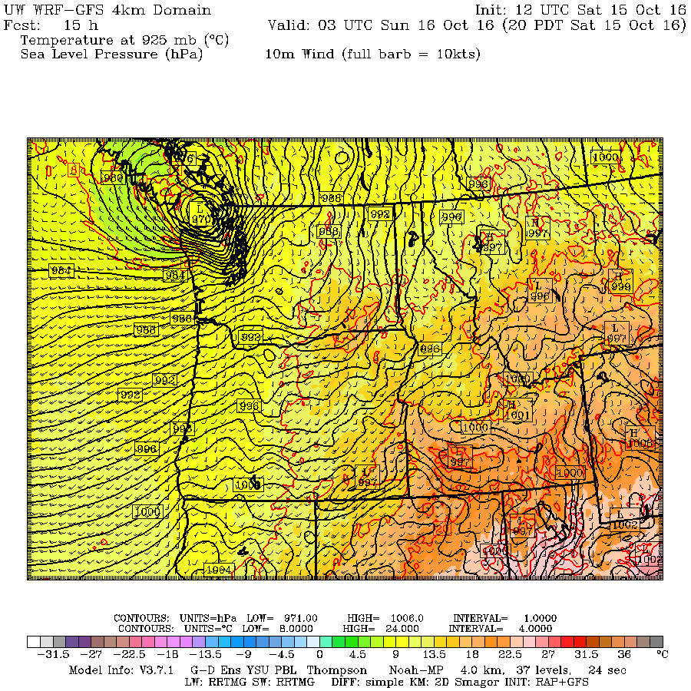
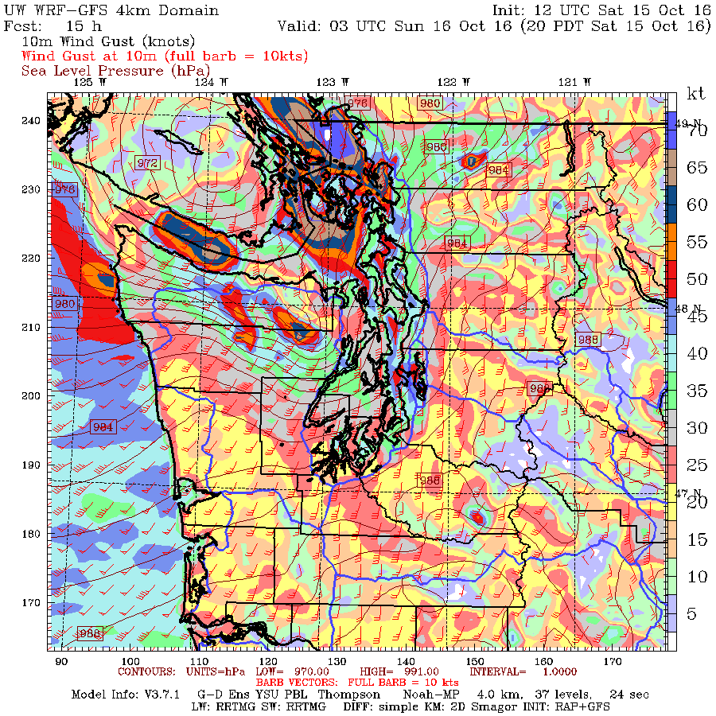
In anticipation of downed trees and widespread power outages, many Seattle residents, opted to remain at home, resulting in loss revenue for stores, restaurants, and event holders who would have typically enjoyed good business on a Saturday night. If the forecast track of the windstorm could have been predicated with greater accuracy, earlier in the day, the economic impacts of this forecast bust may have been averted. To determine whether the large number of new smartphones added to the uWx network in the lead up to this event, could have improved outcomes by better constraining the track and intensity of this windstorm, this event was selected as the second case study for review.
Figure 24: 15-h forecasts from the UW-WRF initialized at 1200 UTC on October 15th, 2016. MSLP, wind and temperature (displayed on the left), MLSP and 10 m Wind Gust (displayed on the right).
  - Methods
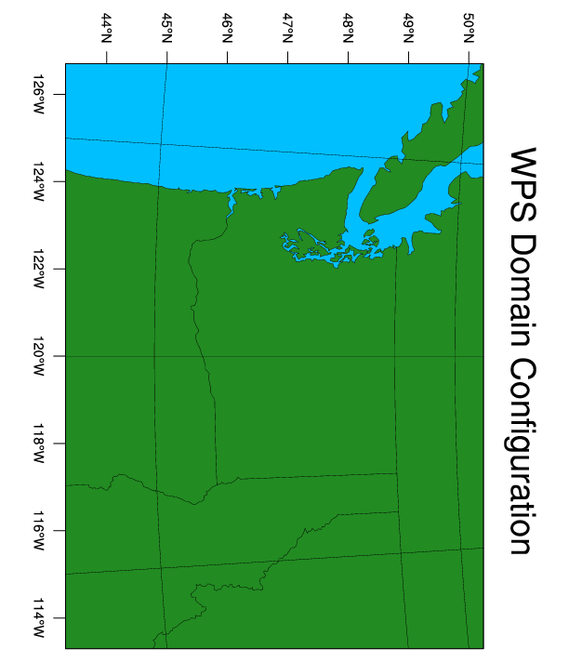
For both cases, assimilation experiments were executed with the Data Assimilation Research Testbed’s (DART; Anderson et al., 2009) ensemble square root adjustment filter, and advanced with the Weather Research and Forecast (WRF) model (Skamarock, et al., 2008). Initial conditions were provided by the Rapid Refresh (RAP) model analysis, while hourly boundary conditions were generated with one-hour RAP forecasts. Physics parameterizations were set to mimic the operational HRRR model. WRF was run with a total of thirty-eight vertical levels and a horizontal resolution of four kilometers. The model domain consisted of a 1200 km x 900 km grid encompassing most of the PNW (Fig. 25). A total of 48 ensemble members were produced by allowing the Stochastic Kinetic-Energy Backscatter Scheme (SKEBS) to spin up perturbations in both WRF initial and boundary conditions (Berner et al., 2011). SKEBS parameters such as the total backscattered dissipation rate for stream function and potential temperature, were set to 5x10⁻⁵ and 1x10⁻⁴, respectively. The decorrelation time scale for both stream function and potential temperature was set to one hour. SKEBS was allowed to spin-up perturbations for twelve hours prior to the start of each case.
Figure 25: WRF-ENKF domain for both case studies.
The first case-study examined a frontal passage and subsequent wind ramp event on November 15th, 2016. For this case, both full cycling and no-cycling experiments were performed over a sixty-hour period beginning at 1200 UTC on Nov. 14th and ending at 0000 UTC on Nov. 17th 2016. An initial control experiment was performed in which observations were used for verification but not assimilated. In this run, the WRF ensemble was advanced one hour, every hour, with boundary conditions perturbed by SKEBS and provided by one-hour RAP forecasts. No-cycling experiments utilized previously generated 1-hr forecasts from the control ensemble to assimilate pressure observations. Since the model is not run after each assimilation step in the no-cycling runs, these experiments lack any memory of the assimilation and are less expensive to run. In full cycling experiments the model is run after each assimilation step allowing the model to retain some memory of the assimilation. No-cycling and full-cycling experiments examined the impact of assimilating SPOs and traditional in-situ pressure observations from the MADIS network. In no-cycling experiments, the impact of assimilating pressure change was also examined. For this case, uWx SPOs were bias corrected with random forests trained on data retrieved between Aug. 15th and Nov. 9th, 2016. The RMSE of bias prediction??? Not clear was combined with estimates of location uncertainty and sensor noise to provide a unique estimate of observational uncertainty for every SPO.
The second case-study examined a windstorm that evolved from the remnants of tropical storm Songda. For this case, both full cycling and partial-cycling experiments were performed over a sixty-hour period beginning at 1200 UTC on Oct. 14th and ending at 0000 UTC on Oct. 17th, 2016. As in the first case an initial control experiment was performed in which observations were evaluated but not assimilated. Two full cycling experiments examined the impact of assimilating SPOs and a combination of SPOs and SPCOs. In partial cycling experiments the WRF ensemble was cycled until the start of a forecast run, during which the model was allowed to evolve freely. Two partial cycling experiments examined how the assimilation of SPOs impacted short-term forecasts of the extant and track of the windstorm. Partial cycling forecast runs were initialized at 1900 and 2100 UTC on Oct. 15th. In each forecast run, the WRF ensemble utilized SKEBS perturbed RAP forecast boundary conditions. Both the 1900 and 2100 UTC runs produced ensemble forecasts out to 04 UTC on Oct. 16th. Since many SPOs collected during this case were retrieved from smartphones that had just joined the uWx network, bias correcting SPOs on past data was not feasible. As a result, SPOs assimilated in this case study were bias corrected with random forests trained on data retrieved during the month after the event, between Oct. 19 and Nov. 23, 2016. Each SPO was assigned a unique observational uncertainty derived from the RMSE of bias prediction, location uncertainty and sensor noise.
All of the aforementioned DART-WRF experiments were performed on the Microsoft Azure Cloud. Cloud computing resources were provided by Microsoft through a $20,000 Azure Research Grant. A 256-core, high performance computing (HPC) cluster was built from sixteen H-Series virtual machine instances. Each virtual machine consisted of an intel processor with 16 cores, 7 GB of RAM per core, and a backend 32 GB/s InfiniBand network capable of Remote Data Memory Access (RDMA) ideal for low-latency high throughput communication. To the best of the author’s knowledge, this study is the first to successfully run DART on the cloud.
  - Results
4.3.1) Case I: No-Cycling Experiments
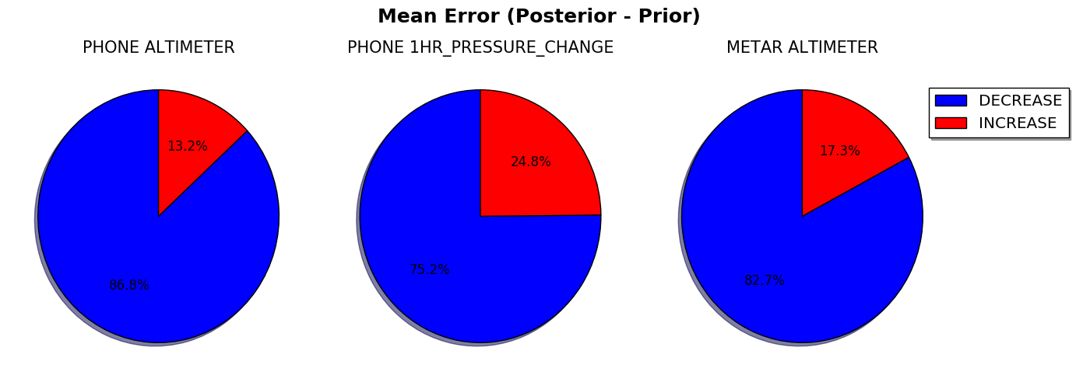
In previous work by Madaus and Mass (2017) a key finding was that no-cycling assimilation of SPOs degraded the analysis at the vast majority of SPO locations. For comparison, a similar analysis was performed with uWx SPOs assimilated during no-cycling experiments. The difference between the ensemble mean posterior (analysis) error and the ensemble mean prior (background) error for all sixty assimilation steps was evaluated at the location of each assimilated observation to determine whether the assimilation of SPOs, SPCOs, and METAR altimeter setting improved the model analysis of the assimilated variable. Ideally, the assimilated observations should decrease the analysis error locally, ensuring that the ensemble mean state is nudged closer to the observations, producing an ensemble mean analysis with less error. In previous work, Madaus and Mass (2017) found that SPOs were unable to achieve this result over the entire domain ** (did so locally**). In their experiments the analysis error was greater than the background error for ~45% of SPOs. In this study, a mere 13% of uWx SPOs increase the analysis error relative to the background error. Figure 26, highlights the change in analysis error relative to the background error in METAR and smartphone no-cycling assimilation experiments.
Figure 26: Mean Error difference between Posterior (analysis) and Prior (1h-forecast). If Posterior - Prior is negative (blue) assimilating X decreased the analysis error of X and vice versa (red).
The analysis error was less than the background error for ~82% of METAR pressures, ~87% of SPCOs, and ~75% of SPOs. This result is not entirely surprising given that qualitatively, smartphone pressure analyses appear self-consistent and coherent after bias correction with random forests and RBF-QC (Fig. 18).
While Figure 26 revealed that assimilating SPOs improved the analysis error at the plurality of SPO locations, it is unclear whether the same result would be achieved if the analysis was verified with high-quality METAR observations instead of SPOs. Figure 27, displays the domain average time-series of altimeter analysis error, verified against METAR altimeter observations, for four unique no-cycling assimilation experiments. Relative to the background error (CNTRL) assimilating SPOs (PHONE_ALT) consistently reduces the analysis error at METAR locations by nearly 50%. but using metar only is better???

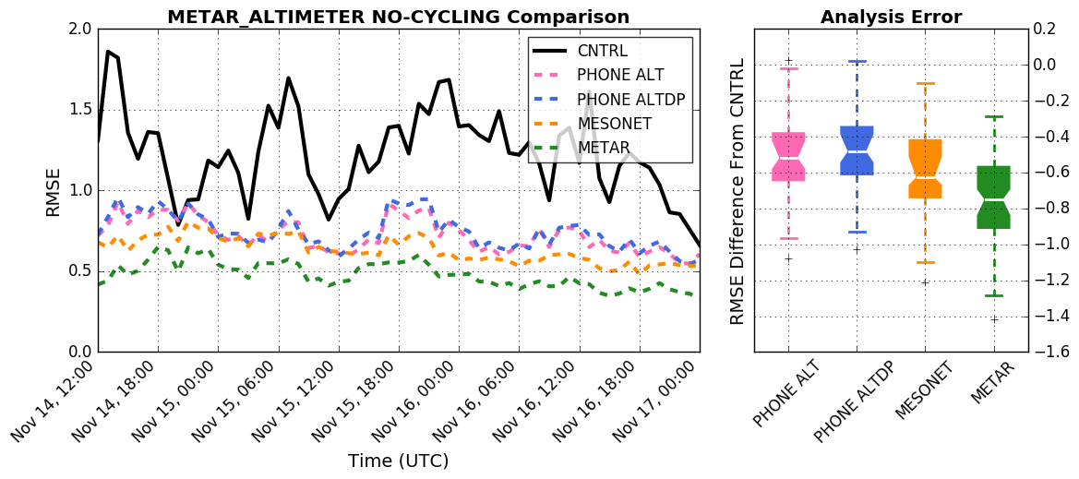
The median reduction in altimeter analysis error over the sixty-hour period was approximately 0.5 hPa. Assimilating 1hr SPOCs in addition to SPOs (PHONE_ALTDP) did not provide any added value, as reductions in analysis error were virtually equivalent to the PHONE_ALT assimilation experiment. Assimilating MESONET pressures provided a slight improvement over assimilating SPOs. This is not surprising as the spatial extent of MESONET observations is substantially greater than the spatial extent of SPOs in the eastern half of the model domain, east of the Cascade. When METAR pressures are assimilated **alone??*, the greatest reductions in altimeter analysis error are achieved. Since verification is performed with METAR observations, it is expected that METAR pressures should have the biggest impact on the analysis at METAR locations. ** might be better to leave out some METAR obs from assimilation and use those?*
Figure 27: Time series of domain averaged altimeter analysis RMSE relative to the background altimeter RMSE from the control ensemble (no assimilation). METAR altimeter observations used for verification.
To determine the effects of smartphone pressure assimilation on unobserved variables, the analysis error for 2-m temperature, 2-m dew point, and 10-m wind were examined. Figure 28, displays time-series of temperature, dew point, and wind analysis error relative to the background (CNTRL) error.
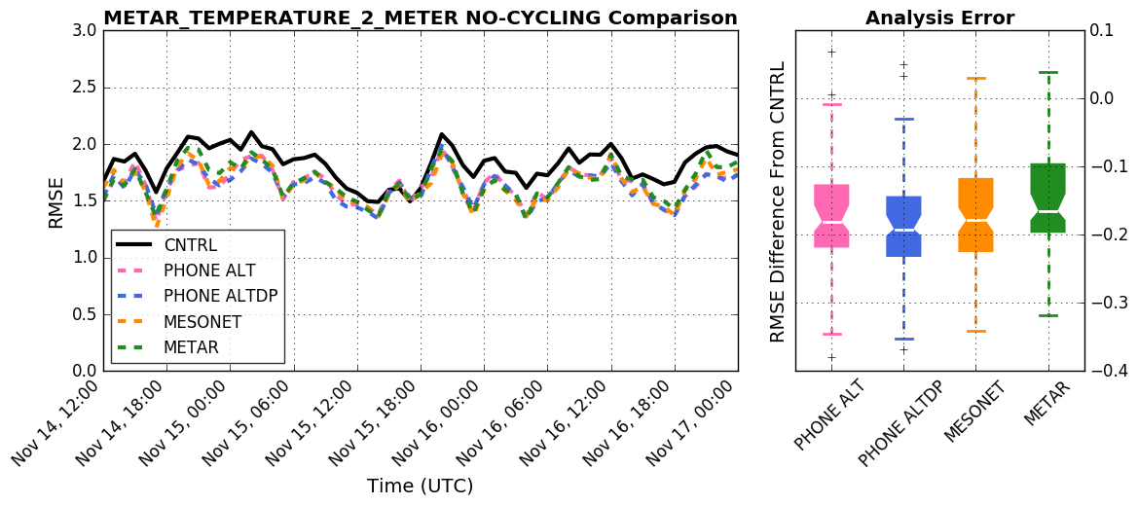
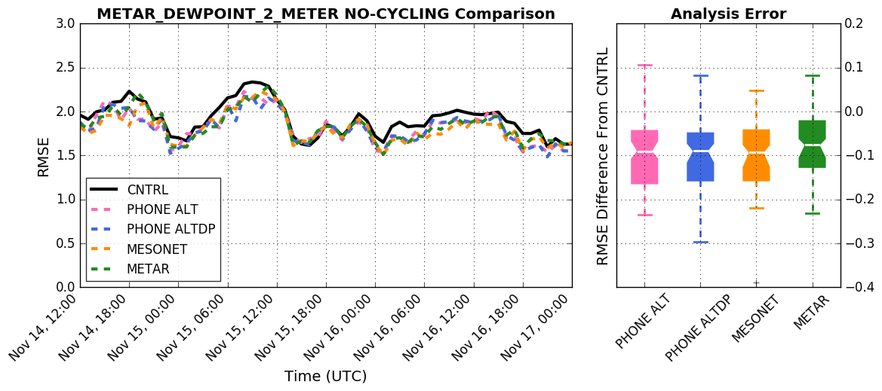
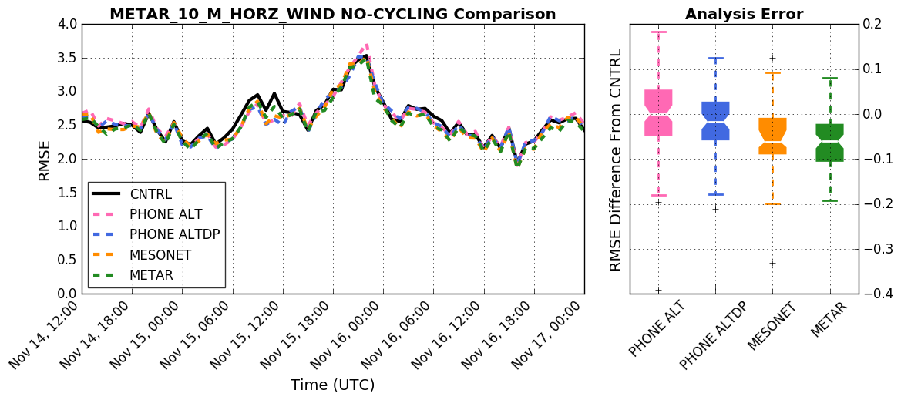
Figure 28: Time series of domain averaged 2-m temperature, 2-m dew point, and 10-m wind analysis RMSE relative to the background RMSE from the control ensemble (no assimilation). METAR observations used for verification.
Differences in error between the CNTRL and four unique assimilation experiments are also displayed (right panel). Assimilating SPOs (PHONE_ALT), consistently reduces dew point and temperature analyses errors by a small margin. The median reduction in analysis error for dew point and temperature is ~0.1 K and ~0.18 K respectively. No improvements are observed in 10-m wind analysis when SPOs are assimilated. Assimilating 1hr SPCOs in addition to SPOs does not produce any notable reductions in analysis error beyond that achieved by assimilating only SPOs. When MESONET and METAR pressures are assimilated individually, reductions in dew point and temperature analysis, similar in magnitude to the PHONE_ALT assimilation case, are observed. METAR pressure assimilation, and to a lesser degree MESONET pressure assimilation, does produce slight reductions in 10-meter wind analyses, but these reductions are small. The median wind analysis error reduction was a mere ~0.06 m/s when MESONET pressures were assimilated.
The ability of SPOs to constrain analysis of observed and unobserved variables suggests that the quality of bias-corrected uWx SPOs may be comparable to existing MESONETs. SPOs are able to reproduce the reductions in analysis error achieved by assimilating traditional in-situ observations. This is a notable achievement considering that the vast majority of SPOs are concentrated in the western half of the domain. Only a few tens of SPOs are retrieved east of the Cascade crest during any given hour, nevertheless, significant reductions in domain averaged analysis error are achieved through SPO assimilation. This is partly due to the large covariance length scale of surface pressure which allows the SPOs in the western half of the domain to influence the pressure field downstream, east of the Cascades. Compared to MESONETs and METARs, the spatial distribution of SPO is largely inhomogeneous. The location of SPOs mimics population density to a greater degree than traditional in-situ pressure networks. This may explain why SPOs struggled to constrain wind analyses. Since the covariance between pressure and wind is often weak and the covariance length scale of wind is relatively small (< 100 km), improving the wind analyses often requires input from several pressure observations. While SPOs may have sufficient density in urban areas to constrain wind analyses, elsewhere SPOs are distributed like oases in a desert. This may explain why SPOs were less successful than MESONETs and METARs in constraining wind analyses. ** but there is great hope in getting more pressure observations from rural areas*
4.3.2) Case I: Full Cycling Experiments
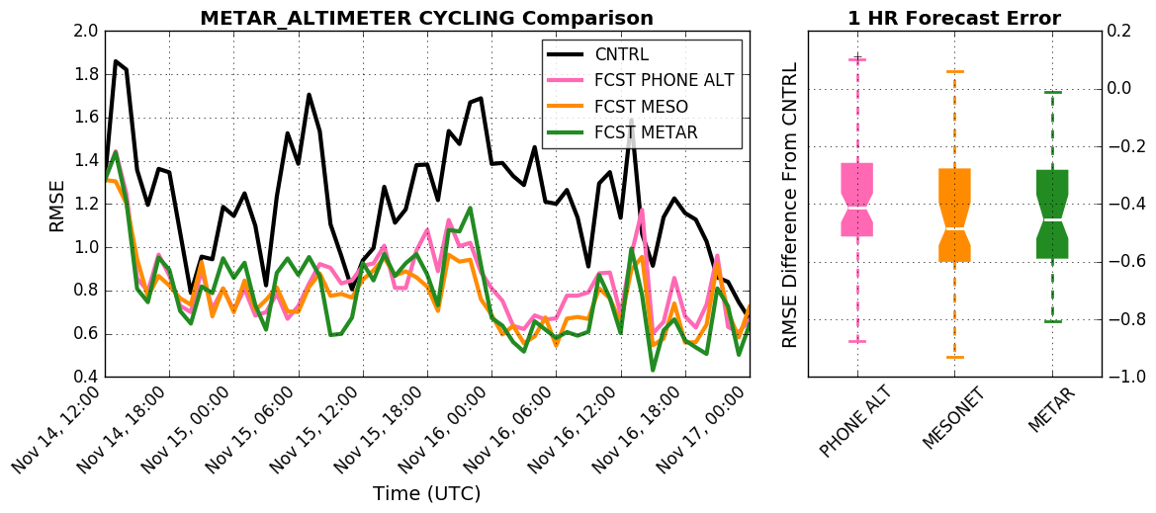
No-cycling experiments showed that SPOs were able to constrain analysis error. To evaluate the impact of SPOs on forecasts, full-cycling experiments were examined. Figure 29, displays time-series of domain averaged 1-hr altimeter forecast RMSE for three unique assimilation experiments relative to the background 1-hr forecast RMSE from the control ensemble.
Figure 29: Time series of domain averaged altimeter 1-hr forecast RMSE relative to the background 1-hr forecast RMSE from the control ensemble (no assimilation). METAR altimeter observations used for verification.

Compared to the METAR and MESONET pressure assimilation experiments, the PHONE_ALT experiment which assimilated only SPOs does remarkably well. Assimilating SPOs consistently reduces 1-hr forecast errors, to a magnitude similar to that observed when MESONET or METAR observations are assimilated. The right panel of figure 29, shows the difference in 1-hr forecast RMSE between each assimilation experiment and the control. In this panel, bootstrapped 95% confidence intervals for the median are displayed as notches in the boxplots. Since the boxplot notches overlap for all three cases, the median reduction in 1-hr forecast RMSE of altimeter setting observed in the PHONE_ALT experiment is not statistically significantly different than the median reduction observed in the METAR and MESONET experiments.
In no-cycling experiments, SPO assimilation was able to constrain analyses error for temperature and dew point but not wind. To determine whether improvements in these analyses were conveyed into forecasts, 1-hr forecasts of temperature, dew point, and wind were compared for three full-cycling assimilation experiments, in which pressures observations from smartphones (PHONE_ALT), METARs, and MESONETs were assimilated. Figure 30, displays the domain averaged 1-hr forecast RMSE for temperature, dew point, and wind relative to the background control ensemble 1-hr forecast RMSE. The right panel, displays the difference in the 1-hr forecast RMSE between each assimilation experiment and the control. SPOs are able to improve 1-hr temperature forecasts, and to a lesser degree 1-hr dew point forecasts. Overall, SPOs slightly degrade the performance of 1-hr wind forecasts.

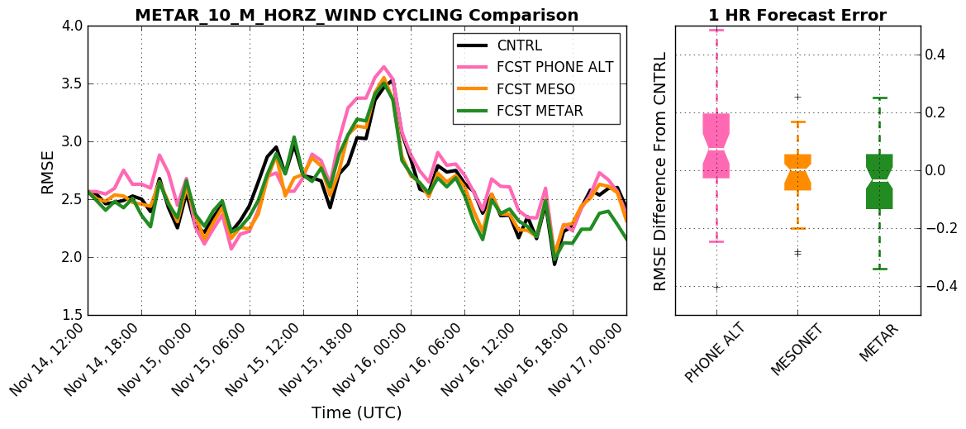
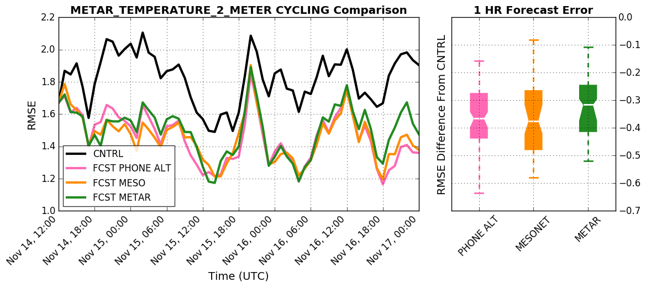
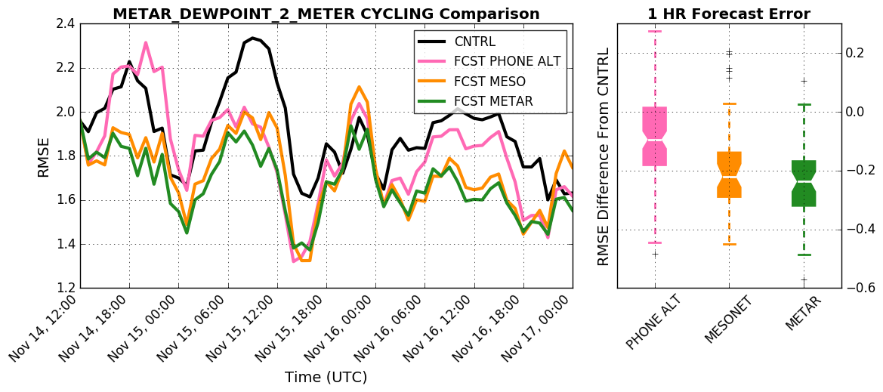
Figure 30: Time series of domain averaged 2-m temperature, 2-m dew point, and 10-m wind 1-hr forecast RMSE relative to the background RMSE from the control ensemble (no assimilation). METAR observations used for verification.

The ability of SPOs to constrain 1-hr forecasts of temperature is comparable to that of MESONET and METAR pressures. MESONET pressure assimilation produces slightly larger reductions in 1-hr forecasts of dew point relative to the PHONE_ALT case. On average, assimilating pressure from any observing network does little to improve or degrade 10-m wind forecasts. Even when METAR wind forecasts are evaluated at the same location that METAR pressures were assimilated an hour prior, no improvement in 1-hr wind forecasts is observed.
It is telling that a modest smartphone network capable of assimilating just over a thousand pressures an hour, from a dense network of smartphones is able to nearly match the performance of pressure assimilation from existing in-situ pressure networks. In this case, SPOs were able to constrain both analysis and forecast errors of pressure, temperature, and to a lesser degree moisture. In the study region, there are likely well over a million smartphones capable of retrieving pressure. This would imply that in the experiments shown previously, less than one-tenth of one percent of potential SPOs were assimilated. Since a little over a thousand uWx SPOs were able to match the performance of MESONET pressures in constraining forecasts of pressure and temperature it is natural to ponder whether a similar smartphone network with 10x, 100x, or even 1000x the number of smartphones could provide additional forecasts improvements beyond that achieved by assimilating pressures from existing MESONET or METAR networks. Nearly 10x as many SPOs were utilized by Madaus and Mass (2017) in their study but over a much larger area; they found that full-cycling SPO assimilation degraded temperature forecasts and produced only marginal improvements in altimeter forecasts. This serves as a reminder that quality is more important than quantity. If SPOs are not bias-corrected and quality controlled, a lack of self-consistency among observations can inhibit EnKF assimilation by generating spurious analysis increments which hinder improvements in the ensemble mean analysis.
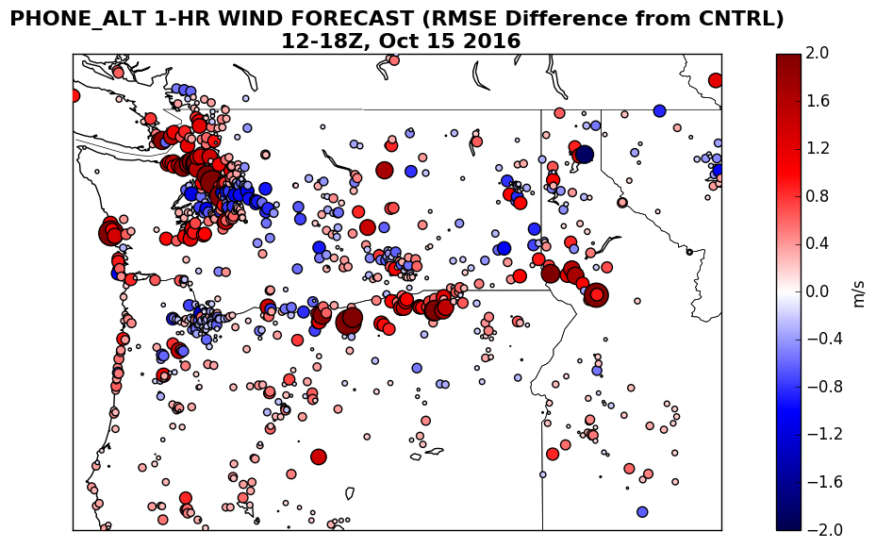
The fact that SPOs were unable to constrain wind analysis and forecasts is expected as previous work by Madaus et al., (2014) found that assimilating high-density pressure observations had no impact on 3-hr, 10-m wind forecasts in the Pacific Northwest. Nevertheless, one reason this case was selected was due to its importance for wind-energy. Domain averaged 10-m wind forecast errors slightly increased on average after assimilation of SPOs. This does not imply that SPOs degraded wind-forecasts throughout the entire domain. To evaluate how SPO assimilation impacted wind forecasts during the wind ramp event, 1-hr wind forecasts were temporally averaged over the six-hour period between 1200 and 1800 UTC on Nov. 18th, 2016. The **Missing stuff before this *** average difference between the PHONE_ALT 1-hr wind forecasts and 1-hr forecasts from the control ensemble over this period is displayed in figure 31.
Figure 31: 1-hr wind forecast RMSE difference between the PHONE_ALT experiment and CNTRL experiment, averaged over the 6-hour period spanning 12-18Z, on Oct. 15, 2016. Verification was performed with MESONET observations.
???? something is wrong/missing here.

To improve the readability of the figure, the size of each circle in the scatter plot was scaled linearly with the RMSE difference. 1-hr wind forecasts were verified with MESONET observations to get a better appreciation for how SPOs impact wind-forecasts throughout the domain, especially in locations where SPO density is high. During the period examined in Figure 31, a frontal passage swept through the CRG resulting in a wind ramp event (Fig. 22). In the domain average, 1-hr wind forecast performance decreased when SPOs were assimilated during this period. Figure 31, reveals that changes in the performance of 1-hr wind forecasts are not uniform throughout the domain, with 1-hr wind forecast improvements appearing where the density of assimilated SPOs is high. Wind forecast improvements are observed in the Seattle and Portland metro areas, two locations where SPOs are abundant. The RMSE difference downstream of the CRG, where wind energy assets are located, varies before becoming positive east of Boardman, Oregon.
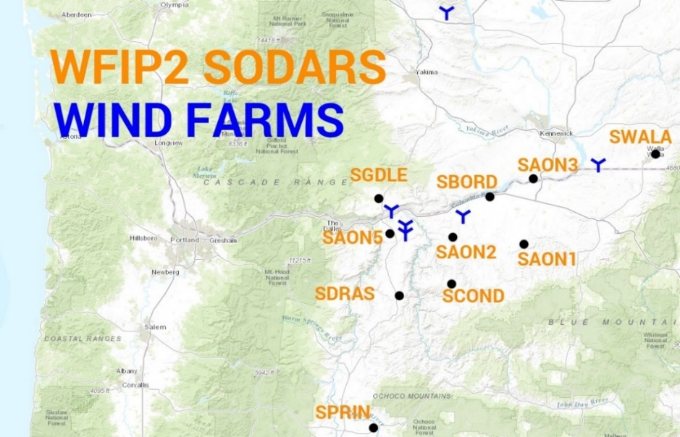
To determine whether SPOs may have aided wind-energy stakeholders by reducing wind forecasts error in the near surface layer, vertical wind profiles from WFIP2 SODARs were used to verify low-level wind forecasts during the six-hour (12-18UTC) wind ramp event. During this period, profiles of wind forecast RMSE between each assimilation experiment and the CNTRL experiment were temporally averaged. Figure 32, displays the location of wind farms and WFIP2 SODAR assets used to verify ensemble mean vertical wind profiles.
Figure 32: Location of wind forms and SODAR assets in Washington and Oregon.

The RMSE difference between vertical profiles of 1-hr wind forecasts for each assimilation experiment and the CNTRL experiment are displayed in figure 33.
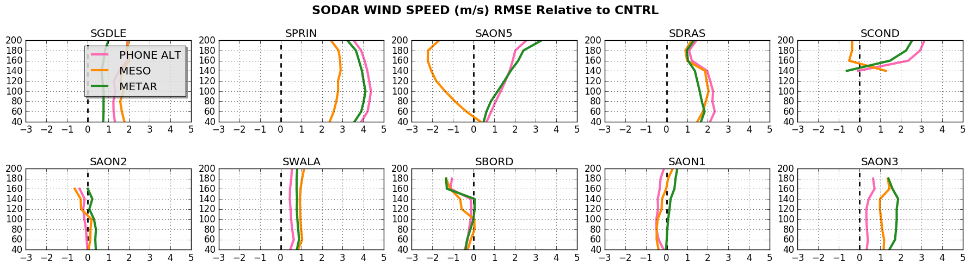
Figure 33: 1-hr wind profile forecast RMSE difference between assimilation experiments and the CNTRL experiment, averaged over the 6-hour period spanning 12-18Z, on Oct. 15 2016. Verification was performed with SODAR observations from WFIP2.

At three of the ten SODAR verification sites (AON1, AON2, and BORD) the assimilation of SPOs improved wind forecasts throughout the near surface layer. These three sites are co-located south of the Columbia River between Condon, Oregon and Hermiston, Washington. At all other locations assimilating SPOs increased the RMSE of near-surface wind forecasts. With the exception of AON5, assimilating MESONET pressures has a similar effect on wind forecast RMSE in the near-surface layer. When only METAR pressures are assimilated, wind forecasts RMSE at virtually all SODAR increases relative to the control experiment. In this case, pressure assimilation tended to have a detrimental effect on near-surface winds in the WFIP2 study region (Fig 32). A challenge often observed in regions of complex terrain is overmixing. When this occurs, the downward momentum flux is too large, resulting in larger than observed wind speeds in the PBL. In all pressure assimilation experiments the cross-barrier pressure gradient across the CRG was increased, resulting in an increase in the magnitude of near-surface winds within the WFIP2 study region. At most SODAR sites near-surface wind speeds were over-forecast. By increasing the cross-barrier flow, pressure assimilation likely enhanced overmixing in the PBL, resulting in near-surface wind errors that were larger than observed in the CNTRL experiment.
4.3.3) Case II: Full Cycling Experiments
In the previous case study, the covariance between wind and pressure was relatively weak and improvements to wind forecasts were mostly limited to urban centers where the density of SPOs was high. Since this case-study focuses on a major PNW windstorm, the signal to noise ratio is considerably lower and the relationship between wind and pressure is much more pronounced. For this reason, it is not unreasonable to expect that if pressure forecasts can be constrained wind forecasts may also be constrained.
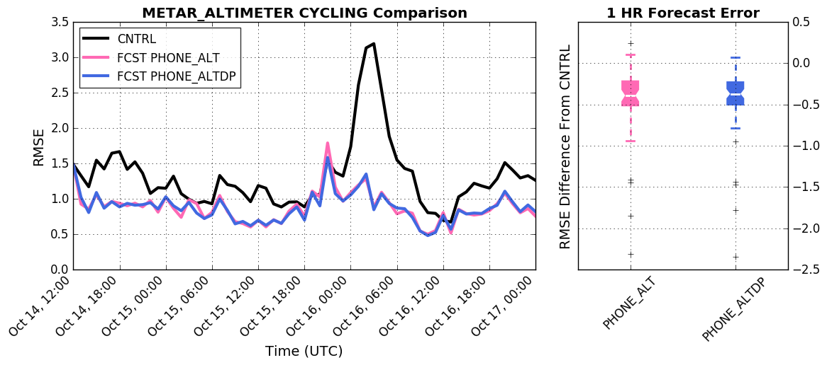
To determine the impact of SPOs on pressure forecasts, time series of 1-hr altimeter forecast RMSE is displayed in figure 34.
Figure 34: Time series of domain averaged 1-hr altimeter forecast RMSE relative to the background 1-hr forecast RMSE from the control ensemble (no assimilation). METAR altimeter observations used for verification.
The right panel of this figure shows 1-hr forecast RMSE differences from the CNTRL ensemble experiment, during which no assimilation was performed. For both PHONE_ALT (SPO only assimilation) and PHONE_ALTDP (SPO and 1h SPCO assimilation) the median reduction in 1-hr altimeter forecasts was approximately ~0.4 hPa. At 21UTC on Oct 15th, the assimilation of SPCOs in addition to SPOs appears to have constrained domain averaged altimeter forecast errors relative to the PHONE_ALT case. The largest reductions in domain average 1-hr altimeter forecast error occur during the period when the wind storm made landfall, between 00Z and 06Z on Oct. 16th. At 02 and 03UTC, the domain averaged 1-hr forecast altimeter RMSE decreased by 1.8 hPa and 2.3 hPa, respectively, when SPOs were assimilated. The magnitude of these reductions suggests that as the windstorm approached and made landfall SPOs had a major influence on the modeled track and intensity of the windstorm.
In this case study, the most important forecast variable is wind. The intense winds forecast for the Puget Sound lowlands late in the day on Oct. 15th, had a major public impact. To evaluate how SPOs and SPCOs influenced 1-hr wind forecasts, wind forecasts from the PHONE_ALT and PHONE_ALTDP full-cycling experiments were verified with METAR wind observations. Figure 35, displays time-series of 1-hr wind forecasts errors, relative to the CNTRL experiment. The right panel shows the 1-hr wind forecast RMSE difference from the CNTRL for each assimilation experiment. The median reduction in 1-hr wind forecast RMSE is very small over the entirety of the case; however, the time-series plot in figure 35, reveals that substantial reductions in domain averaged wind forecast RMSE are observed during the peak of the windstorm between 00-06UTC on Oct. 16.

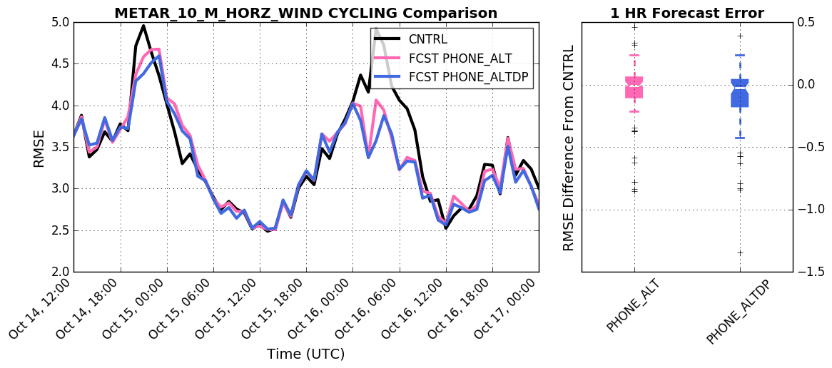
During this period, the 1-hr wind forecast RMSE is decreased by up to 0.8 m/s when SPOs are assimilated and up to 1.4 m/s when SPO and SPCOs are assimilated. It is interesting that assimilating SPCOs provides additional improvements over assimilating SPOs alone. Recall that in the short-term, pressure minima tend to propagate toward the region where pressure falls are greatest. Thus, by assimilating SPCOs, the propagation of the surface low can be constrained. Since in this case, strong winds are collocated with the surface low, improvements in the low’s track forecast can produce improvements in wind forecasts.
Figure 35: Time series of domain averaged 1-hr wind forecast RMSE relative to the background 1-hr forecast RMSE from the control ensemble (no assimilation). METAR altimeter observations used for verification.
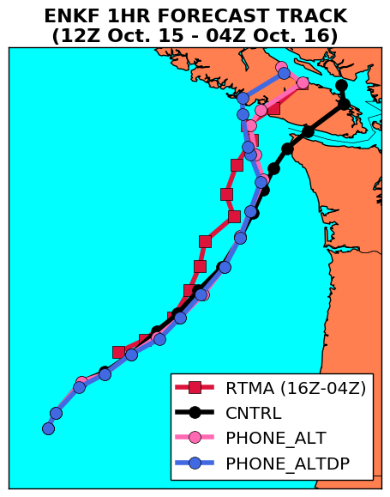
To examine how SPOs and SPCOs influenced the forecast track of the windstorm, the location of the minimum pressure in 1-hr forecasts of mean sea level pressure was analyzed for the CNTRL, PHONE_ALT, and PHONE_ALTDP experiments. 1-hr track forecasts for each of these experiments, starting at 12UTC on Oct 15 and ending at 04UTC on Oct 16, are displayed in figure 36. For reference, an estimate of the true storm track from the Real Time Mesoscale Analysis (DePondeca et al., 2011) was also included in this figure. At 18UTC, the assimilation of SPOs and SPCOs began to produce small but notable changes in the 1-hr forecast track of the storm. Large changes in the forecast track appeared at 00UTC, when the storm track in both assimilation experiments abruptly shifted westward relative to the control track. The PHONE_ALT experiment produces the most realistic forecast track. In the RTMA the storm tracks approximately sixty miles west of the entrance to the Strait of Juan de Fuca before making landfall on Vancouver Island near the western edge of Canada’s Pacific Rim National Park. While the shift in the 1-hr forecast track was not observed until 00Z, this shift still occurred three hours prior to the time when the strongest winds were anticipated to impact the Puget Sound lowlands.
Figure 36: 1-hr forecast track for CNTRL, PHONE_ALT, and PHONE_ALTDP full cycling experiments. Each point on the forecast track represents the location of the minimum observed pressure in 1-hr cycled forecasts.
4.3.4) Case II: Partial Cycling Experiments
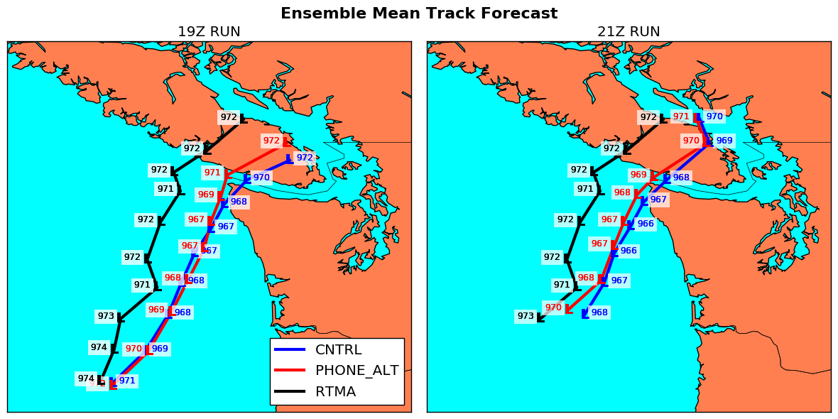
To determine whether the western shift of the windstorm track could have been forecasted at earlier lead times, two partial cycling experiments were performed. In these experiments, a 48-member WRF ensemble was advanced freely with SKEBS perturbed RAP boundary conditions and initial conditions from either the CNTRL ensemble or the PHONE_ALT ensemble. The first partial cycling experiment was initialized at 19 UTC, while the second experiment was initialized at 21 UTC, on Oct. 15th. At each of these times the surface low was a few hundred kilometers offshore, allowing its structure and location to be influenced by SPOs along the coast. The forecast tracks for each of these experiments initialized at 19 and 21UTC, respectively, are displayed in Figure 37. For reference, an estimate of the true storm track, from the RTMA, is also displayed.
Figure 37: Forecast tracks for CNTRL and PHONE_ALT free runs initialized at 19Z and 21Z, respectively.
In both experiments, the initial surface low is slightly weaker in the PHONE_ALT run than in the CNTRL run. In the 21 UTC run, the initial difference in the magnitude of the surface low is more pronounced as by this time several SPO assimilation cycles have progressively weakened the surface low in the analysis. In both runs, the PHONE_ALT track diverges from the CNTRL track around 00 UTC. While the westward shift of the PHONE_ALT track is a fraction of the shift observed in the full-cycling experiments, it is still notable. Both PHONE_ALT runs, initialized at 19UTC and 21 UTC nudge the windstorm track roughly 25-30 miles west of the CNTRL track preventing the storm from making landfall on the Olympic Peninsula. In both experiments the track and the intensity of the wind storm are nudged in the right direction by the assimilation of SPOs. In the 19Z run the surface low is marginally weaker in the PHONE_ALT case than in the CNTRL case between 00Z and 01Z. In the 21Z run the minimum pressure is higher in the PHONE_ALT case than in the CNTRL case, at all forecast lead times. By constraining both the track and intensity of the surface low as it approached the PNW coast, SPOs were able to provide more accurate initial conditions to the WRF ensemble. This is a notable achievement as it suggests that SPOs could be incorporated into operational models, many of which utilize partial cycling, to improve initial conditions and short-term forecast skill.
Improvements in the track and intensity forecast of the windstorm were observed in full-cycling and partial cycling experiments, yet it remains unclear how these forecast adjustments affect the spatial distribution of wind forecast skill. The location of wind forecast skill is crucial. If the forecast adjustments produced by SPOs only improved offshore wind forecast skill this would be less satisfactory than if wind forecast skill was improved throughout the Puget Sound lowlands, where strong winds were expected to cause damage to property and infrastructure. The Brier Skill Score (BSS) metric was used to compare wind forecast skill between assimilation and CNTRL experiments. The BSS is defined by the following equation:
$$B_{SS}=1-\frac{BS_{test}}{BS_{ref}}, where BS=\frac{1}{n}\sum_{t=0}^{n}{{\left(F_{t}-o_{t}\right)}^{2}}$$
This metric utilizes the Brier score (Brier, 1950) which essentially estimates the MSE for probabilistic forecasts. In the Brier score, $f_{t}$ represents the fraction of the ensemble members that forecast an event to occur at time $t$, while $o_{t}$ is a boolean that defines whether an event occurred or not at time $t$. In this case study, the Brier score is averaged in time and the reference forecast is the CNTRL forecast. When the BSS is negative (positive) the test forecast is less (more) skillful than the reference.
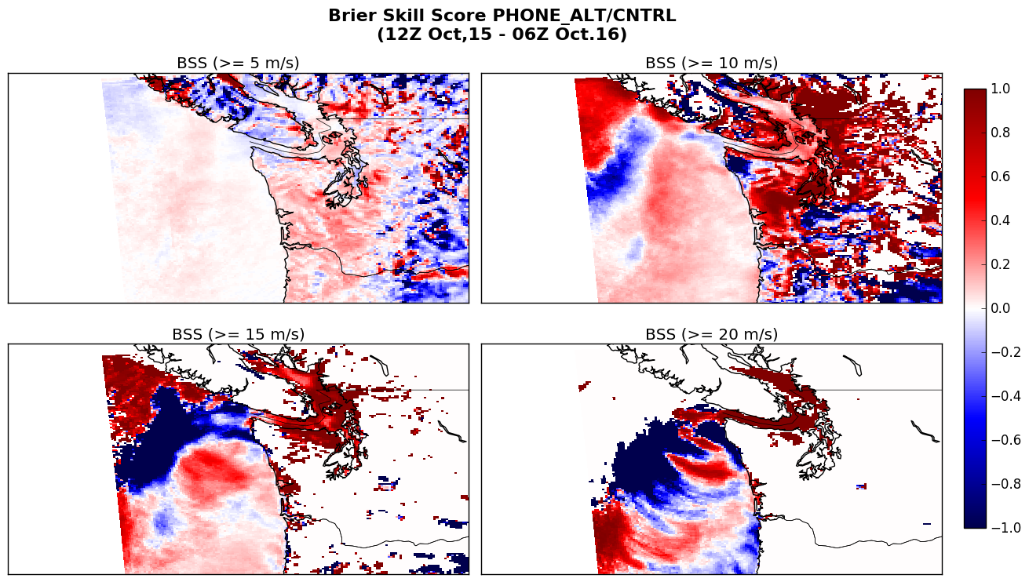
To evaluate how SPOs affected wind forecast skill in full-cycling experiments the BSS was used to compare wind forecast skill in the PHONE_ALT and CNTRL experiments. In each of these experiments gridded verification of 1-hr wind forecasts was performed with wind analysis from the RTMA. The time period used to compute Brier scores for the PHONE_ALT and CNTRL experiments extended from 12Z Oct 15th to 06Z Oct. 6th. The BSS was computed for wind forecasts exceeding 5, 10, 15, and 25 m/s (Fig. 38).
Figure 38: BSS of fully-cycling 1-hr wind forecasts greater than 5, 10, 15, and 20 m/s between 12Z Oct. 15 and 06Z Oct. 16. Red shading indicates that the PHONE_ALT forecast was more skillful, while blue shading indicates the CNTRL forecast was more skillful.
For all thresholds examined, 1-hr wind forecasts from the PHONE_ALT experiment were more skillful than CNTRL forecasts. The largest increases in wind forecast skill relative to the CNTRL experiment are observed throughout Puget Sound and the Strait of Juan de Fuca. The BSS for lower threshold wind probability forecasts (5, 10 m/s) was positive over a significant portion of offshore waters. This may be a consequence of SPOs limiting the spatial extent of winds around the surface low by constraining its structure. The substantial improvements in wind forecast skill achieved by fully-cycling SPOs every hour, is not unexpected since the position and the intensity of the surface low dictated the location and strength of the winds. Since SPOs were able to better constrain the forecast track and intensity of the windstorm the forecast wind probabilities were more skillful.
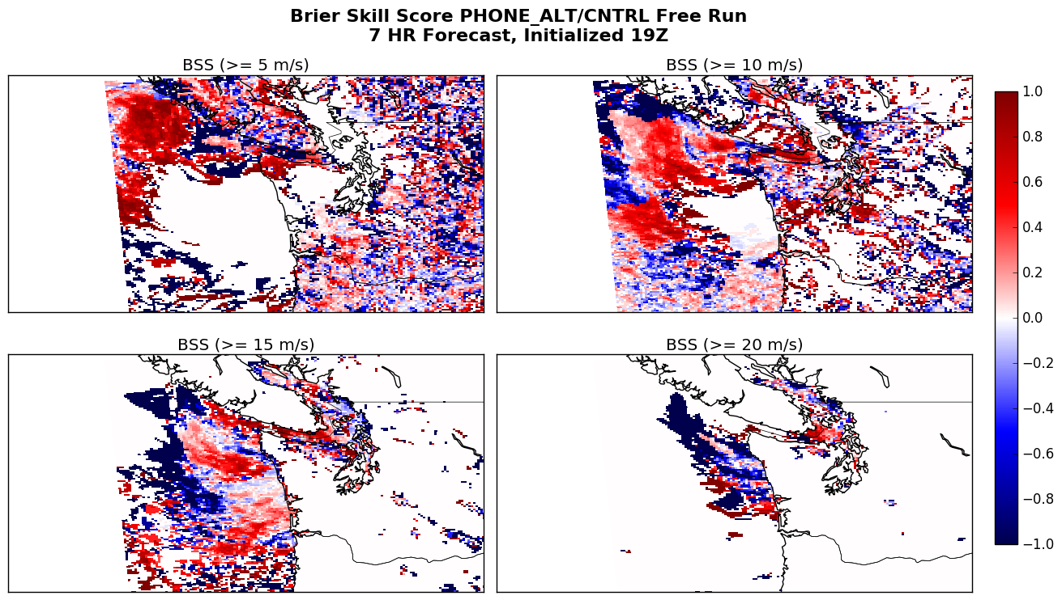
Since the value of 1-hr forecasts is limited, two partial cycling experiments were performed. For each of these experiments the BSS for wind forecasts exceeding 5, 10, 15, and 20 m/s was evaluated at a single forecast lead time, valid at 02 Z, on Oct 16th. The BSS for seven-hour wind forecasts initialized at 19Z are displayed in figure 39.
Figure 39: BSS of 7-hr wind forecasts greater than 5, 10, 15, and 20 m/s valid at 02Z Oct. 16. Red shading indicates that the PHONE_ALT forecast was more skillful, while blue shading indicates the CNTRL forecast was more skillful.
Recall that during the first partial cycling experiment the surface low was slightly weaker and more westward in the PHONE_ALT run than in the CNTRL run at 02Z. The slight decrease in magnitude and westward shift of the surface low was enough to produce improvements in wind forecast skill in the Strait of Juan de Fuca and in the lower Puget Sound. Offshore, positive BSS for wind forecasts exceeding 10 and 15 m/s are observed west of the Olympic Peninsula near the location of the surface low in the seven-hour forecast. At the highest threshold of 20 m/s, the PHONE_ALT run is less skillful than the CNTRL. The 19Z free run was unable to achieve widespread improvements in wind forecast skill throughout the domain. Nevertheless, the improvement to initial conditions, provided by the assimilation of SPOs, was able to produce modest improvements in wind forecast skill at a forecast lead time of seven hours.
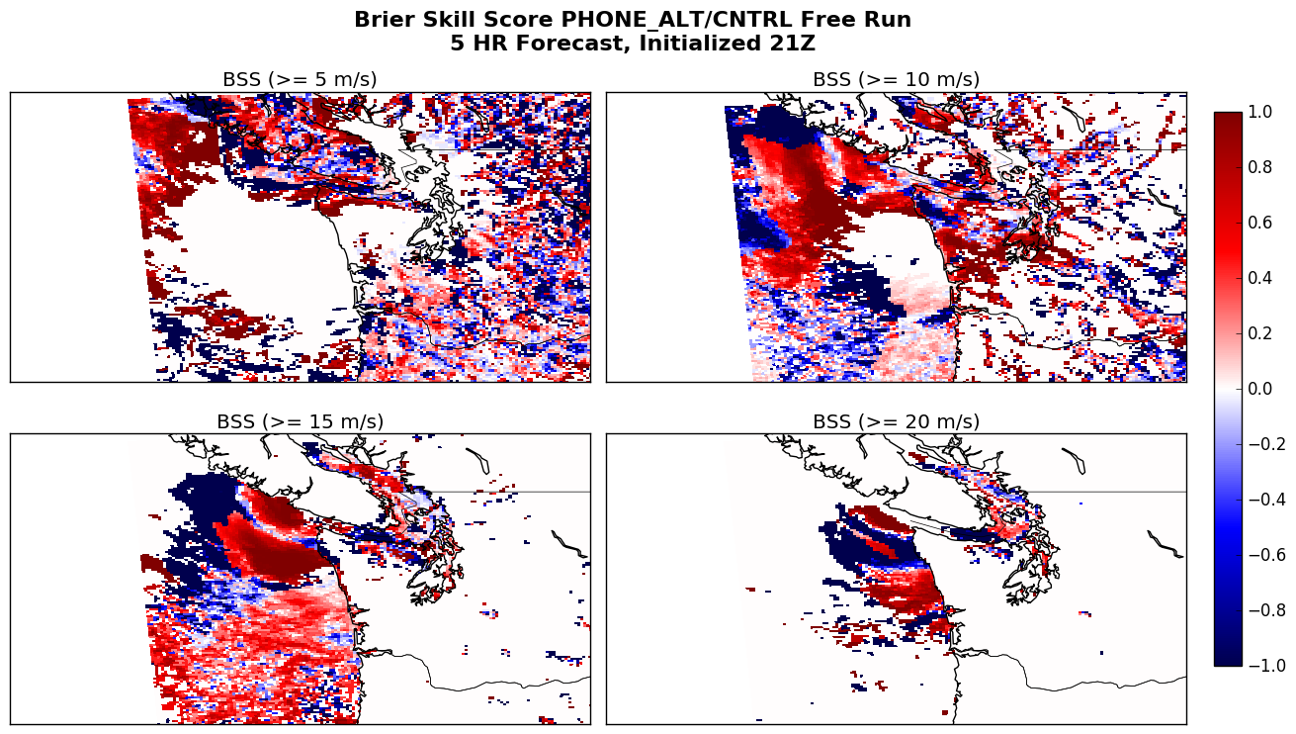
Wind forecast skill in the second partial cycling experiment is examined in figure 40. At 02UTC the forecast position of the surface low in the PHONE_ALT run was just off the coast of Neah Bay at the tip of the Olympic Peninsula. Relative to the CNTRL run, wind forecast skill for the 15 m/s threshold is markedly increased to the west and southwest of the Olympic Peninsula. Improvements in wind forecasts for the 10 m/s threshold are also observed in southern portions of Puget Sound and the Olympic Peninsula. At the highest wind forecast threshold the PHONE_ALT run is less skillful than the CNTRL run in the Strait of Juan de Fuca and off the northwest Olympic coast. It is noted that the spatial distribution of wind forecast skill improvements is markedly similar for both partial cycling experiments. In both experiments the PHONE_ALT wind forecast skill exceeded the CNTRL forecast skill in the southern Puget Sound lowlands and in the vicinity of the surface low. At these locations improvements in wind forecast skill were larger in magnitude in the second partial cycling case. This is the case because in the second partial cycling experiment free forecasts were initialized at a later hour, when the surface low was closer to shore and more strongly influenced by the assimilation of SPOs. Since the forecast intensity of the windstorm was better constrained in the second partial cycling experiment improvements in wind forecast skill were more pronounced.
Figure 40: BSS of 5-hr wind forecasts greater than 5, 10, 15, and 20 m/s valid at 02Z Oct, 16. Red shading indicates that the PHONE_ALT forecast was more skillful, while blue shading indicates the CNTRL forecast was more skillful.
  - Summary
** Lead with a more general statement” Don’t start with the app. I would lead with the need for better calibration and QC and the potential of machine learning. Then the potential for large number of pressure observations from smartphones.
In this study, a novel smartphone pressure app (uWx) was created to determine whether SPOs could improve NWP. Through the process of building, designing, and implementing uWx a variety of impediments to SPO quality were discovered. IIR filter driver settings were found to be responsible for dynamic lag, while spurious changes in location were found to be caused by a failure to specify the GPS as a mandatory location provider. Many of these obstacles to SPO data quality were resolved through the development of uWx. For this reason, the development of a unique, built from scratch, pressure collection app was necessary. **STRESS machine learning more*
Although pseudo-random ?? sources of error were largely eliminated within uWx, large biases persisted in SPOs. Since traditional QC techniques failed to produce the desired results, a machine learning approach to post processing SPOs was developed. Random forests, trained on a plethora sensor and location data, were largely successful in predicting and thus reducing phone bias. With the data quality problem mitigated, two case-studies were examined to test whether SPOs may be used to improve NWP. In the first experiment a wind ramp event downstream of the Columbia River Gorge was examined due to the availability of verification assets from a local field project, WFIP2. In this experiment SPOs were able to consistently reduce analysis error of altimeter setting, temperature, and dew point. Reductions in 1-hr forecasts for these surface variables were also achieved when SPOs were assimilated in full-cycling mode. When compared to experiments that assimilated pressures from traditional MESONETs or METARs, SPOs were able to achieve nearly the same reductions in forecast and analyses error of altimeter and temperature. This result suggests that when properly collected and bias corrected, the quality of SPOs is comparable to in-situ MESONETs. The fact that this result is achieved by assimilating observations from less than 2,000 phones is very promising, given that there are hundreds of millions of phones capable of collecting pressures. When wind forecasts were examined during this case-study, improvements were confined spatially to regions where the density of SPOs was greatest. In general, pressure assimilation from all networks did little to improve forecasts of the wind ramp event observed during this case. If substantial observational density could be achieved in regions where wind ramp forecasts are desired, it is possible that pressure assimilation could provide some value to wind energy stakeholders.
In the second case-study, a windstorm forecast bust was examined. The assimilation of SPOs in this case produced substantial improvements in altimeter forecasts during the climax of the event, when the windstorm made landfall. By fully cycling SPOs, errors in the forecast track of the windstorm were markedly reduced. Running free forecasts at early lead times revealed that partially cycling SPOs could constrain the forecast track and intensity of the windstorm at forecast lead times out several hours. When the skill of probabilistic wind forecasts was evaluated for fully cycled experiments, widespread improvements in skill were observed. In partially cycled experiments, freely run forecasts at six hour and eight-hour lead times produced modest improvements in wind forecast skill in the southern Puget Sound lowlands and in the vicinity of the surface low.
  - Implications FORGET WEARABLE DEVICES…talk about calibration and QC of crowdsourced wx observation. The potential of machine learning in atmospheric sciences.
Many of the techniques and methods developed to quality control and bias correct SPOs in this study could be applied to other unique mobile observing platforms. The same sensors used to quality control and bias correct uWx observations are found in wearable devices For example, both the Samsung Gear smart watch and Microsoft Band fitness tracker have network connectivity (Wi-Fi) and an embedded ambient light sensor, barometer, and GPS. Crowdsourcing of meteorological data from these devices could extend beyond pressure. The machine learning techniques applied in this study, could be modified to quality control temperature measurements from wearable devices. As more meteorological sensors are embedded in devices, vehicles, buildings, and other items the potential for crowdsourcing weather observations will grow. This thesis lays the groundwork for this future, by demonstrating that crowdsourced meteorological data from mobile platforms can improve NWP.

References
ML Altimeter
Anderson J., T. Hoar, K. Raeder, H. Liu, N. Collins, R. Torn, and A. Avellano, 2009: The Data Assimilation Research Testbed: A community facility. Bull. Amer. Meteor. Soc., 90, 1283–1296.
Anderson J., B. Wyman, S. Zhang, and T. Hoar, 2005: Assimilation of PS observations using an ensemble filter in an idealized global atmospheric prediction system. J. Atmos. Sci., 62, 2925–2938.
Berner, J., S.-Y. Ha, J. P. Hacker, A. Fournier, and C. Snyder, 2011: Model uncertainty in a mesoscale ensemble prediction system: stochastic versus multiphysics representations. Mon. Wea. Rev., 139, 1972–1995.
Breiman, L. 1996: Bagging Predictors. Machine Learning. 24, 123-140.
Breiman, L, 2001: Random Forests. Machine Learning. 45, 5–32.
Brier, G., 1950: Verification of Forecasts Expressed in Terms of Probability. Mon. Wea. Rev., 78, 1–3.
Compo, G. P., and Coauthors, 2011: The twentieth century reanalysis project. Quart. J. Roy. Meteor. Soc., 137, 1–28.
Compo, G. P, J. S. Whitaker, and P. D. Sardeshmukh, 2006: Feasibility of a 100-year reanalysis using only surface pressure data. Bull. Amer. Meteor. Soc., 87, 175–190.
De Pondeca, M. S. F. V., and Coauthors, 2011: The real-time mesoscale analysis at NOAA’s National Centers for Environmental Prediction: Current status and development. Wea. Forcasting, 26, 593–612.
Dirren, S., R. Torn, and G. Hakim, 2007: A data assimilation case study using a limited-area ensemble filter. Mon. Wea. Rev., 135, 1455–1473.
Duchon, 1976, Splines minimizing rotation invariant semi-norms in Sobolev spaces. pp 85–100, In: Constructive Theory of Functions of Several Variables, Oberwolfach 1976, W. Schempp and K. Zeller, eds., Lecture Notes in Math., Vol. 571, Springer, Berlin, 1977.
Gesch, D.B., Oimoen, M.J., and Evans, G.A., 2014, Accuracy assessment of the U.S. Geological Survey National Elevation Dataset, and comparison with other large-area elevation datasets—SRTM and ASTER: U.S. Geological Survey Open-File Report 2014–1008, 10 p.
Hanson G. S., Greybush S. J, 2016: Impact of Assimilating Surface Pressure Observations from Smartphones on Regional, Convective-Allowing Ensemble Forecasts: Observing System Simulation Experiments. Mon. Wea. Rev.
Ho, T. K., 1998: The random subspace method for constructing decision forests, IEEE Transactions on Pattern Analysis and Machine Intelligence, vol. 20, no. 8, pp. 832-844.
Lei, L., and J. Anderson, 2014: Impacts of frequent assimilation of surface pressure observations on atmospheric analysis. Mon. Wea. Rev., 142, 4477–4483.
Madaus, L., G. Hakim, and C. Mass, 2014: Utility of Dense Pressure Observations for Improving Mesoscale Analyses and Forecasts. Mon. Wea. Rev., 142, 2398–2413.
Madaus, L. and C. Mass, 2017: Evaluating Smartphone Pressure Observations for Mesoscale Analyses and Forecasts. Wea. Forecasting, 32, 511–531.
Marquis, M., Olson, J., Kenyon, J., Benjamin, S., Wilczak, J., Bianco, L., Djalalova, I., McCaffrey, K., Pichugina, Y., Banta, R., Choukulkar, A., Echman, R., Clifton, A., Carley, J., & Cline, J. (2015, June). Wind forecast improvement project-2, improving model physics in complex terrain, noaa's plans for improving the rapid refresh and high resolution rapid refresh models. Paper presented at the North American Wind Energy Academy 2015 Symposium, Blacksburg, VA.
Miller, P. A., M. F. Barth, and L. A. Benjamin, 2005: An update on MADIS observation ingest, integration, quality control and distribution capabilities. Preprints, 21st Int. Conf. on Interactive Information and Processing Systems, San Diego, CA, Amer. Meteor. Soc., J7.12.
Skamarock, W. C., and Coauthors, 2008: A description of the Advanced Research WRF version 3. Tech. Rep. NCAR/TN- 4751STR, National Center for Atmospheric Research, Boulder, CO, 125 pp.
Wheatley, D., and D. Stensrud, 2010: The impact of assimilating surface pressure observations on severe weather events in a WRF mesoscale system. Mon. Wea. Rev., 138, 1673–1694.
Whitaker, J. S., G. P. Compo, X. Wei, and T. M. Hamill, 2004: Reanalysis without radiosondes using ensemble data assimilation. Mon. Wea. Rev., 132, 1190–1200.

