The Impact of Lightning Data Assimilation on Deterministic and Ensemble Forecasts of Convective Events
Ken Dixon, Clifford F. Mass *, Gregory J. Hakim, and Robert H. Holzworth
University of Washington, Seattle, Washington

Submitted to
Journal of Atmospheric and Oceanic Technology
September 2015
Revised January 2016

___________
* Corresponding Author Address: Clifford F. Mass, Department of Atmospheric Sciences, Box 351640, University of Washington, Seattle, WA 98195-1640.
Email: cmass@uw.edu

ABSTRACT
A general lightning data assimilation technique is developed and tested with observations from the World Wide Lightning Location Network (WWLLN). The technique nudges the water vapor mixing ratio toward saturation within 10 km of a lightning observation and is more general than other approaches that require specific model microphysics or flash rates. It is applied to both deterministic and ensemble forecasts of the 29 June 2012 derecho event over the eastern U.S. and a deterministic forecast of the 17 November 2013 convective event over the Midwest using the Weather Research and Forecasting (WRF) model run at a convection-permitting resolution. Lightning data are assimilated over the first 3 hours of the forecasts, and the subsequent impact on forecast quality is evaluated. For both events, the deterministic simulations with lightning-based nudging produce more realistic composite reflectivity fields. For the ensemble forecasts of the 29 June 2012 event, forecast improvements from lightning assimilation were more subtle than for the deterministic forecasts, suggesting that lightning assimilation may produce greater improvements in ensemble convective forecasts where conventional observations (e.g., aircraft, surface, radiosonde, satellite) are less dense or unavailable.
1. Introduction
Advances in computing power have made it possible for operational regional forecast systems to reach convection-permitting horizontal grid spacing ($Δx≤4$ km), alleviating the need for a cumulus parameterization scheme (CPS) and creating the opportunity to assimilate convective-scale observations to improve forecasts (Weisman et al. 1997; Kain et al. 2008). Today, radar reflectivity and lightning flash rate observations are assimilated through latent heating into the operational Rapid Refresh (RAP) and High-Resolution Rapid Refresh forecast systems (HRRR; Weygandt et al. 2008). As advances in computing power continue, operational global forecast systems are expected to reach convection-permitting horizontal resolutions in the near future, creating a demand for convective-scale observations, particularly over data sparse regions such as the open ocean.
In recent years, long-range, land-based detection networks such as the World Wide Lightning Location Network (WWLLN) operated by the University of Washington and the Global Lightning Dataset (GLD360) operated by Vaisala have made global lightning detection possible. Continuous coverage of lightning activity over much of the Western Hemisphere will also soon be available from the Geostationary Lightning Mapper (GLM) aboard the R-Series Geostationary Operational Environmental Satellite (GOES-R), which is expected to launch in 2016 (Goodman, 2013). Given the difficulty of acquiring continuous mesoscale observations (e.g., radar or surface) with global coverage and the lack of GOES-R GLM coverage in the Eastern Hemisphere, lightning location information from long-range, land-based lightning networks such as WWLLN could help fill the gap in convective-scale observations available for assimilation on a global scale. Thus, a goal of this research is to evaluate a robust lightning assimilation approach using WWLLN, verifying our results in a region with dense observational assets (the eastern U.S.).
There have been several attempts to assimilate lightning data into numerical weather prediction systems. A central task of these efforts is to establish a relationship between lightning activity and resolved atmospheric variables. Some assimilation experiments have derived regional relationships between flash rate and rainfall rate, and then scaled the vertical latent heating profile based on the inferred rainfall rates (Alexander et al. 1999; Chang et al. 2001; Pessi and Businger 2009). Pessi and Businger (2009), using a long-range lightning detection network, found that forecasts of large-scale fields such as sea level pressure were improved by assimilating lightning; however, the low horizontal resolution of the models employed ($Δx≥27$ km) prevented explicit resolution of convection. It is also unclear how relationships between flash rate and rainfall rate, which are known to vary spatially (Petersen and Rutledge 1998), can be applied on a global scale.
A second group of studies have assimilated lightning into higher resolution, but not convection-permitting, regional models ($Δx=10$ km). In Papadopoulos et al. (2005), model humidity profiles were nudged toward humidity profiles derived from observed soundings when lightning occurred. Although the technique produced improved convective precipitation forecasts during the assimilation period and the subsequent 12-hour forecasts, it made use of regionally and seasonally specific moisture profiles, making it difficult to apply globally. Mansell et al. (2007) forced lifting to the level of free convection when lightning was observed and added moisture to lifted parcels to satisfy minimum cloud depth and peak updraft criteria; their approach resulted in improved cold pool representation and subsequent convective initiation. Although these studies improved convective forecasts by assimilating lightning, they relied on CPSs to produce convection and may not be relevant to simulations at convection-permitting horizontal resolutions.
The first attempt to assimilate lightning using a convection-permitting horizontal grid spacing, by Fierro et al. (2012, 2014; $Δx=1$ km), modified the water vapor mixing ratio in the mixed-phase region ($-20°C≤T≤0°C$), where charge separation is most significant according to non-inductive charging theory (Saunders 2008 and references therein). This assimilation technique was motivated by the successful initialization of a high-resolution simulation of Hurricane Rita by saturating vertical levels between 3 km and 11 km above the surface in region where lightning is observed (Fierro and Reisner, 2011). The water vapor mixing ratio was nudged based on observed gridded flash rates of total lightning, with the amount of nudging inversely proportional to the amount of graupel present in a model grid cell. This technique improved the simulation of a line of thunderstorms in Oklahoma as well as the 0-6 hour forecast of a destructive derecho in the upper Midwest and mid-Atlantic United States on 29 June 2012.
In addition to decreases in horizontal grid spacing, advances in computing power have facilitated high-resolution ensemble forecasting and associated data assimilation techniques, such as the Ensemble Kalman Filter (EnKF, Evensen 1994) approach, which uses error covariance statistics derived from ensemble members to update model state variables away from the observation location. Assimilating lightning using an EnKF is problematic because it is difficult to specify a forward model; furthermore, the discontinuous nature of convection can result in the rejection of a lightning observation when no ensemble members are producing convection in that location. Thus, an approach is needed to assimilate lightning that is compatible with the assimilation of observations by an EnKF system. An attempt at such a hybrid approach was made by Ballabrera-Poy et al. (2009), which reduced analysis error in the Lorenz and Emanuel (1998) model when including large-scale, slowly evolving observations in EnKF updates and assimilating small-scale observations using nudging.
Given the ease of implementation of observation nudging, as well as the success of moisture nudging in a range of previous high-resolution studies, a lightning data assimilation technique based on moisture nudging is described in this work, using global lightning location data available from the WWLLN network. For the first time, this technique is tested for both high-resolution deterministic and ensemble forecasts, considering the June 2012 derecho and the 17 November 2013 convective event. The performance of the lightning assimilation technique is assessed based on its impact on a short-term forecast ($≤$ 24 hours) of convective features.

2. Data and methods
a. Lightning data
For this study, lightning location data from the Worldwide Lightning Location Network (WWLLN) is employed. WWLLN is a network of approximately 70 sensors that detect sferics; very low frequency (3-30 kHz) radiation packets produced by lightning strokes. The propagation of sferics within the Earth-ionosphere wave-guide allows for the detection of lightning at distances of thousands of kilometers, enabling WWLLN to provide global lightning detection coverage (Dowden et al. 2002).
WWLLN is able to detect both intracloud (IC) and cloud-to-ground (CG) lightning strokes. Since detection efficiency increases with the peak current of lightning strokes, WWLLN is more efficient at detecting CG lightning due to the associated higher peak currents (Jacobson et al. 2006). The detection efficiency of WWLLN is approximately 10-11%, with location errors less than 10 km based on comparisons with observations from the short-range lightning observation networks in North America, which have detection efficiencies exceeding 90% and location accuracies within 1 km (Abarca et al. 2010; Abreu et al. 2010). Despite its modest detection efficiency, WWLLN is highly efficient at detecting lightning-producing storms during 3-hour periods (Jacobson et al. 2006).
Although the time of group arrival technique employed by WWLLN requires four sensors to locate a lightning stroke (Dowden et al. 2002), only strokes detected by five or more lightning sensors are retained by WWLLN. To reduce the potential for poorly located lightning strokes, observed lightning events are placed into $0.5°×0.5°$bins and strokes are removed when no other lightning stroke is observed in the same bin, or any adjacent bin, within the previous 60 minutes. Strokes observed by six or more sensors are exempt from the filtering procedure (R. Holzworth and J. Brundell 2013, personal communication).

b. Assimilation technique
In this study, a four-dimensional data assimilation technique known as Newtonian relaxation or nudging, is applied to lightning data. Specifically, we use the approach of Stauffer and Seaman (1994), which was designed for assimilation of surface and upper-air measurements of prognostic variables such as temperature, wind, and water vapor mixing ratio. Since the Weather Research and Forecasting (WRF) model does not explicitly forecast lightning, it is necessary to design a way to nudge the simulated atmospheric state toward conditions that are representative of the lightning observed by WWLLN.
As noted above, WWLLN is more efficient at detecting CG lightning than IC lightning, with CG lightning occurring after the cloud top has reached its maximum height (Williams et al. 1989; Solomon and Baker 1998). Thus, in this study the water vapor mixing ratio is nudged toward the saturation water vapor mixing ratio (100% relative humidity) at all vertical levels in the troposphere (levels where atmospheric pressure exceeds 200 hPa) within 10 km of any observed lightning stroke. Smaller radii were tested, but did not produce superior performance. The addition of moisture decreases the lifting condensation level (LCL) and increases the convective available potential energy (CAPE), encouraging the production of a deep cloud where lightning strokes are observed.
Although some previous studies have used nudging as part of their lightning data assimilation approach (Papadopoulos et al. 2005; Fierro et al. 2012, 2014), the water vapor nudging approach used in this study is substantially different and addresses several limitations of those techniques. First, this approach is independent of parameterized microphysical quantities, unlike the technique in Fierro et al. (2012, 2014), avoiding the need to establish a relationship between microphysical quantities (e.g., graupel) and lightning. It thus avoids the need to tune the technique for different microphysics schemes. Second, this approach does not restrict nudging to any vertical layer of the troposphere, instead encouraging both surface-based and elevated convection by nudging the water vapor mixing ratio at all vertical levels within the troposphere. This is in contrast to the assimilation technique of Fierro et al. (2012, 2014), which restricts moisture nudging (and therefore convective initiation) to the mixed-phase region. Third, this technique nudges moisture, a requirement of convective activity, instead of nudging a quantity such as latent heating that is a consequence of convective activity (Alexander et al. 1999; Chang et al. 2001; Pessi and Businger 2009). By taking this approach, there is no need to rely on region-specific relationships between lightning and rainfall or assumed latent heating profiles. Fourth, this technique is independent of the observed flash rate, taking advantage of a simple physical interpretation of WWLLN-observed lightning strokes that obviates tuning the amount of moisture nudging for spatial variations in flash rates, such as between land-based and ocean-based storms (Williams and Chan 2004). Furthermore, because of the low detection efficiency of WWLLN, particularly over remote regions, flash rate information will not allow reliable extraction of convective intensity, such as updraft strength. There are, of course, potential drawbacks of this approach. It does not modulate the strength of convection by the lightning flash rate and the nudging layer could extend into the lower stratosphere when the tropopause is below 200 hPa (although since there is little moisture in the cold lower stratosphere the impacts would be minimal).
The technique described above is performed using a modified version of the observation nudging described in Stauffer and Seaman (1994) and implemented in WRF by Liu et al. (2005). In our application of observation nudging, WWLLN strokes are binned into 5-minute intervals, so grid points are nudged long enough to initiate convection and short enough so the distribution of nudged grid points is representative of the current distribution of thunderstorms and not their path of motion. The quality of the WWLLN lightning strokes (filtered as described in Section 2a) is assumed to be perfect, and all spatial and temporal weighting functions are modified such that the water vapor mixing ratio at a grid point is nudged only if lightning is observed within 10 km during the current 5-minute interval. Nudging only occurs below 200 hPa. A schematic of this weighting approach is presented in Figure 1. The relaxation time scale is set to 5 minutes, which yields a nudging coefficient of$G=3.33×10$⁻³ s⁻¹. The nudging term does not depend on the number of lightning strokes within 10 km of a grid point; one is sufficient for maximum effect.
Equation 1 describes the water vapor mixing ratio tendency equation, where $x$ is the spatial location of the grid point, $t$ is time, $F(α, x, t)$ represents the physical forcing terms in the model, $q$_{v} is the model water vapor mixing ratio, $q$_{v,s} is the saturation water vapor mixing ratio, and $d$ is the distance from the grid point to the nearest lightning stroke observed in the 5-minute bin that includes the current time step.
c. Model configuration
All numerical weather simulations analyzed in this work are produced using version 3.4 of the Weather Research and Forecasting model with the Advanced Research dynamics solver (WRF-ARW). This is a fully compressible, non-hydrostatic model supported by the Mesoscale and Microscale Meteorology Division of the National Center for Atmospheric Research (NCAR/MMM; Skamarock et al. 2008).
All simulations are performed on a single domain over the eastern United States with 3 km horizontal grid spacing, 750 $×$ 550 grid points, and 38 vertical levels. The Thompson 6-class bulk microphysics scheme with graupel and double-moment rain and ice is used (Thompson et al. 2008). No convective parameterization scheme is applied since the horizontal grid spacing is convection permitting. Other parameterizations include the Rapid Radiative Transfer Model (RRTM) long-wave and MM5 short-wave radiation schemes (called every 30 minutes) as well as the YSU boundary layer scheme. The time-step is 12 seconds and boundary conditions are provided every 3 hours from the National Centers for Environmental Prediction (NCEP) Global Forecast System (GFS) forecast (0.5$°$ grid) initialized at the same time. In order to prevent numerical instabilities during data assimilation, vertical motions that result in CFL numbers exceeding one are damped. Additionally, to prevent upper boundary reflection, vertical motions are relaxed toward zero in the upper 7 km of the domain using a coefficient of 0.2 s⁻¹.
1. Deterministic experiments
For the deterministic simulations, 24-hour forecasts are produced using the WRF configuration described above with initial conditions from the GFS 0.5$°$ resolution analysis. For all deterministic experiments, two simulations are performed: a control simulation with no data assimilation (labeled as CNTRL) and a simulation with lightning nudging through the first 3 hours of the simulation, as described in Section 2b (labeled as NUDGE).
2. Ensemble experiments
An ensemble forecast experiment for the June 2012 derecho is completed using the aforementioned WRF configuration and software provided by the Data Assimilation Research Testbed (DART) group of NCAR. The ensemble adjustment Kalman filter variant of the EnKF (EAKF; Anderson 2001) is used to assimilate observations every three hours, using observations available within 30 minutes of the assimilation time. Observations for the EnKF assimilation step are obtained from the National Oceanic and Atmospheric Administration's (NOAA) Meteorological Assimilation Data Ingest System (MADIS) and include: METAR surface data, ship and buoy observations, satellite-observed winds, radiosonde observations, and observations from the Aircraft Communications Addressing and Reporting System (ACARS). Observations within 5 grid points of the lateral boundaries are discarded, as are upper-level observations at altitudes above 20 km or at pressure levels less than 100 hPa. Surface observations with elevations differing by more than 200 m from model terrain elevation are not assimilated. For both aircraft and satellite-wind observations, observations of the same source that are within 45 km horizontally and 25 hPa vertically are averaged together to create a super-observation. Any observation more than three standard deviations from the ensemble mean is discarded. In order to avoid filter divergence, spatially varying inflation is applied to the ensemble prior to EnKF assimilation (Anderson 2009). The Gaspari-Cohn function is used to damp covariances at large distances from observations (horizontal and vertical radii of 1000 km and 16 km, respectively) in order to prevent spurious covariances from affecting the ensemble states at unreasonable distances (Gaspari and Cohn 1999; Hamill et al. 2001). Testing revealed that the results are not sensitive to substantial changes in these damping radii.
For the ensemble experiments, a 64-member ensemble is populated initially by perturbing the GFS 0.5$°$ analysis valid at 1200 UTC 28 June 2012 using version 3.4 of the WRF data assimilation (WRFDA) system maintained by NCAR/MMM. WRFDA perturbs the GFS analysis according to background error covariances estimated from a year of differences in 24- and 48-hour GFS forecasts valid at the same time (the “CV3” option). A 24-hour spin-up between 1200 UTC 28 June 2012 and 1200 UTC 29 June 2012 is performed to develop error covariances that are representative of the uncertainty in the state of the atmosphere at the time of assimilation. To reduce spin-up time and lessen the initialization shock, the digital filter initialization option in WRF is applied at 1200 UTC 28 June 2012 using 30 minutes of backward integration and 15 minutes of forward integration (Huang and Yang 2002). For ensemble integrations beginning at 0000, 0600, 1200, and 1800 UTC, boundary conditions are from the GFS forecasts initialized 6 hours prior. For ensemble integrations beginning at 03, 09, 15, and 21 UTC, boundary conditions are from GFS forecasts initialized 3 hours prior. In order to maintain ensemble spread, the boundary conditions are perturbed using the fixed covariance perturbation method (Torn et al. 2006). No EnKF assimilation step is performed at 1200 UTC 28 June 2012, and inflation is not introduced until just before the 1800 UTC 28 June 2012 EnKF assimilation step. No moisture nudging is performed during the 24-hour spin-up period.
After the spin-up period, which concludes with an EnKF assimilation step at 1200 UTC 29 June 2012, two versions of the ensemble are run: (1) one without lightning-related moisture nudging, with a final EnKF assimilation step at 1500 UTC 29 June 2012 (ENS-CNTRL), and (2) a run with lightning-related moisture nudging from 1200 UTC to 1500 UTC 29 June 2012, with a final EnKF assimilation step at 1500 UTC 29 2012 (ENS-NUDGE).
d. Evaluation
In order to evaluate the numerical forecasts, simulated rainfall is compared to the NOAA Stage IV precipitation analysis (Lin and Mitchell 2005). This product combines radar and rain gauge-based precipitation observations and is available on a 4 km grid covering most of the domain described in Section 2c, except for small portions of the Canadian provinces of Ontario and Quebec. In this study, the Stage IV data is interpolated to the 3 km grid used in the WRF simulations. Only the portions of the domain with Stage IV precipitation data are used to evaluate the forecasts. The Stage IV product was used to evaluate the rainfall rates from 1 to 20 mm hr⁻¹ using the equitable threat score (ETS; Schaefer 1990). For plan view verification of the numerical simulations, composite reflectivity is used.
3. Results: 29 June 2012
On 29 June 2012, a particularly severe, long-lived bow echo/derecho event produced damaging straight-line winds across several Midwestern and Mid-Atlantic states. This mesoscale convective system (MCS) is an ideal candidate for examining the impact of lightning data assimilation for a number of reasons. First, the event was poorly forecast by operational models, with both the GFS and NAM (horizontal grid spacings of $Δx=$ 27 km and $Δx=$12 km, respectively) failing to forecast the MCS with any lead time, providing an opportunity for improving the forecast. Second, the MCS developed within an amorphous area of isolated thunderstorms on the morning of 29 June 2012, suggesting that model forecast quality can be improved by forcing the correct timing and placement of this convection. Third, the lack of obvious synoptic-scale lifting mechanisms to trigger the isolated thunderstorms in an unstable environment suggests that lowering the LCL and raising the CAPE where lightning is observed could encourage the formation of thunderstorms in the correct locations. It is worth noting that the experimental HRRR model, initialized at 1100 UTC 29 June 2012 and run at 3-km grid spacing, successfully forecast the development of the derecho, and that the HRRR assimilates radar reflectivity and short-range lightning flash rate observations (Weygandt et al. 2008).
a. Lightning
Between 1200 UTC and 1500 UTC 29 June 2012, WWLLN observed 4317 lightning strokes within the WRF domain described above. Location data from 4315 lightning strokes were assimilated using the observation nudging technique described in Section 2 (two lightning strokes were filtered out, Figure 2). The lightning strokes over eastern Iowa and western Illinois are associated with the thunderstorms that organized into the MCS.
b. Deterministic experiment
The average temporal change (from the previous five minute period) in integrated water vapor (IWV) at nudged grid points for each 5-minute bin during the first 3 hours of the CNTRL and NUDGE simulations is shown in Figure 3a. In CNTRL, no nudging is performed and average changes in IWV are nearly zero through the first 3 hours of the simulation. In NUDGE, noticeable increases in IWV occur through the first 3 hours, particularly over the first 5 minutes when the average increase in IWV exceeds 15 kg m⁻². Subsequently, average increases in IWV hover around 5 kg m⁻². A similar result is found for the average change in convective available potential energy (CAPE) at grid points where nudging is performed (Figure 3b). In CNTRL, average changes in CAPE over each 5-minute interval are nearly zero through the 3-hour period. In NUDGE, substantial increases in CAPE occur at nudged locations, particularly over the first 15 minutes of the simulation when increases in CAPE exceed 2000 J kg⁻¹. After that time, increases in CAPE over the 5-minute intervals are modest compared to the initial period. Average condensate increases substantially during the first 60 minutes of the nudged simulation in comparison to the far lesser and slower increase in the control (Figure 3c).
The impact of the nudging is evident in the simulated composite reflectivity fields (Figure 4-7). Between 1200 UTC and 1500 UTC 29 June 2012 (the first 3 hours of the simulations), the observed composite reflectivity indicates the development of thunderstorms along an east-west line across Iowa and eastern Nebraska that organize into a squall line in northwestern Illinois, while another line of thunderstorms, unrelated to the derecho event, moves across central South Dakota (Figure 4 c,f,i). During these 3 hours, CNTRL does not produce thunderstorms over Iowa or Illinois, with limited thunderstorm development over central South Dakota and Nebraska (Figure 4 a,d,g). In NUDGE, nudging over this period forced or enhanced thunderstorm development in several locations, more closely reflecting observations (Figure 4 b,e,h). At 1500 UTC, there is a gap in the thunderstorms in NUDGE just west of the Illinois/Iowa border that is not present in the observations, a gap due to a lack of WWLLN lightning strokes in this portion of the line (Figure 5). Overall, the convection in NUDGE is more consistent with observed reflectivity than in CNTRL, which is important since this convection develops into the derecho.
In all simulated reflectivity fields there is a notable lack of stratiform precipitation (e.g., behind the squall lines in South Dakota and Iowa in NUDGE), which may be due to the microphysics scheme being two-moment in only ice and rain. Microphysics sensitivity studies of mid-latitude squall lines suggest that full two-moment schemes facilitate the development of trailing stratiform precipitation behind convective lines (e.g., Morrison et al. 2009, Bryan and Morrison 2012, Baba and Takahashi 2014).
By 1800 UTC 29 June 2012, 3 hours after the nudging has ended, no convection associated with the MCS has initiated in CNTRL. In contrast, in the NUDGE simulation, earlier thunderstorms propagated into east-central Illinois, although displaced to the southwest of the observed line (Figure 6 a,b,c). At 2100 UTC (Figure 6 d,e,f) in CNTRL, a MCS has formed across northern Illinois, far to the west of and oriented perpendicular to the observed MCS. In contrast, the MCS in NUDGE more closely resembles the observed MCS, exhibiting a similar orientation, with a slight westward displacement of the northern portion of the line. By 0000 UTC (Figure 6 g,h,i), CNTRL has produced an area of disorganized thunderstorms propagating in roughly the same direction as the observed MCS, but are poorly oriented and west of the observed positions. In NUDGE, a more realistic looking MCS continues to propagate to the east-southeast, and is similar to the observed MCS in position and orientation.
Between 0300 UTC and 0900 UTC 30 June 2012, the weakly organized line of storms in CNTRL are positioned west of the observed MCS and decays as it moves over the Appalachian mountains (Figure 7). At 0300 UTC in NUDGE, the northern end of the MCS has failed to maintain an organized structure, with the remainder of the line roughly matching the location of the observed convection (Figure 7 b, c). By 0600 UTC, the MCS in NUDGE has dissipated while the observed MCS has moved to the eastern portion of the domain (Figure 7 e, f).
To evaluate the sensitivity of the above results to model configuration, we tested the use of a more computationally expensive fully double moment microphysical scheme (Morrison) instead of Thompson microphysics. Figure 8 shows the Equitable Threat Scores for precipitation equaling to or exceeding 10 mm per hour. Nudging improves upon the control simulations for both the Thompson and Morrison microphysical schemes at virtually all times, with the greatest improvement after roughly 7 hours. The two microphysical schemes provide similar results during the first 8 hours, with Morrison modestly superior between 8 and 16 h. Tests at other precipitation intensities are consistent with these results. Reducing the radius of lightning influence to 5 and 3 km did not significantly change the position of the convection and resulted in a small intensification of maximum intensities. Changing the top of the nudging influence to 500 hPa had nearly no impact on the results. In another experiment, the initial nudging period was reduced from 3 to 1 hr. Again changes were small, with modest degradation of the phasing, structure, and amplitude during the middle part of the event for the 1-h nudging period. In short, the results of these simulations were generally robust to significant changes in important simulation parameters, such as microphysical scheme, vertical extent of the nudging, radius of influence of the lightning, and period of nudging.

b. Ensemble data assimilation experiment
An important question regards the value of lightning assimilation when other mesoscale observations are present. To that end, WWLLN lightning data was assimilated along with a variety of additional observational assets for the June 2012 derecho. Specifically, an EnKF assimilation procedure is performed nine times (every 3 hours) between 1500 UTC 28 June 2012 and 1500 UTC 29 June 2012. At all times, less than 1.5% of the total observations are rejected, indicating that the ensembles did not suffer from filter divergence.
The impact of the nudging on the ensemble forecast is evident in the ensemble-mean composite reflectivity fields (Figures 9-11). While these mean fields cannot provide the detail provided by a single ensemble member or a deterministic simulation because of the smoothing effects of the averaging, they indicate the degree of consensus among ensemble members regarding deep convection. Unlike the deterministic simulations, which are initialized with no water condensate, ensemble members develop thunderstorms during the 24-hour spin-up period prior to 1200 UTC 29 June 2012. At 1200 UTC 29 June 2012, before any lightning nudging has occurred, ENS-CNTRL and ENS-NUDGE are identical. In contrast to the deterministic simulations, convection is evident over Iowa at the end of the ensemble spin-up period. Although there is agreement among ensemble members regarding the line of thunderstorms oriented in the east-west direction, the line is displaced north of the observed and is too narrow (Figure 9a, b, c). At 1500 UTC 29 June 2012, prior to the EnKF assimilation but after the three-hour lightning nudging period, the line of thunderstorms in ENS-CNTRL remains stationary and fails to capture the storms in Nebraska and western Iowa. It also underplays the intensity of the storms in central South Dakota (Figure 9 d, f). In contrast, the moisture nudging in ENS-NUDGE has forced the simulated thunderstorms to develop more consistently with observations (Figure 9 e, f). The effect of the EnKF assimilation step at 1500 UTC 29 June 2012 (using a variety of mesoscale observations) is to increase the ensemble-mean composite reflectivities of ENS-CNTRL, but does not noticeably change the ensemble-mean composite reflectivities of ENS-NUDGE (Figure 9 g, h).
At 1800 UTC 29 June 2012, the ensemble-mean composite reflectivity of ENS-CNTRL indicates member agreement for thunderstorms in northwest Indiana, which are southwest of the observed line (Figure 10a,c). At the same time, the ENS-NUDGE ensemble-mean composite reflectivity indicates stronger convection that is positioned closer to the observations than ENS-CNTRL (Figure 10 b, c). At 2100 UTC 29 June 2012, ENS-CNTRL indicates convection in western Ohio that are more diffuse and less arc-shaped than observed. In contrast, ENS-NUDGE produces a more realistic structure (Figure 10 d, e, f). At 0000 UTC 30 June 2012, the ensemble-mean composite reflectivity of ENS-CNTRL is weaker and westward compared to the observed reflectivity (Figure 10 g,h,i). Again, ENS-NUDGE produces a more realistic arc shape and higher reflectivities.
At 0300 UTC 30 June 2012, the MCSs in both ENS-CNTRL and ENS-NUDGE have decayed significantly, perhaps due to interactions with the Appalachian Mountains. There is much greater consensus regarding the location of the MCS among the members of ENS-NUDGE, which are also closer to the observed location of the MCS than in ENS-CNTRL (Figure 11 a,b, c). By 0600 UTC 30 June 2012, most of the observed MCS has moved outside of the domain, with both ensemble predictions underplaying the intensity of the convection (Figure 11 d, e, f). At 0900 UTC 30 June 2012, the MCS is outside of the domain in ENS-CNTRL, ENS-NUDGE, and the observations (Figure 11g, h, i). Neither the control nor nudged ensemble forecasts predicted the observed strong convection over Indiana at the end of the simulation (e.g., 0600 UTC 30 June 2012).
An important question regards the variability of the ensemble members in the simulations nudged with WWLLN lightning (ENS-NUDGE). Figure 12, shows simulated reflectivities from the ensemble mean (upper left) and eight ensemble members (1, 6, 11, 16, 21, 26, 31, 36). The individual members have more defined structures than the ensemble mean, with high reflectivities of the main convective line, but have extremely similar structures and positions. Clearly, the assimilated observations are a strong constraint for these simulations.
Time series of equitable threat scores (ETS) for the members of ENS-CNTRL and ENS-NUDGE, as well as the deterministic CNTRL and NUDGE simulations are shown in Figure 13 for both the 1 mm and 10 mm per hour thresholds. The low ETS values may be attributed to the conservative nature of the point-by-point comparison of this metric, as small precipitation location errors result in false alarms and misses. First, consider the lower (1mm). With the sole exception of the last three hours, the deterministic nudged run has a substantially higher equitable threat score than the deterministic control simulation. In contrast, the differences in between the ensemble runs are much smaller. Between 1200 UTC and 1500 UTC 29 June 2012 (hours 0 to 3 in the figure, shaded), the moisture nudging forces thunderstorm development in all members of ENS-NUDGE, resulting in ETS exceeding those of ENS-CNTRL. The sudden increase in the maximum ENS-CNTRL ETS values at hour 3 (1500 UTC 29 June 2012) is due to the observed line of thunderstorms over the Illinois and Iowa border being co-located with the stationary line of thunderstorms in ENS-CNTRL that persisted between 1200 UTC and 1500 UTC 29 June 2012 (Figure 8 a, d, g). At hour 6 (1800 UTC 29 June 2012), both ensembles forecast precipitation too far southwest of the observed precipitation in northwest Indiana (Figure 10a,b,c). The corresponding decrease in ETS values is less dramatic in ENS-NUDGE since the displacement error is less than in ENS-CNTRL. Between hr 9 and 12 (2100 UTC 29 June 2012 and 0000 UTC 30 June 2012), the ETS values for both ensembles increase, as the MCS in both falls within the large region of observed rainfall (Figure 10 d-i). Between hr 12 and 18 (0000 UTC and 0600 UTC 30 June 2012), the ETS values for both ensembles steadily decrease due to the decay of the simulated MCS as it crossed the Appalachian Mountains (Figure 11a-f). Between hr 18 and 21 (0600 UTC and 0900 UTC 30 June 2012), the decrease in ETS reflects the motion of the MCS out of the domain (Figure 11g, h, i). The increase in the upper end of the range of ETS values in ENS-CNTRL during the final three hours is due to some members of ENS-CNTRL accurately locating precipitation in eastern Iowa (not shown).
The ETS is considerably reduced for the 10 mm per hour threshold. There is very little skill for the non-nudged control, with substantial improvement for most hours with lightning nudging. As with the 1 mm threshold, the use of ensembles produces modest improvements without nudging, and small but noticeable gains using nudging. The value of moisture nudging is limited to middle period of the simulation, roughly from hours 6-18. In summary, nudging with WWLLN lightning substantially improves the deterministic model ETS at nearly all times. In contrast, in the ensemble (EnKF) data assimilation experiment the improvement is more modest and limited to the period in which the derecho was over Indiana, Ohio, and West Virginia.
Further insights into the impact of lightning on the ensembles is provided in Figure 14, which shows the average changes in integrated water vapor (IWV), convective available potential energy (CAPE), and condensate for the ensemble control (ENS-CNRL) and nudged (ENS-NUDGE) simulations during the three-hour nudging period. ENS-NUDGE shows a large increase during the initial 15 minutes, followed by modest increases for the remainder of the period. The range of the ensemble members (blue lines) is relatively small, reflecting the similarities of the moisture-nudged solutions. Changes in average CAPE have a similar temporal progression, with the largest increases during the first 15 minutes, with a slightly larger range. Finally, there is a substantial change in average condensate for ENS-NUDGE during the first hour, with a relatively small variation among members. In contrast, the control shows very small growth during the three-hour period. In summary, nudged ensemble members evince very similar changes in IWV, CAPE, and condensate during the initial 3-h period, with a large enough ramp up during the first hour.
4. Results: 17 November 2013
To evaluate the generality of the lightning nudging approach described above, a substantially different event over the U.S. Midwest was examined. On 17 November 2013, a deepening cyclone and associated cold front moved across the Midwest, producing numerous supercells and squall lines across Illinois, Missouri, Iowa, and Wisconsin. A coherent line of convection formed along the cold front, extending from the Great Lakes into the northern portions Alabama and Mississippi. The event was accompanied by numerous reports of tornadoes and straight-line wind damage across the Midwest. Unlike the 29 June 2012 event, this convective activity was forced by an obvious synoptic scale feature, a cold front associated with an intensifying cyclone. The November 2013 event provides the opportunity to examine the impacts of lightning data assimilation on the analysis and forecast of a synoptically well-resolved event.
a. Lightning
Between 1500 UTC and 1800 UTC 17 November 2013, WWLLN observed 6075 lightning strokes within the WRF domain described in Section 2c. Location data from 6071 lightning strokes were assimilated using the observation nudging technique described in Section 2 (two lightning strokes were filtered out, Figure 15). The assimilated lightning strokes are associated with the earliest storms of the event.
b. Deterministic experiment
The average change in IWV at nudged grid points for each 5-minute bin during the first 3 hours of the CNTRL and NUDGE simulations is shown in Figure 16a. In CNTRL, no nudging is performed and average changes in IWV are minimal during the first 3 hours of the simulation. In contrast, in NUDGE there are 1-3 kg m⁻² increases in IWV occur during that period, with the largest values during the first 15 minutes. The average change in maximum convective available potential energy (CAPE) at grid points where nudging is performed (Figure 16b), indicates average changes in CAPE are nearly zero through the 3-hour period in CNTRL, while in NUDGE increases in CAPE occur at nudged locations through the first 3 hours. Note that the average increases in IWV and CAPE at nudged points is much smaller for this case than in the 29 June 2012 event, likely due to colder atmospheric temperatures. For NUDGE, the average water condensate at nudged locations increases more gradually than in the 29 June 2012 case (Figure 16c).
The impact of nudging is apparent in the simulated composite reflectivity fields. Between 1500 UTC and 1800 UTC 17 November 2013 (the first 3 hours of the simulations), the CNTRL simulation develops weaks scattered thunderstorms across Illinois and Michigan as well as larger, discrete cellular thunderstorms in Missouri and southern Illinois (Figure 17 a,d,g). CNTRL fails to capture the formation of observed lines of convection over northern Illinois (Figure 17 c, f, i). During the same period, NUDGE develops lines of more intense thunderstorms across northern Illinois and southern Wisconsin, as well as an isolated thunderstorm in Indiana that more closely match the observed structure and intensity, including the suggestion of the observed double line over Illinois (Figure 17 b, e, h).
At 2100 UTC 17 November 2013, 3 hours after the nudging has ended, the observed showers and thunderstorms that extended meridionally across Michigan were absent in CNTRL, but appear in NUDGE (Figure 18 a, b, c). At 0000 UTC 18 November 2013, CNTRL forms a line of showers in northern Michigan, west of the line of showers evident in NUDGE and the observations (Figure 18d,e,f). At 0300 UTC 18 November there is a westward lag in the northern extent of the line of showers in CNTRL compared to NUDGE, but there are no radar or precipitation observations in southern Canada for verification (Figure 18 g,h,i).
The time series of hourly ETS scores for this event show more subtle differences between CNTRL and NUDGE compared to the 29 June 2012 event (Figure 19). In general, NUDGE was modestly superior for the majority of the simulation period. Consistent with the more gradual development of storms in this event, the ETS scores of CNTRL and NUDGE diverge more slowly than for the 29 June 2012 event over the first 3 hours of the simulation. Subsequently, the difference in ETS scores is nearly constant until the frontal precipitation moves out of the domain (forecast hour 20; 1100 UTC 18 November 2013).

5. Conclusions
In this work, a lightning assimilation approach based on moisture nudging is described and tested using data from the WWLLN lightning network and applied at convection-permitting (3 km) resolution. The technique, which is substantially different from previous lightning assimilation techniques using nudging, was evaluated in both deterministic and ensemble-based assimilation modes; specifically, the experiments were run over the Midwest and the eastern United States for deterministic short-term numerical forecasts of the 29 June 2012 derecho and 17 November 2013 convective events and an ensemble prediction of the 29 June 2012 event. In contrast to other approaches, the nudging method used in this paper does not require a specific microphysics scheme, does not limit nudging to a specific altitude range or microphysical species, and does not require a lightning flash rate since it works with individual lightning strikes. This work also strives to understand the value of lightning assimilation in a region in which mesoscale observations are relatively dense.
Results from the deterministic simulations indicate that the lightning nudging technique increases the IWV and CAPE at locations where nudging is performed and improve the fidelity of the forecasts. For the 29 June 2012 event, this technique triggered convection in the 3-hour nudging period, leading to a substantially improved forecast. The control simulation failed to simulate realistically the initiation and organization of convection and subsequently did not correctly forecast the organization, timing, and location of the observed derecho/Mesoscale Convective System (MCS). For the 17 November 2013 event, lightning nudging triggered thunderstorms ahead of a cold front in realistic way; such thunderstorms were not produced in the control simulation. In neither case did the lightning nudging degrade the forecast compared to the control simulation.
Since this study made use of a single microphysics scheme for all simulations, the Morrison double moment scheme was tested; qualitatively, the results were unchanged. Other tests of nudging period, vertical extent of nudging and radius of influence also suggested that the results presented above are robust.
The application of the technique within an ensemble-based data assimilation and forecasting for the 29 June 2012 event improved the evolution of the convection during the lightning nudging period, although the impact on the subsequent forecast was less dramatic than in the deterministic simulations. The application of the nudging to all ensemble members reduced the spread of the predicted location of the convective line. The improvement in the forecasts going from deterministic to ensemble control simulations highlights the potential value of a high-resolution ensemble data assimilation and forecasting system (EnKF). The lesser impact of lightning nudging in the simulations with ensemble-based data assimilation suggests that the large volume of data assimilated into the EnKF (aircraft, surface, maritime, radiosonde, and satellite-observed winds) can produce an accurate forecast of convective events even without lightning data. Since the eastern United States is heavily observed by those data sources, future work should repeat this experiment for events in locations where less data is available (e.g., over oceans, mountainous terrain, less populated regions) or by reducing the density of observations. Radar reflectivity and precipitation observations from field campaigns and satellites such as the Tropical Rainfall Measuring Mission (TRMM) or the Global Precipitation Measurement (GPM) project could be used for verification in other regions. Further studies could also determine whether lightning data assimilation is most effective during specific seasons or periods.
Finally, the proposed method would probably be most effective when the environment is generally favorable to convection (e.g., substantial CAPE), but the instability or moisture is just below the necessary thresholds. Furthermore, it would probably be more useful when the model had no convection or convection over too small an area. If convection was already in place, then the area of interest would already be saturated, thus lessening the impact of this approach.
Acknowledgements.
The authors acknowledge use of the World Wide Lightning Location Network (http://wwlln.net), a collaboration among over 50 universities and institutions, for providing the lightning location data used in this paper. The authors also wish to thank the Data Assimilation Research Section of UCAR for their assistance with DART and the Mesoscale and Microscale Meteorology Division of NCAR for their assistance with WRFDA. We also acknowledge high-performance computing support from the Yellowstone computer system provided by NCAR's Computational and Information Systems Laboratory, sponsored by the National Science Foundation. Three anonymous reviewers provided constructive suggestions that substantially improved this manuscript. This research supported in part by NOAA grant NA10OAR4320148.

REFERENCES
Abarca, S. F., K. L. Corbosiero, and T. J. Galarneau, Jr., 2010: An evaluation of the Worldwide Lightning Location Network (WWLLN) using the National Lightning Detection Network (NLDN) as ground truth. J. Geophys. Res., 115, D18 206.
Abreu, D., D. Chandan, R. H. Holzworth, and K. Strong, 2010: A performance assessment of the World Wide Lightning Location Network (WWLLN) via comparison with the Canadian Lightning Detection Network (CLDN). Atmos. Meas. Tech., 3, 1143-1153.
Alexander, G. D., J. A. Weinman, V. M. Karyampudi, W. S. Olson, and A. C. L. Lee, 1999: The effect of assimilating rain rates derived from satellites and lightning on forecasts of the 1993 Superstorm. Mon. Wea. Rev., 127, 1433-1457.
Anderson, J. L., 2001: An ensemble adjustment Kalman filter for data assimilation. Mon. Wea. Rev., 129, 2884-2903.
Anderson, J. L., 2009: Spatially and temporally varying adaptive covariance inflation for ensemble filters. Tellus A, 61, 72-83.
Baba, Y. and K. Takahashi, 2014: Dependency of stratiform precipitation on a two-moment cloud microphysical scheme in mid-latitude squall line. Atmos. Res., 138, 394-413.
Ballabrera-Poy, J., E. Kalnay, and S.-C. Yang, 2009: Data assimilation in a system with two scales - combining two initialization techniques. Tellus A, 61, 539-549.
Bryan, G. H. and H. Morrison, 2012: Sensitivity of a simulated squall line to horizontal resolution and parameterization of microphysics. Mon. Wea. Rev., 240, 202-225.
Chang, D.-E., J. A.Weinman, C. A. Morales, and W. S. Olson, 2001: The effect of spaceborne microwave and ground-based continuous lightning measurements on forecasts of the 1998 Groundhog Day storm. Mon. Wea. Rev., 129, 1809-1833.
Dowden, R. L., J. B. Brundell, and C. J. Rodger, 2002: VLF lightning location by time of group arrival (TOGA) at multiple sites. J. Atmos. Sol. Terr. Phys., 64, 817-830.
Evensen, G., 1994: Sequential data assimilation with a nonlinear quasi-geostrophic model using Monte Carlo methods to forecast error statistics. J. Geophys. Res., 99, 10,143-10,162.
Fierro, A. O., J. Gao, C. L. Ziegler, E. R. Mansell, D. R. MacGorman, and S. R. Dembek, 2014: Evaluation of a cloud scale lightning data assimilation technique and a 3DVAR method for the analysis and short-term forecast of the 29 June 2012 derecho event. Mon. Wea. Rev., 142, 183-202.
Fierro, A. O., E. R. Mansell, C. L. Ziegler, and D. R. MacGorman, 2012: Application of a lightning data assimilation technique in the WRF-ARW model at cloud-resolving scales for the tornado outbreak of 24 May 2011. Mon. Wea. Rev., 140, 2609-2627.
Fierro, A. O. and J. M. Reisner, 2011: High-resolution simulation of the electrification and lightning of hurricane Rita during the period of rapid intensification. J. Atmos. Sci., 68, 477-494.
Gaspari, G. and S. E. Cohn, 1999: Construction of correlation functions in two and three dimensions. Quart. J. Roy. Meteor. Soc., 125, 723-757.
Goodman, S. J., et al., 2013: The GOES-R geostationary lightning mapper (GLM). Atmos. Res., 125-126, 34-49.
Hamill, T. M., J. S. Whitaker, and C. Snyder, 2001: Distance-dependent filtering of background error covariance estimates in an ensemble Kalman filter. Mon. Wea. Rev., 129, 2776-2790.
Huang, X.-Y. and X. Yang, 2002: A new implementation of digital filtering initialization schemes for HIRLAM. Tech. Rep. 53, Danish Meteorological Institute.
Jacobson, A. R., R. Holzworth, J. Harlin, R. Dowden, and E. Lay, 2006: Performance assessment of the World Wide Lightning Location Network (WWLLN), using the Los Alamos Sferic Array (LASA) as ground truth. J. Atmos. Oceanic Technol., 23, 1082-1092.
Kain, J. S., et al., 2008: Some practical considerations regarding horizontal resolution in the first generation of operational convection-allowing NWP. Wea. Forecasting, 23, 931-952.
Lin, Y. and K. E. Mitchell, 2005: The NCEP Stage II/IV hourly precipitation analyses: Development and applications. Preprints, 19th Conf. on Hydrology, San Diego, CA, Amer. Meteor. Soc., 1.2.
Liu, Y., A. Bourgeois, T. Warner, S. Swerdlin, and J. Hacker, 2005: Implementation of observation-nudging based FDDA into WRF for supporting ATEC test operations. WRF/MM5 Users' Workshop, Boulder, CO, Natl. Cent. Atmos. Res., 10.7.
Lorenz, E. and K. A. Emanuel, 1998: Optimal sites for supplementary weather observations: Simulation with a small model. J. Atmos. Sci., 55, 399-414.
Lynn, B. H., G. Kelman, and G. Ellrod, 2015: An evaluation of the efficacy of using observed lightning to improve convective lightning forecasts. Wea. Forecasting. 30, 405–423.
Mansell, E. R., C. L. Ziegler, and D. R. MacGorman, 2007: A lightning data assimilation technique for mesoscale forecast models. Mon. Wea. Rev., 135, 1732-1748.
Morrison, H., G. Thompson, and V. Tatarskii, 2009: Impact of cloud microphysics on the development of trailing stratiform precipitation in a simulated squall line: Comparison of one- and two-moment schemes. Mon. Wea. Rev.
Papadopoulos, A., T. Chronis, and E. N. Anagnostou, 2005: Improving convective precipitation forecasting through assimilation of regional lightning measurements in a mesoscale model. Mon. Wea. Rev., 133, 1961-1977.
Pessi, A. T. and S. Businger, 2009: The impact of lightning data assimilation on a winter storm simulation over the North Pacific Ocean. Mon. Wea. Rev., 137, 3177-3195.
Petersen, W. A. and S. A. Rutledge, 1998: On the relationship between cloud-to-ground lightning and convective rainfall. J. Geophys. Res., 103, 14,025-14,040.
Schaefer, J. T., 1990: The critical success index as an indicator of warning skill. Wea. Forecasting, 5, 570-575.
Saunders, C., 2008: Charge separation mechanisms in clouds. Space Sci. Rev., 137, 335-353.
Skamarock, W. C., et al., 2008: A description of the advanced research WRF version 3. Tech. Rep. NCAR/TN-475+STR, National Center for Atmospheric Research.
Solomon, R. and M. Baker, 1998: Lightning flash rate and type in convective storms. J. Geophys. Res., 103, 14,041-14,057.
Stauffer, D. R. and N. L. Seaman, 1994: Multiscale four-dimensional data assimilation. J. Appl. Meteor., 33, 416-434.
Thompson, G., P. R. Field, R. M. Rasmussen, and W. D. Hall, 2008: Explicit forecasts of winter precipitation using an improved bulk microphysics scheme. Part II: Implementation of a new snow parameterization. Mon. Wea. Rev., 136, 5095-5115.
Torn, R. D., G. J. Hakim, and C. Snyder, 2006: Boundary conditions for limited-area ensemble Kalman filters. Mon. Wea. Rev., 134, 2490-2502.
Weisman, M. L., W. C. Skamarock, and J. B. Klemp, 1997: The resolution dependence of explicitly modeled convective systems. Mon. Wea. Rev., 125, 527-548.
Weygandt, S. S., S. G. Benjamin, M. Hu, T. G. Smirnov, and J. M. Brown, 2008: Use of lightning data to enhance radar assimilation within the RUC and Rapid Refresh models. Preprints, 3rd Conf. on Meteorological Applications of Lightning Data, New Orleans, LA, Amer. Meteor. Soc., 8.4.
Williams, E. and T. Chan, 2004: Islands as miniature continents: Another look at the land-ocean lightning contrast. J. Geophys. Res., 109, D16 206.
Williams, E. R., M. E. Weber, and R. E. Orville, 1989: The relationship between lightning type and convective state of thunderclouds. J. Geophys. Res., 94, 13,213-13,220.
List of Figures
- A schematic of the lightning nudging process. Top: A timeline during a portion of the simulation, divided into 5-minute bins. The green highlighting indicates the temporal bin containing the current time step, with blue vertical lines representing observed lightning strokes. Bottom: An example of how the lightning stroke locations (blue dots) influence which grid points are nudged on the model domain (grid points within light blue circles) when the current simulation time step is within the green-highlighted bin.
- Lightning strokes observed by WWLLN between 1200 UTC and 1500 UTC 29 June 2012 on the WRF domain described in Section 2c. Location data from 4315 lightning strokes were assimilated in the NUDGE and ENS-NUDGE experiments (blue dots). Two lightning strokes were removed by the filtering technique described in Section 2a (red dots).
- Average temporal changes in (a) IWV and (b) CAPE at grid points where nudging is performed in NUDGE for the 29 June 2012 event. (c) Average column condensate (liquid and solid water path) at nudged locations. Red bars and lines represent results from CNTRL, while blue bars and lines represent results from NUDGE.
- Simulated and observed composite reflectivity for the first three hours of the deterministic simulations of the 29 June 2012 event (1300-1500 UTC 29 June 2012) for CNTRL, NUDGE, and the observations, respectively. The northwest portion of the model domain is displayed.
- (a) Lightning strokes observed by WWLLN between 1200 UTC and 1500 UTC over eastern Iowa and western Illinois. (b) Simulated composite reflectivity in NUDGE over the same region at 1500 UTC (at the end of the 3-hour nudging period). The red arrow indicates an area location with a lack of WWLLN-observed lightning strokes.
- Same as in Figure 5, except results are displayed at 3-hour intervals between 1800 UTC 29 June 2012 and 0000 UTC 30 June 2012. The central portion of the model domain is displayed.
- Same as in Figure 5, except results are displayed at 3-hour intervals between 0300 UTC and 0900 UTC 30 June 2012. The east central portion of the model domain is displayed.
- Ensemble-mean and observed composite reflectivity after the 1200 UTC 29 June 2012 EnKF assimilation step (top row), before the 1500 UTC 29 June 2012 EnKF assimilation step (middle row), and after the 1500 UTC 29 June 2012 EnKF assimilation step. The columns of panels correspond to ENS-CNTRL, ENS-NUDGE, and the observations, respectively. The northwest portion of the model domain is displayed.
- Same as in Figure 9, except results are displayed at 3-hour intervals between 1800 UTC 29 June 2012 and 0000 UTC 30 June 2012. The central portion of the model domain is displayed.
- Same as in Figure 9, except results are displayed at 3-hour intervals between 0300 UTC 30 June 2012 and 0900 UTC 30 June 2012. The central portion of the model domain is displayed.
- Time series of equitable threat scores (ETS) for CNTRL (thick red line), NUDGE (thick blue line), ENS-CNTRL (light red shaded region), and ENS-NUDGE (light blue shaded region) for the 29 June 2012 event. The gray shaded area indicates times of moisture nudging in the NUDGE and ENS-NUDGE simulations.
- Lightning strokes observed by WWLLN between 1500 UTC and 1800 UTC 17 November 2012 on the WRF domain described in Section 2c. Location data from 6071 lightning strokes were assimilated in the NUDGE simulation (blue dots). Two lightning strokes were removed from by the filtering technique described in Section 2a (red dots).
- Average temporal changes in (a) IWV and (b) CAPE at grid points where nudging is performed in NUDGE for the 17 November 2013 event. (c) Average column condensate (liquid and solid water path) at nudged locations. Red bars and lines represent results from CNTRL, while blue bars and lines represent results from NUDGE.
- Simulated and observed composite reflectivity for the first three hours of the deterministic simulations of the 17 November 2013 event (1600-1800 UTC 17 November 2013) for CNTRL, NUDGE, and the observations, respectively. The north central portion of the model domain is displayed.
- Same as in Figure 15, except results are displayed at 3-hour intervals between 2100 UTC 17 November 2013 and 0300 UTC 18 November 2013. The north central portion of the model domain is displayed.
- Time series of ETS for CNTRL (thick red line) and NUDGE (thick blue line) for the 17 November 2013 event. The gray shaded area indicates times during which moisture nudging occurred in the NUDGE simulations.

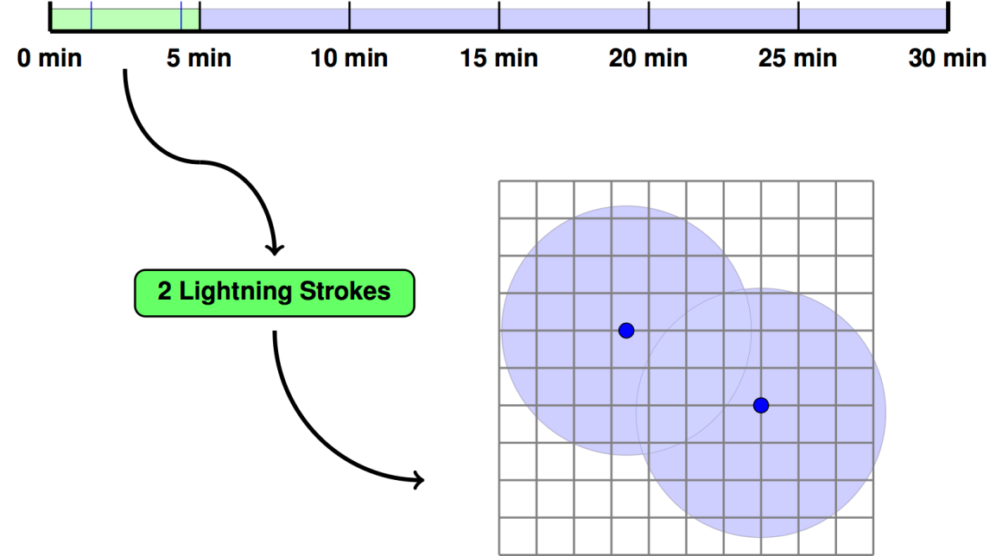
Fig. 1. A schematic of the lightning nudging process. Top: A timeline during a portion of the simulation, divided into 5-minute bins. The green highlighting indicates the temporal bin containing the current time step, with blue lines representing observed lightning strokes. Bottom: An example of how the lightning stroke locations (blue dots) are used to determine which grid points are nudged on the model domain (points within light blue circles) when the current simulation time step is within the green-highlighted bin.

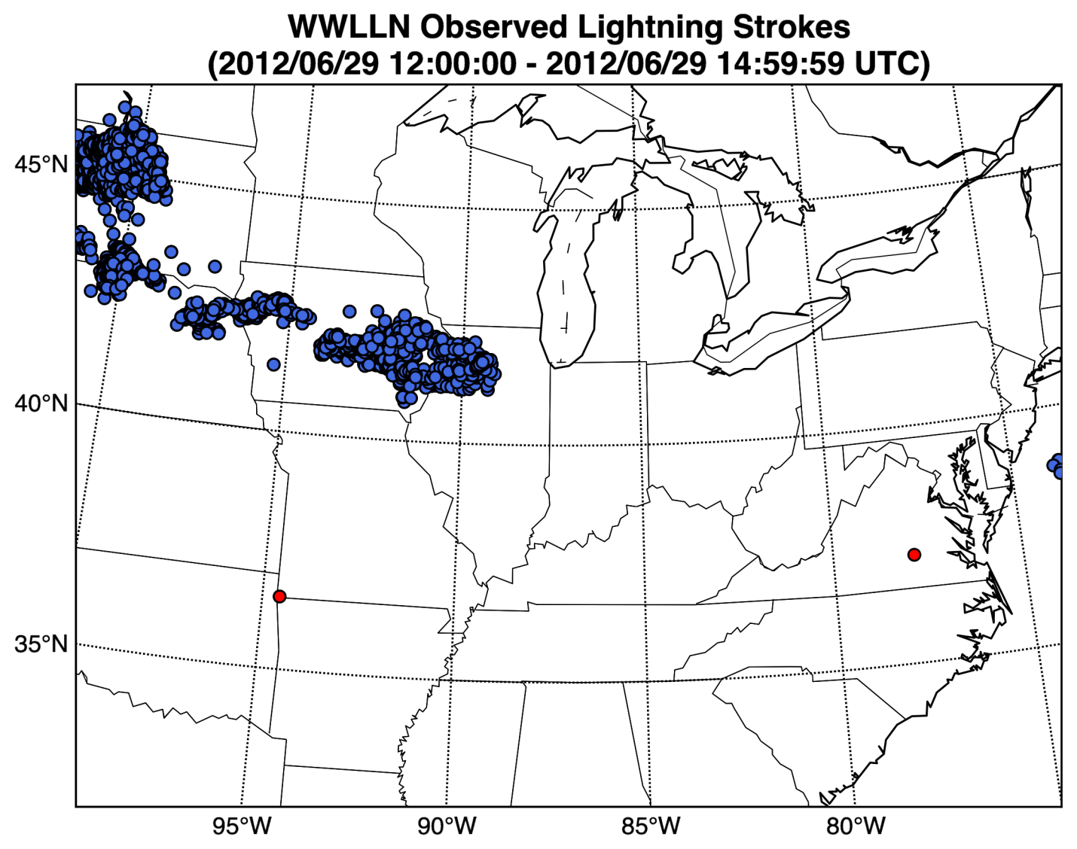
Fig. 2. Lightning strokes observed by WWLLN between 1200 UTC and 1500 UTC 29 June 2012 on the WRF domain described in Section 2c. Location data from 4315 lightning strokes were assimilated in the NUDGE and ENS-NUDGE experiments (blue dots). Two lightning strokes were removed by the filtering technique described in Section 2a (red dots).

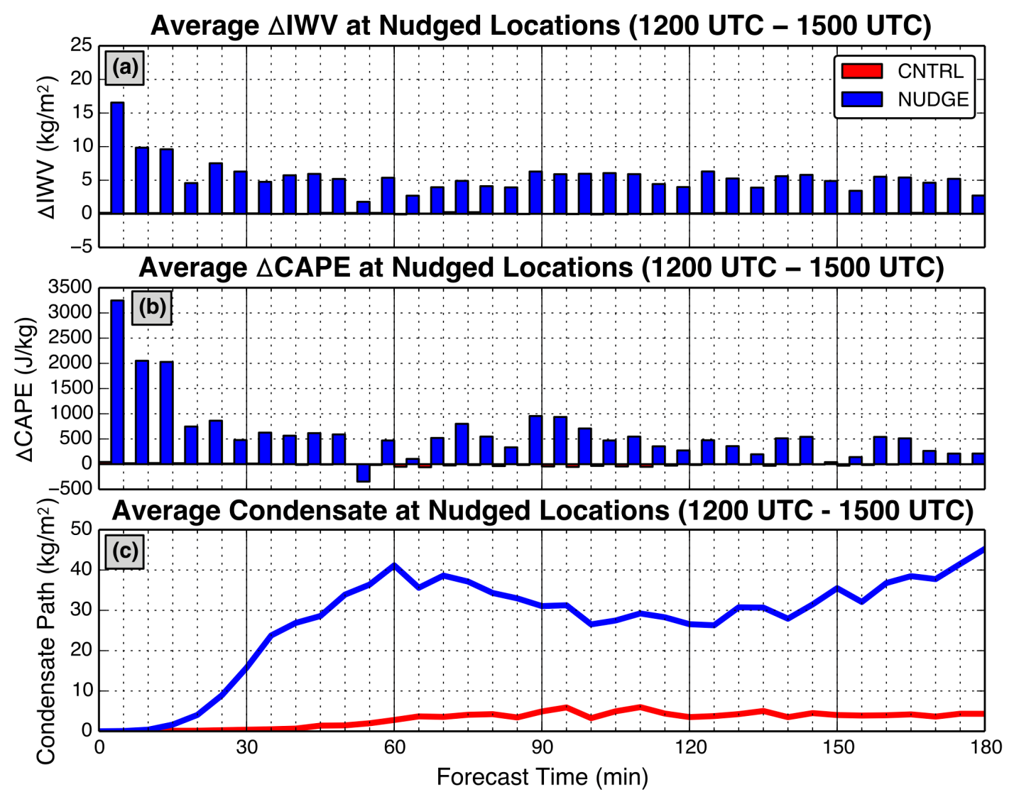
Fig. 3. Average temporal changes in (a) IWV and (b) CAPE at grid points where nudging is performed in NUDGE for the deterministic simulation of the 29 June 2012 event. (c) Average column condensate (liquid and solid water path) at nudged locations. Red bars and lines represent results from CNTRL, while blue bars and lines represent results from NUDGE. The red bars are very small and thus barely legible.

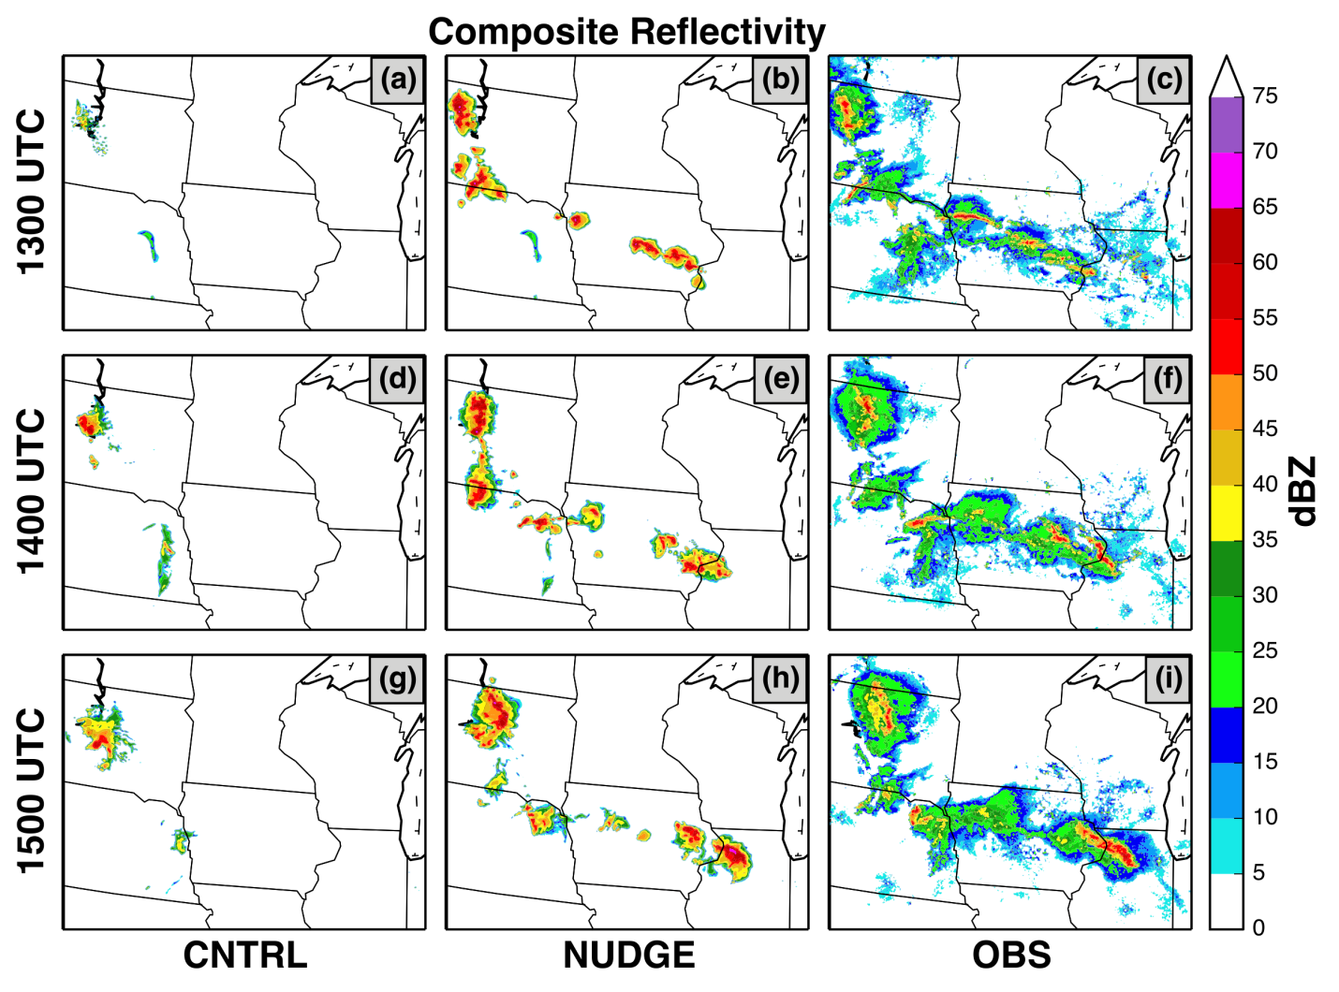
Fig. 4. Simulated and observed composite reflectivity for the first three hours of the deterministic simulations of the 29 June 2012 event (1300-1500 UTC 29 June 2012) for CNTRL, NUDGE, and the observations, respectively. The northwest portion of the model domain is displayed.

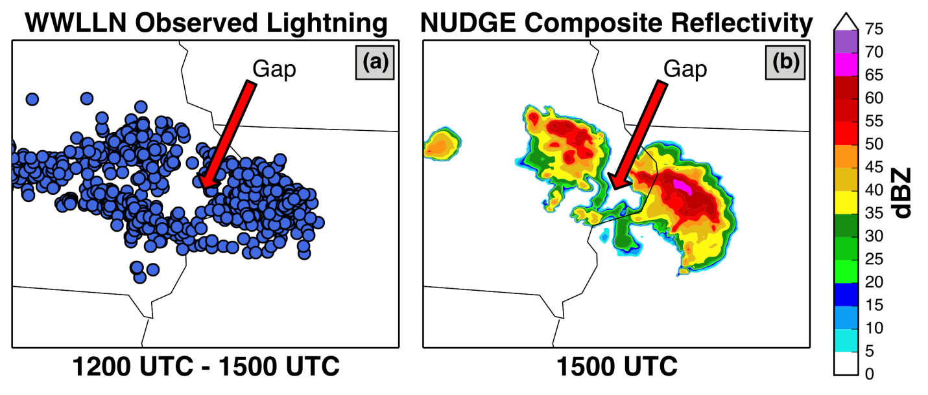
Fig. 5. (a) Lightning strokes observed by WWLLN between 1200 UTC and 1500 UTC over eastern Iowa and western Illinois. (b) Simulated composite reflectivity in NUDGE over the same region at 1500 UTC (at the end of the 3-hour nudging period). The red arrow indicates an area location with a lack of WWLLN-observed lightning strokes.

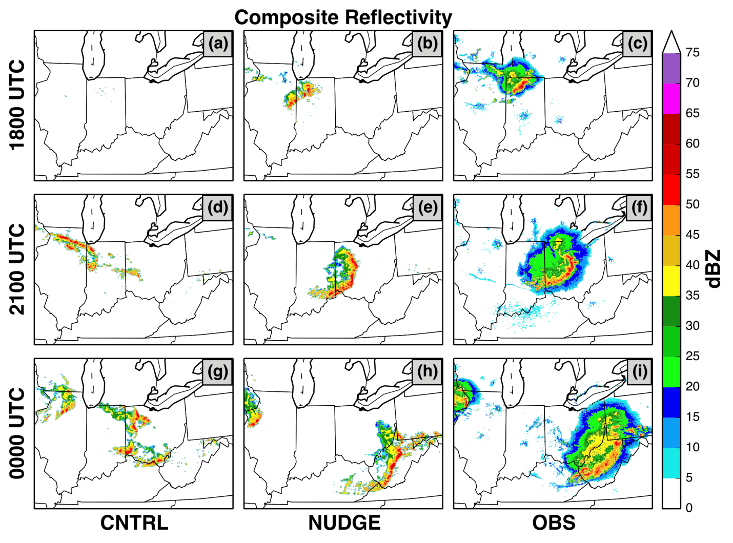
Fig. 6. Same as in Figure 4, except results are displayed at 3-hour intervals between 1800 UTC 29 June 2012 and 0000 UTC 30 June 2012. The central portion of the model domain is displayed.

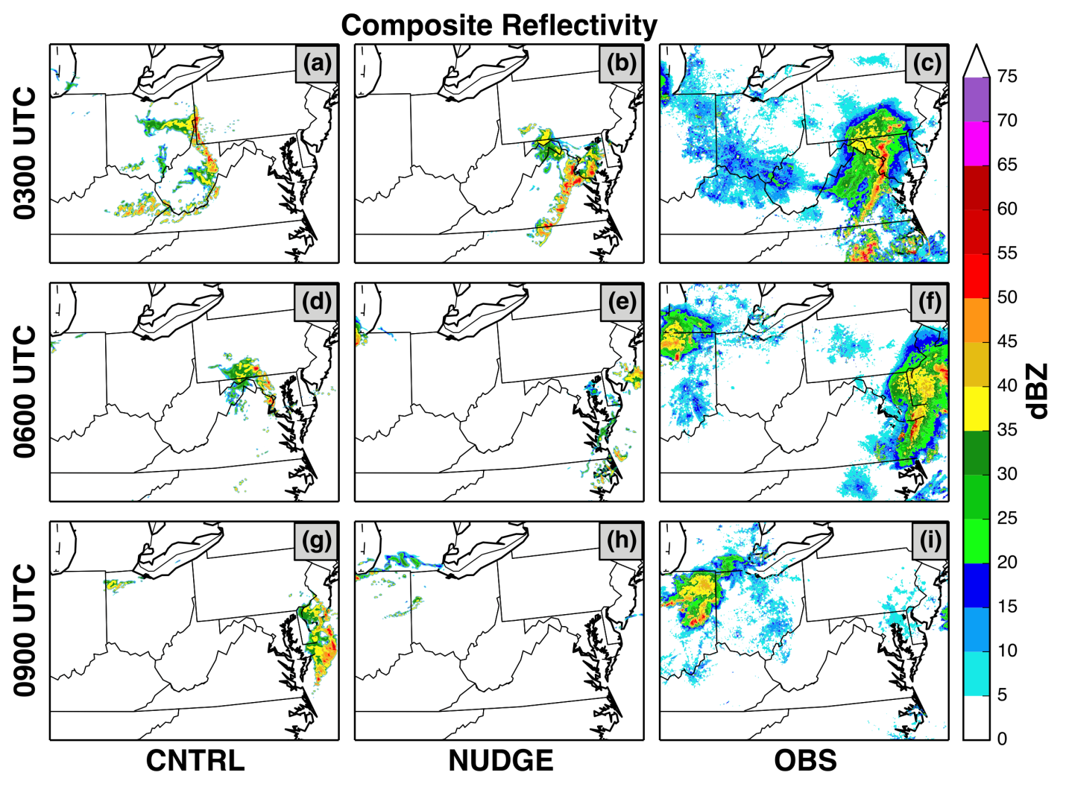
Fig. 7. Same as in Figure 4, except results are displayed at 3-hour intervals between 0300 UTC and 0900 UTC 30 June 2012. The east central portion of the model domain is displayed.

Figure 8: Equitable threat scores for precipitation equaling or exceeding 10 mm for both the control and nudged experiments, using either Thompson or Morrison microphysics.
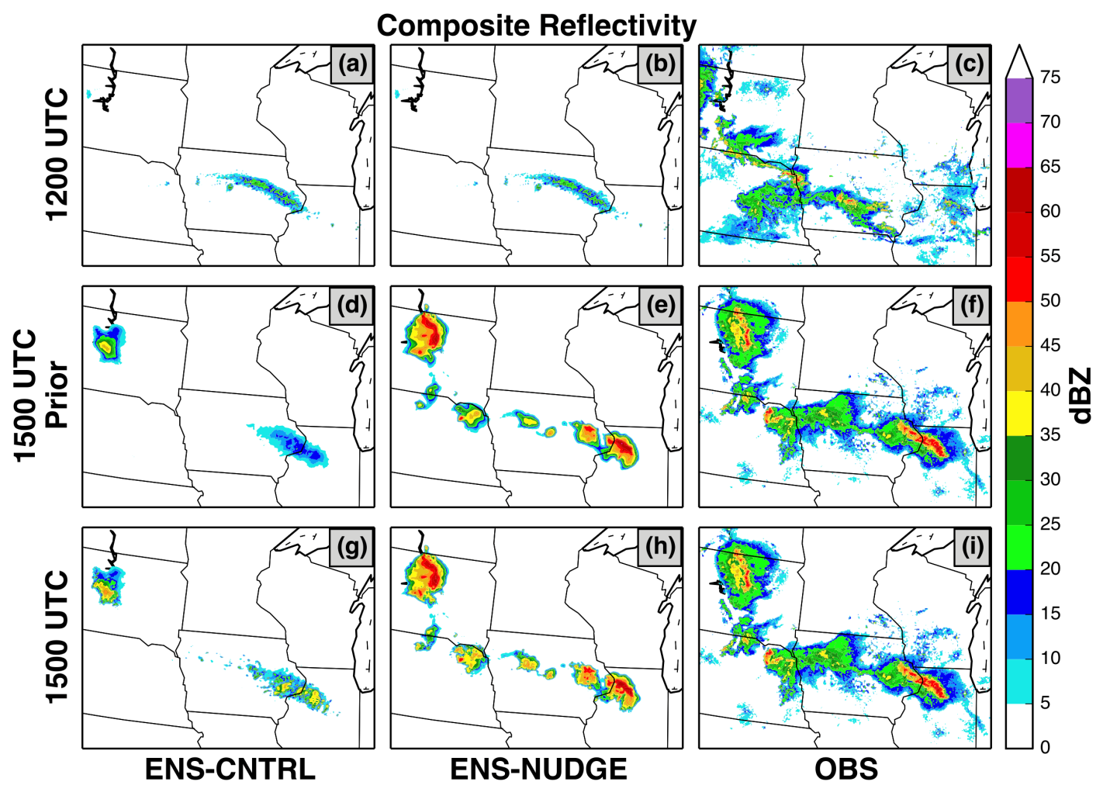
Fig. 9. Ensemble-mean and observed composite reflectivity after the 1200 UTC 29 June 2012 EnKF assimilation step (top row), before the 1500 UTC 29 June 2012 EnKF assimilation step (middle row), and after the 1500 UTC 29 June 2012 EnKF assimilation step. The columns correspond to ENS-CNTRL, ENS-NUDGE, and observed reflectivity, respectively. The northwest portion of the model domain is displayed.

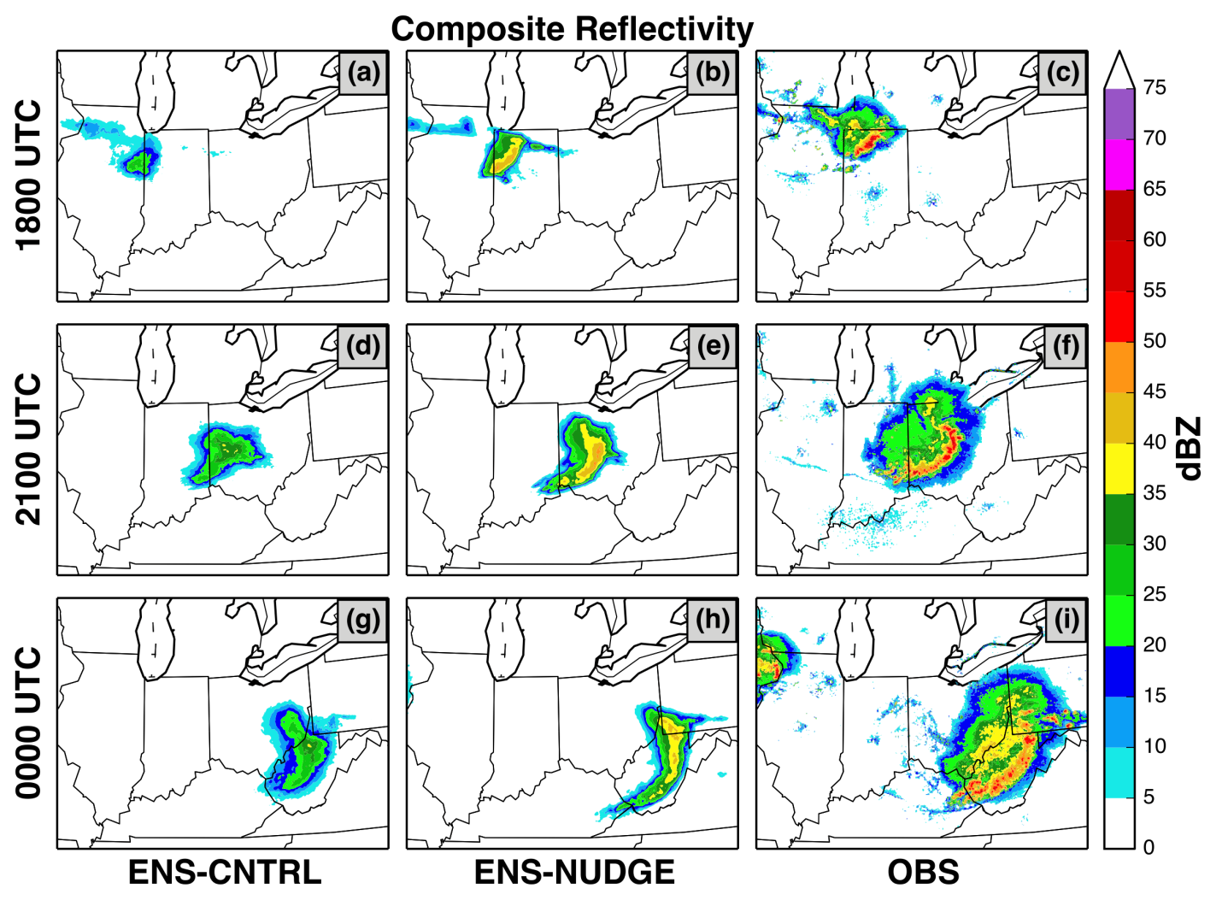
Fig. 10. Same as in Figure 9, except results are displayed at 3-hour intervals between 1800 UTC 29 June 2012 and 0000 UTC 30 June 2012. The central portion of the model domain is displayed.

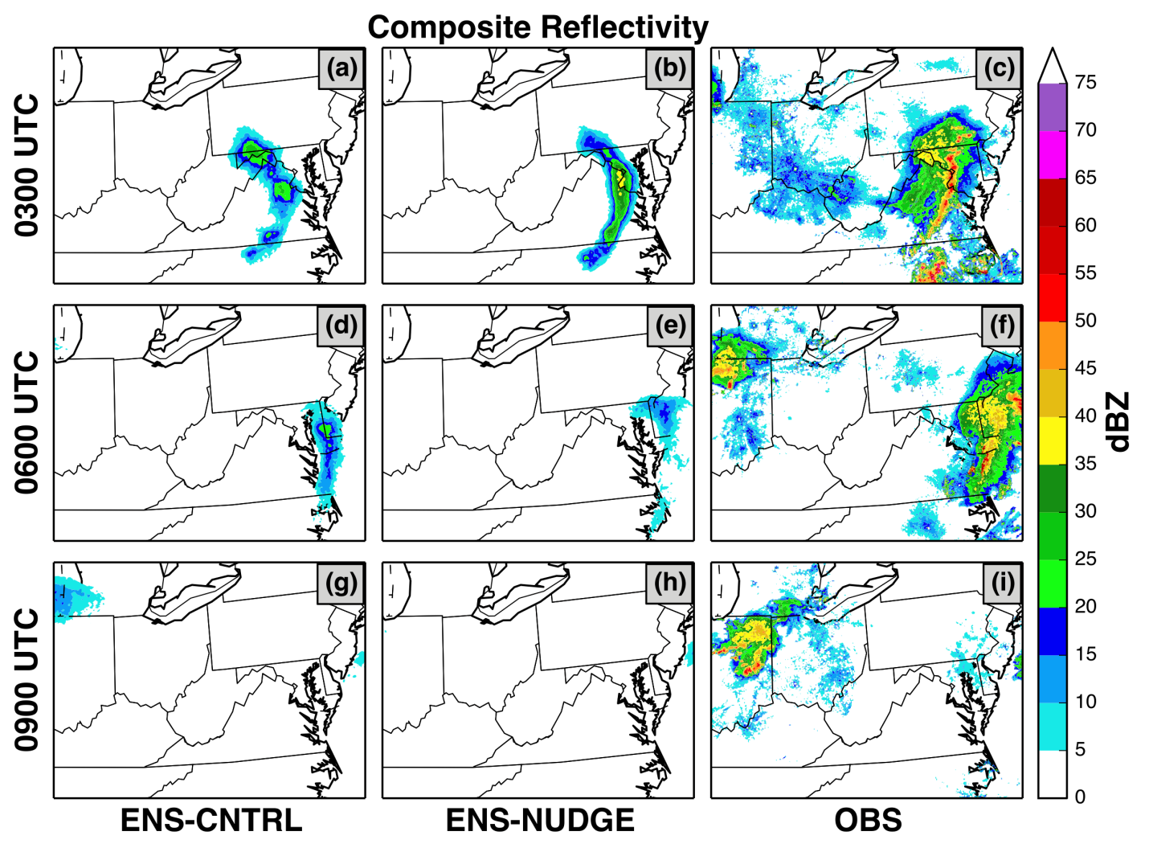
Fig. 11. Same as in Figure 9, except results are displayed at 3-hour intervals between 0300 UTC 30 June 2012 and 0900 UTC 30 June 2012. The central portion of the model domain is displayed.

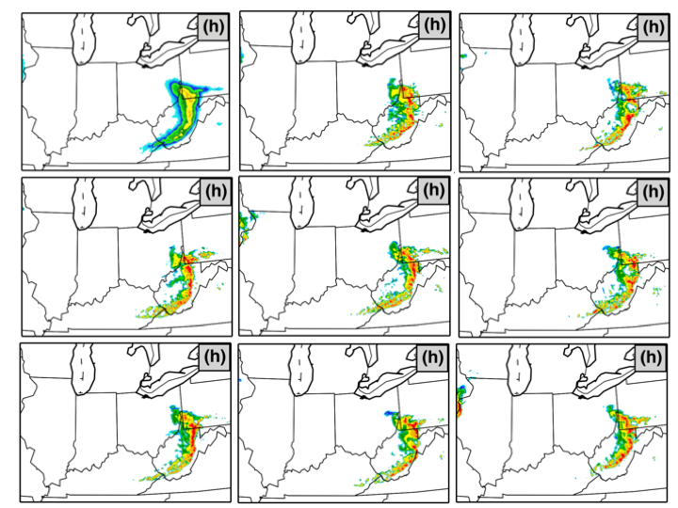
Figure 12: Simulated reflectivities from the ensemble mean (upper left) and eight ensemble members (1, 6, 11, 16, 21, 26, 31, 36).
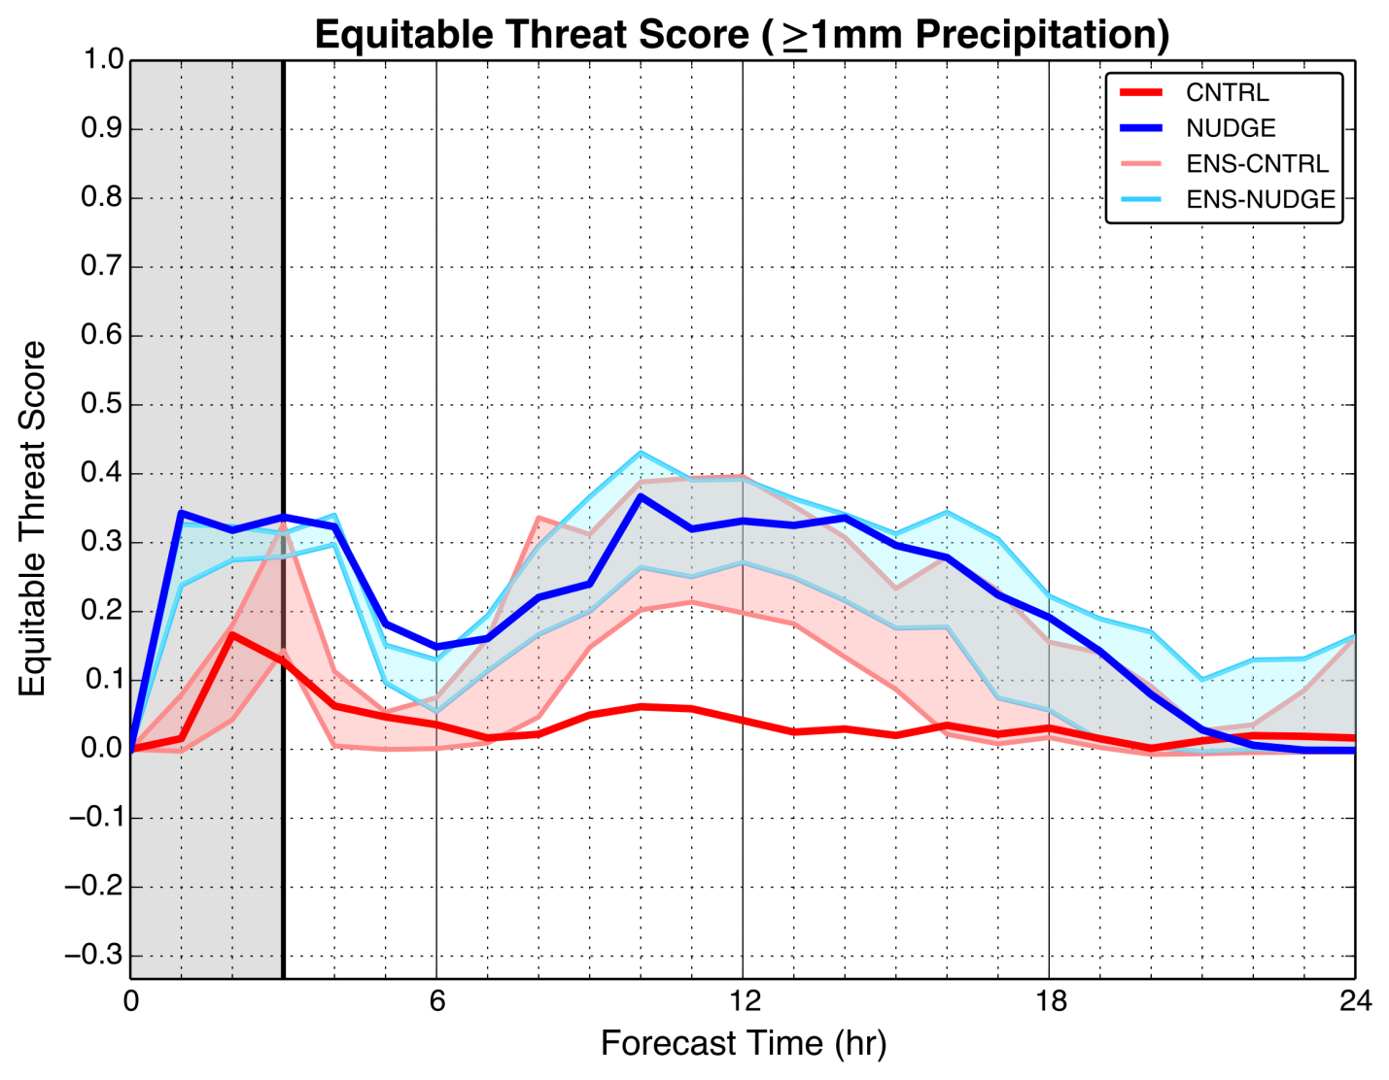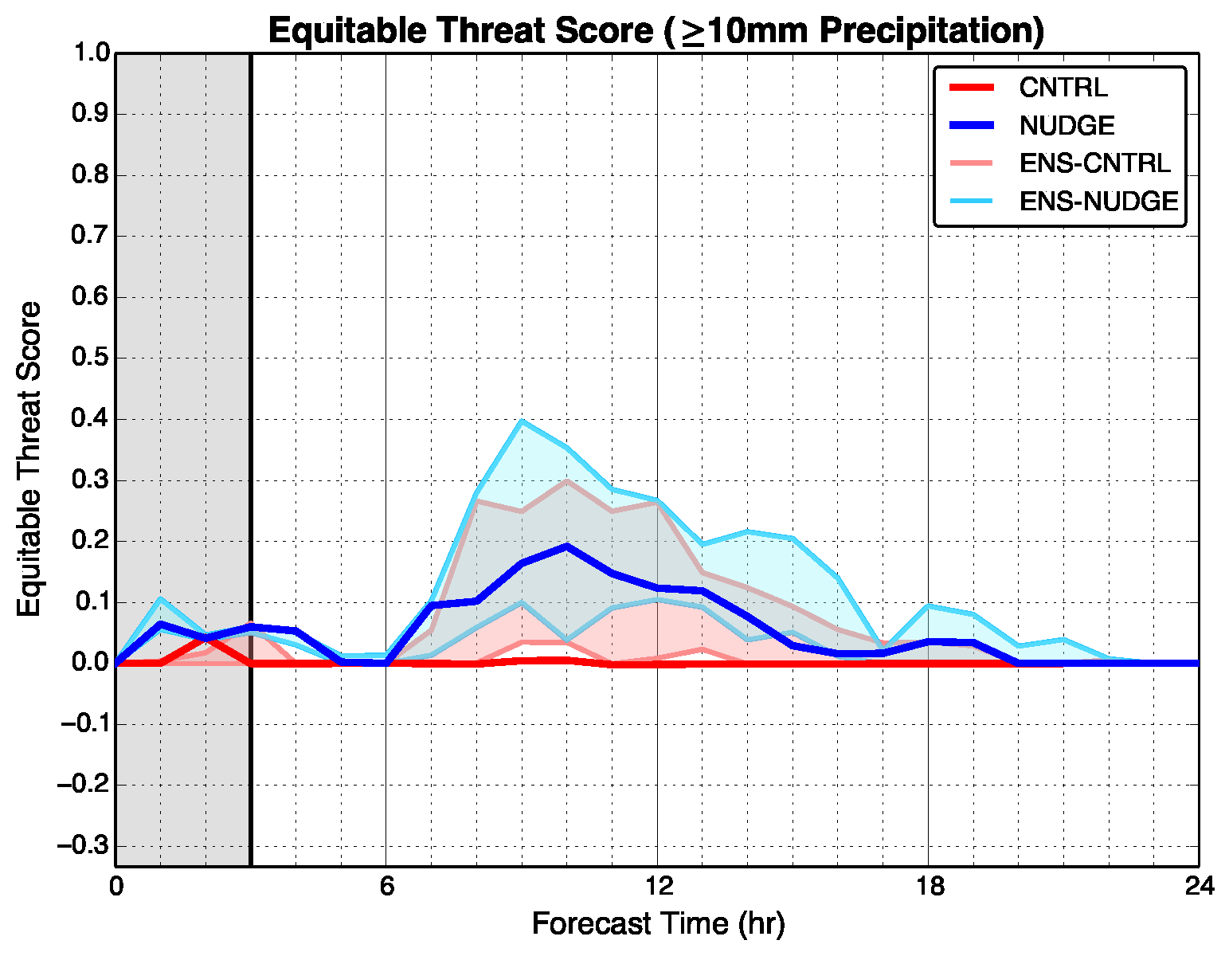
Fig. 13. Time series of equitable threat scores (ETS) for CNTRL (thick red line), NUDGE (thick blue line), ENS-CNTRL (light red shaded region), and ENS-NUDGE (light blue shaded region) for the 29 June 2012 event for greater than or equal to 1 mm (top) and 10 mm (bottom) over the previous hour. The gray shaded area indicates times of moisture nudging in the NUDGE and ENS-NUDGE simulations.

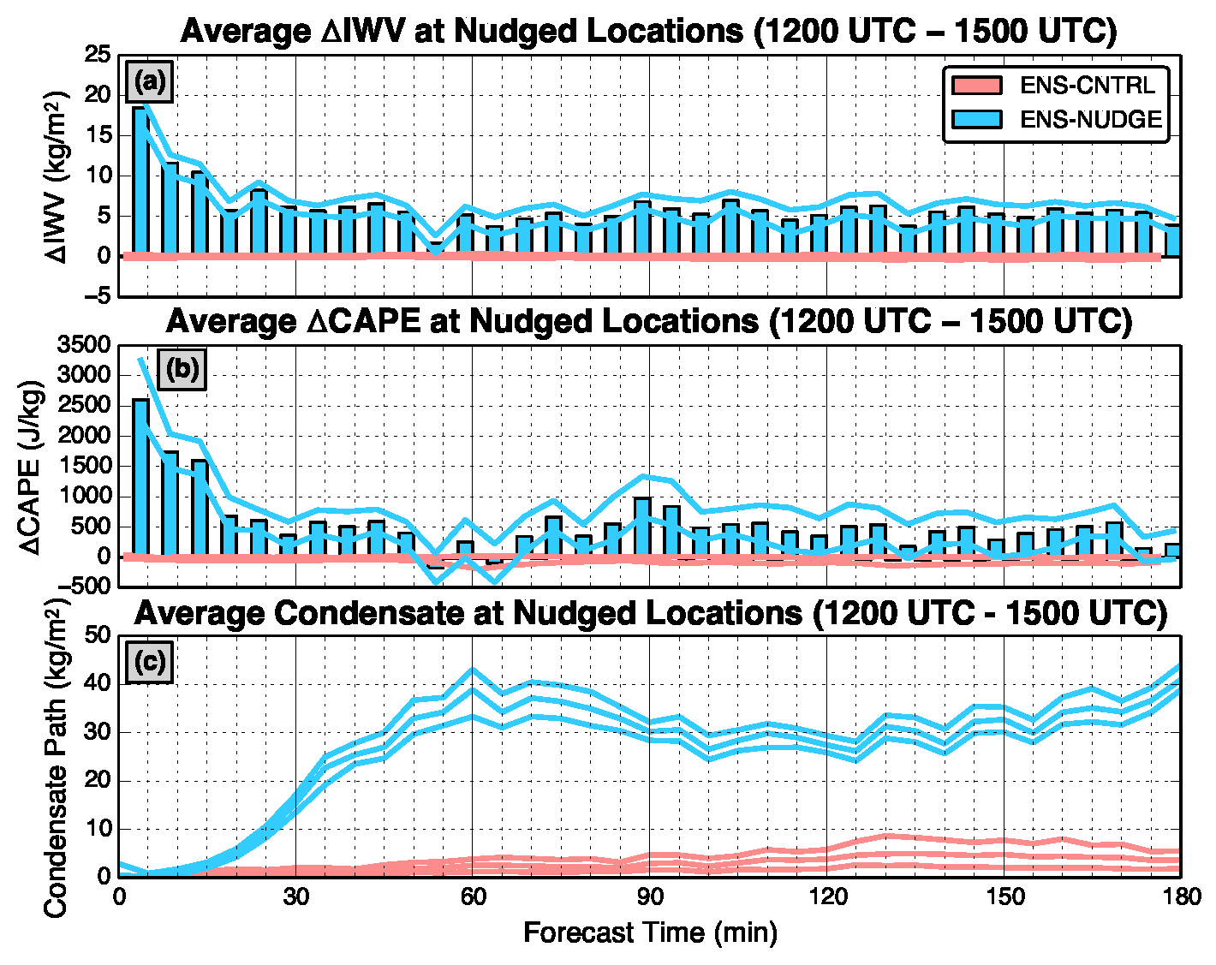
Figure 14. Changes in average values and range of IWV, CAPE, and average condensate during the three-hour moisture nudging period for both the ensemble-control (ENS- CNTRL) an essemble-nudged (ENS-NUDGE) simulations.
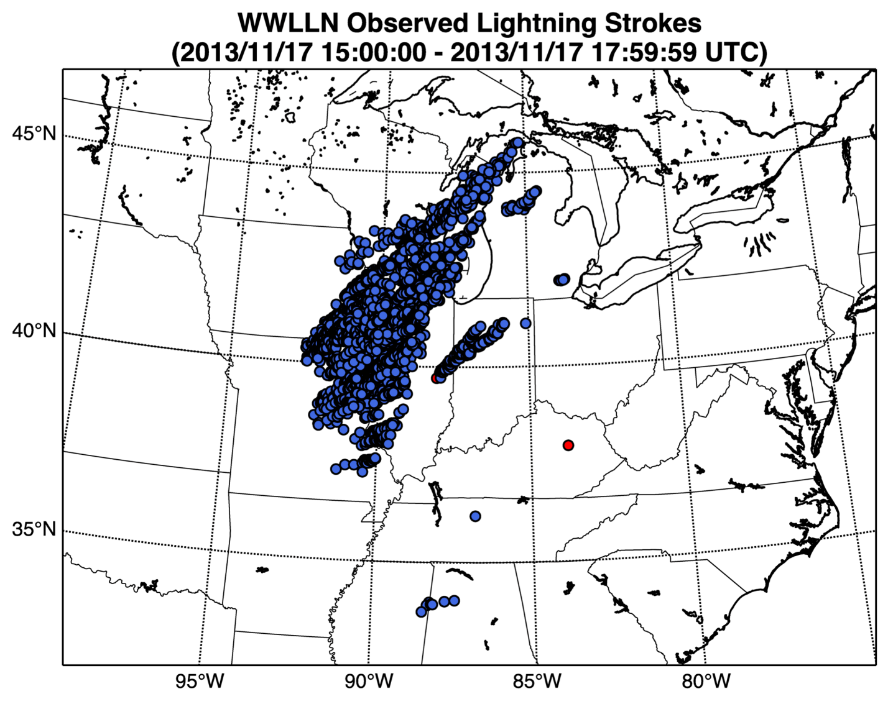
Fig. 15. Lightning strokes observed by WWLLN between 1500 UTC and 1800 UTC 17 November 2012 on the WRF domain described in Section 2c. Location data from 6071 lightning strokes were assimilated in the NUDGE simulation (blue dots). Two lightning strokes were removed from by the filtering technique described in Section 2a (red dots).

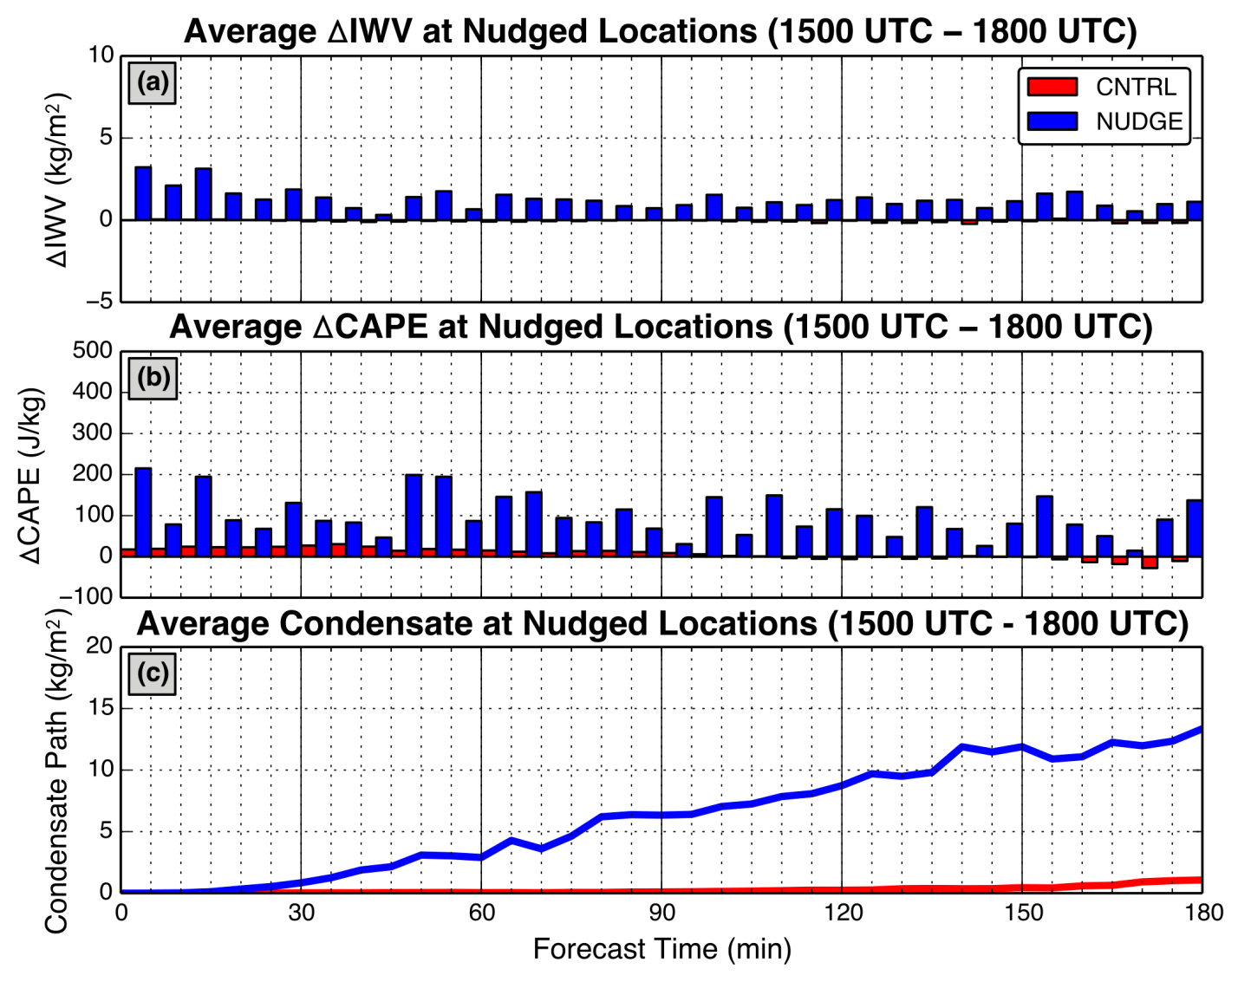
Fig. 16. Average temporal changes in (a) IWV and (b) CAPE at grid points where nudging is performed in NUDGE for the 17 November 2013 event. (c) Average column condensate (liquid and solid water path) at nudged locations. Red bars and lines represent results from CNTRL, while blue bars and lines represent results from NUDGE.

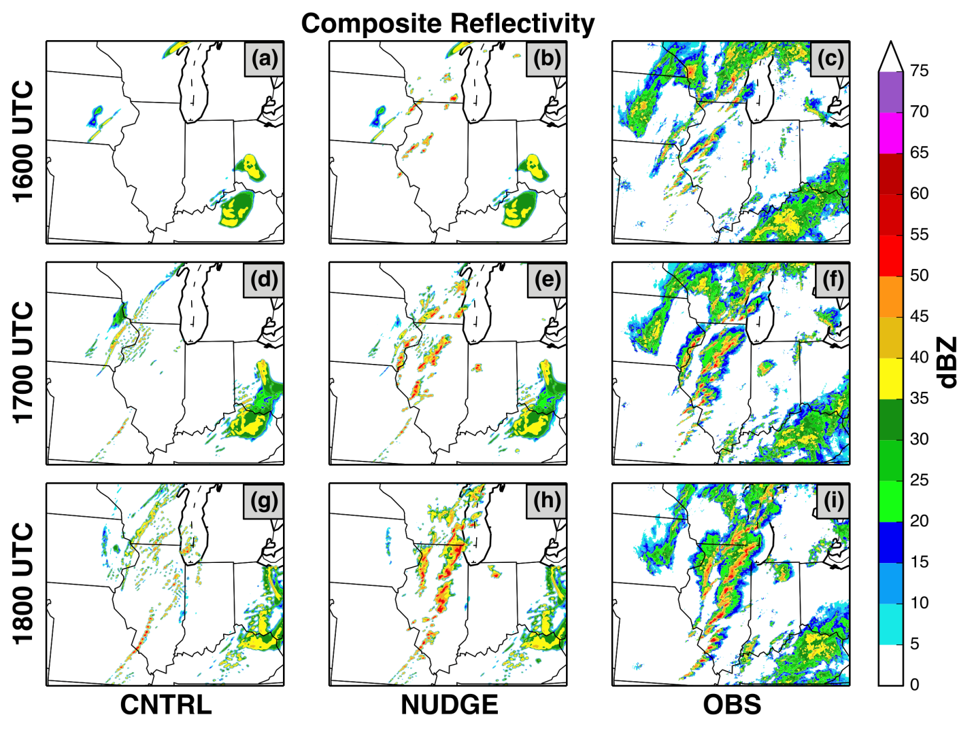
Fig. 17. Simulated and observed composite reflectivity for the first three hours of the deterministic simulations of the 17 November 2013 event (1600-1800 UTC 17 November 2013) for CNTRL, NUDGE, and the observations, respectively. The north central portion of the model domain is displayed.

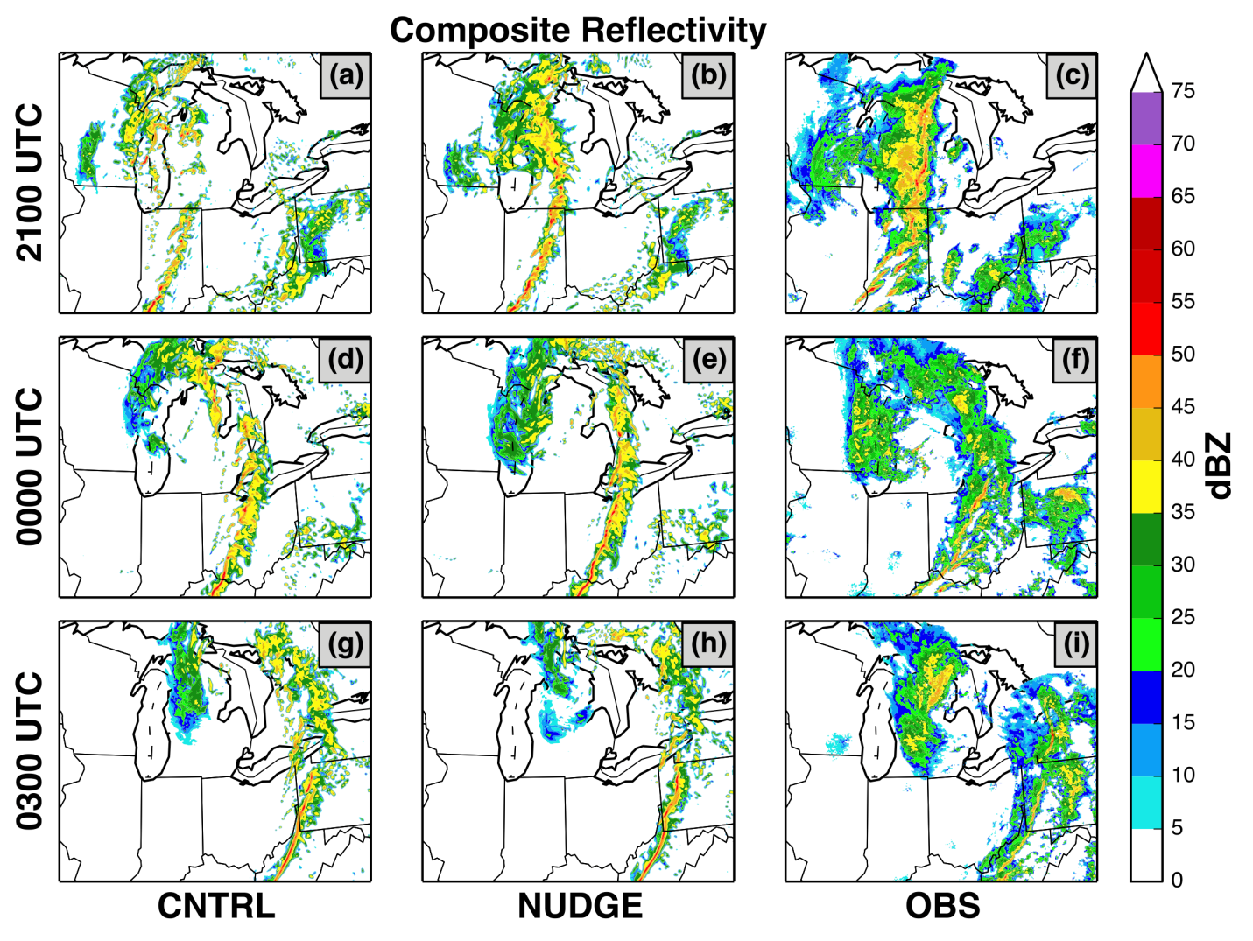
Fig. 18. Same as in Figure 15, except results are displayed at 3-hour intervals between 2100 UTC 17 November 2013 and 0300 UTC 18 November 2013. The north central portion of the model domain is displayed.

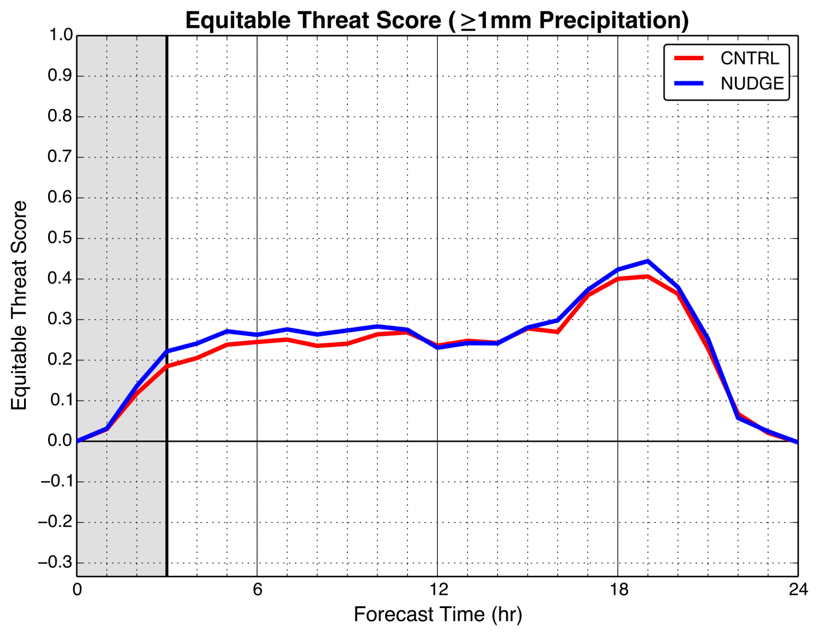
Fig. 19. Time series of ETS for CNTRL (thick red line) and NUDGE (thick blue line) for the 17 November 2013 event. The gray shaded area indicates times during which moisture nudging occurred in the NUDGE simulations.

